OWNERS' HANDBOOK
FOR
OPERATION AND MAINTENANCE OF
BITSER - MODEL DS-HLS AIRPLANE

BOTES AND VAN HEERDEN PRTNS, PRETORIA, SA.

NOTICE

THIS HANDBOOK IS NOT DESIGNED, NOR CAN ANY HANDBOOK SERVE, AS A SUBSTITUTE FOR ADEQUATE AND COMPETENT FLIGHT INSTRUCTION, OR KNOWLEDGE OF THE CURRENT AIRWORTHINESS DIRECTIVES, THE APPLICABLE FEDERAL AIR REGULATIONS, AND ADVISORY CIRCULARS. IT IS NOT INTENDED TO BE A GUIDE OF BASIC FLIGHT INSTRUCTION, NOR A TRAINING MANUAL. THE HANDBOOK IS DESIGNED:

- TO HELP YOU OPERATE YOUR BITSER WITH SAFETY AND CONFIDENCE.
- TO MORE FULLY ACQUAINT YOU WITH THE BASIC PERFORMANCE AND HANDLING CHARACTERISTICS OF THE AIRPLANE.
- TO MORE FULLY EXPLAIN YOUR BITSER'S OPERATION THAN IS PERMISSIBLE TO SET FORTH IN THE AIRPLANE FLIGHT MANUAL

Published by
PUBLICATIONS DEPARTMENT
Botes and Van Heerden Prtns
Issued:
Revised: 2014-03-22

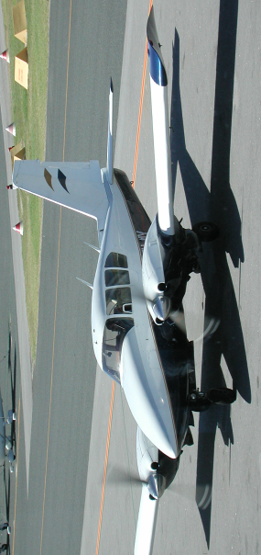

SECTION ONE
DESIGN FEATURES | Page
I. Specifications | 2
II. Engines and Propellers | 4
III. Fuselage and Wing Structures | 6
IV. Landing Gear | 7
V. Hydraulic System | 9
VI. Control System and Surfaces | 10
VII. Fuel System | 14
VIII. Electrical System | 18
IX. Finish | 23
X. Instrument Panel | 23
XI. Seats | 24
XII. Radio Equipment | 25
XIII. Heating and Ventilating | 27

DESIGN FEATURES

I. Specifications

Engines: Lycoming I0-540 C4B5 250 HP at 2575 RPM
Standard Gross Weight 2350 kg (5200 lbs)
Empty Wt. 1380 kg (3042 lbs)
Useful Load 980 kg (2158 lbs)
Wing Span 11.34 m (37 2 ft)
Length 9.52 m (31.22 ft)
Height 3.14 m (10.3 ft)
Propeller 1.96 m (77")
Wing Loading 124.5 kg/m² (25.5 lbs/ ft²)
Power Loading 4.7 kg/HP (10.4 lbs/ HP)
Baggage Capacity Fwd (max.) 68 kg (150 lbs)
Baggage Capacity Aft (max) 68 kg (150 lbs)
Baggage Space Fwd 0.6 m³ (21.3 ft³)
Baggage Space Aft 0.7 m³ (25.4 ft³)
Fuel Capacity 545 lit (144 USG)
Fuel Capacity (Optional) 670 lit (177 USG)
Wheel Base 2.3 m (7.5 ft)
Wheel Tread 3.4 m (11.3 ft)
Top Speed, 85%, 4000' 183 kts
Cruise Speed, 75%, 6000' 181 kts
Cruise Speed 55%, 10000' 170 kts
Stall Speed, Power Off, Gear & Flaps Down 61 kts
Stall Speed, Power Off, Gear & Flaps Up 66 kts
Takeoff Run 250 m (820 ft)
Takeoff Run over 50 ft (ft) 380 m (1250 ft)
Landing Roll, Flaps Down (ft) 260 m (850 ft)
Landing Roll, Flaps Down over 50 ft (ft) 500 m (1620 ft)
Best Rate of Climb Speed 102 kts
Rate of Climb 1,490 fpm
Best Angle of Climb Speed 93 kts
Best Single Engine R/C Speed - Blue Line 89 kts
Single Engine R/C (ft per NM) 240 fpm
Service Ceiling 19,800 ft
Single Engine Abs. Ceiling 6,400 ft
Fuel Flow (Gal./Hr. at 75%) 100 lit/hr
Fuel Flow (Gal./Hr. at 55%) 80 lit/hr
Range at 75% at SL 940 nm
Range at 55% at 10,000' 925 nm
Range Optimum with auxiliary tanks 1047 nm

Note: All speeds are in knots.

II. Engines and Propellers
-
l
-

The Lycoming 0-540-A engines in the Bitser are rated at 250 HP at 2575 RPM. These engines have a compression ratio of 8.5:1 and use 91/96 minimum octane fuel.
Both engines on the standard Bitser are equipped with a geared starter, generator, vacuum pump, two magnetos, shielded harness, shielded spark plugs, diaphragm fuel pump, propeller governor and an oil thermostat. The left engine only is equipped with a hydraulic pump.
Engine mounts are of steel tubing construction and incorporate vibration absorbing load mounts. Engine cowls are largely interchangeable and are cantilever structures attached at the firewall. Side panels are quickly removable by means of quick release fasteners. The nose section is split for quick removal.
The exhaust system is a straight type with exhaust gases directed into muffled jet augmenter tubes located on the outboard side of each engine. This system provides for exhaust elimination without power loss, and effective engine cooling through the pumping action of the exhaust gases into the augmenter tubes, which draws cooling air through the engine compartment; no cowl flaps or cooling flanges are needed on the cowling. Higher aircraft speeds

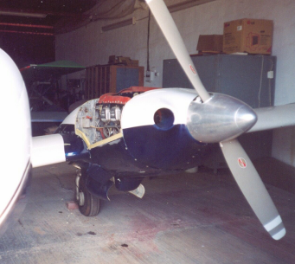
are obtainable with this system due to reduced cooling drag and due to extra thrust furnished by the exhaust augmentation.
Efficient aluminum oil coolers are mounted on the rear of each engine firewall. Engine oil drainage is accomplished with quick oil drain valves located on the right rear corner of the engine crankcases.
Engine air is directed through quickly removable filters, located in the nose cowls, to the throttle body air boxes. Heated air for the throttle body is taken from shrouds on the exhaust manifolds through flexible tubes to the air boxes. (See Section II, Sub Section V for throttle body heat application).
The propellers on the Bitser are Hartzell HC-82XK-2C1 or HC-A2XK-2 constant-speed controllable full-feathering units. These are controlled entirely by use of the propeller pitch levers located in the center of the control quadrant. Feathering of the propellers is accomplished by moving the controls fully aft through the high pitch detent into the feathering position. Feathering takes place in approximately three seconds. A propeller is unfeathered by moving the prop control ahead and engaging the starter. (See Section II, Sub Section VII-2 and 3 for complete feathering and unfeathering instructions).

III. Fuselage and Wing Structures

The Bitser fuselage is a composition of four basic units: the sheet metal tail cone, cabin section, nose section, and the steel tubular structure which extends from the tail cone to the nose wheel. The steel tube unit is intended to withstand the high loads imposed on the center section region of the airplane, and provides an extra safety factor in this area.
Finish on the tubular unit, as on all steel tube structures in the Bitser, is zinc chromate primer with synthetic enamel.
The wing structure is lightweight but rugged, and consists of a massive stepped-down main spar, a front and rear spar, lateral stringers, longitudinal ribs, stressed skin sheets, and a readily detachable wing tip section. The rectangular plan form of the wing permits the use of many interchangeable parts and simplifies the construction while providing for excellent stability and performance characteristics.
The wings are attached to the fuselage steel tubular structure with fittings at the sides and in the center of this structure, and the main spars are bolted to each other with high strength butt fittings
in the center of the fuselage, making in effect a continuous main spar. This arrangement combines high strength and light weight qualities, since heavy wing hinge fittings on the spars and fuselage are eliminated, as well as an elaborate carry-through structure through the center section of the fuselage.

IV. Landing Gear

All three landing gear units on the Bitser incorporate the same soft acting air-oil oleo struts, and contain many directly interchangeable parts. (See Section IV, Sub section V for maintenance).
Main wheels are 600 x 6 Cleveland Aircraft Products units with disc type brakes and 700 x 6 tires with an eight ply rating. The nose

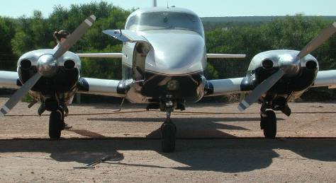

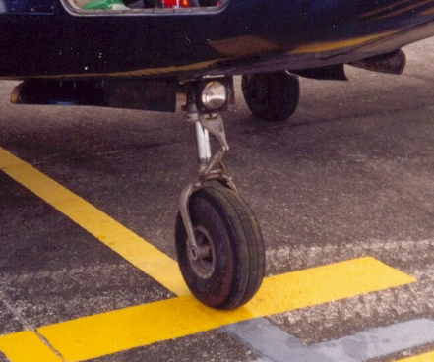

wheel is a Cleveland 600 x 6 model fitted with a 600 x 6 tire with a four ply rating. All tires have tubes. (See Section IV, Sub Section II for tire service).
Main gear brakes are actuated by toe brake pedals on the left set of rudder pedals. Hydraulic brake cylinders located in front of the left rudder pedals are readily accessible in the cockpit for servicing. A brake fluid reservoir which is connected to the brake cylinders with flexible lines provides a reserve of fluid for the brake system, and is mounted on the fuselage structure inside the left nose access panel. (See Section IV, Sub Section IV for brake service).
Parking brake valves, operated by a control on the upper left side of the instrument panel, are installed ahead of the forward cabin bulkhead and are also serviced through the left nose access panel.
The nose wheel is steer able through a 30 degree arc through use of the rudder Pedals. As the nose gear retracts, the steering linkage becomes disconnected from the gear so that rudder pedal action with the gear retracted is not impeded by nose gear operation.
The position of the landing gear is indicated by four light bulbs located on the pedestal. When the three green lights are on, all three legs of the gear are down and locked; when the amber light is on, the gear is entirely up, and when no light is on, the gear is in an intermediate position.
A red light in the landing gear control knob flashes when the gear is up and either one of the throttles is pulled back. When both throttles are closed beyond a given power setting, (approximately 12" hg. manifold pressure) with wheels not down, the landing gear warning horn sounds.
To guard against inadvertent retraction of the landing gear on the ground, a mechanical latch, which must be operated before the landing gear control can be moved upward, is positioned just above the control lever. The control knob is in the shape of a wheel to differentiate it from the flap control knob which has an airfoil shape. There is also an anti retraction valve located on the left main gear which prevents a build up of hydraulic pressure in the retraction system while the weight of the airplane is resting on its wheels.

V. Hydraulic System

The hydraulic system is used for the extension and retraction of both the landing gear and flaps. The operation of these units is accomplished by the landing gear and flap selector valve unit which is housed within the control pedestal under the engine controls. Pressure is supplied to the control unit from an engine driven pump mounted on the left engine.
To effect extension or retraction of the gear and flaps, the controls which protrude through the face of the pedestal are moved from the center "Off" in the desired direction. When the selected component is fully extended or retracted, hydraulic pressure within the selector valve unit forces the control back to a neutral or "Off" position, which allows the hydraulic fluid to circulate freely between the pump and the control unit. Also, it isolates the activating cylinders and associated lines from the hydraulic fluid supply. This prevents complete loss of fluid in the event of a leak in the lines between the selector valve and the component or at the actuating cylinders. The return of the control handle to the "Off" position
is also a secondary indication that the components have reached full extension or retraction. The landing gear position lights and the flap indicator should be used as primary indications.
Gear retraction and extension will occur normally in 10 to 12 seconds. The flap operation requires about 4 seconds.
The emergency hydraulic hand pump, which is integral with the selector valve unit, is used to obtain hydraulic pressure in event of failure of the hydraulic pump on the left engine. To operate the emergency pump, the handle should be extended to its full length by pulling aft and positioning the control handle as desired. 30 to 40 pump strokes are required to raise or lower the landing gear.
For emergency extension of the landing gear, if failure of the hydraulic system should occur due to line breakage or selector valve malfunction, an independent CO2 system is available to extend the landing gear. (See Section II, Sub Section VIII-5).
Included on the left main gear is an oleo actuated by-pass valve which makes it impossible to retract the landing gear while the weight of the airplane is on the gear. This valve is open when the oleo strut is compressed and by-passes all hydraulic fluid, on the pressure side of the system, to the return side, preventing any pressure build-up in the retraction system. When the oleo strut is extended as in flight, or when the aircraft is on jacks, the valve is closed, permitting the system to operate in the normal manner.

VI. Control System and Surfaces

Dual wheel and rudder flight controls are provided in the Bitser as standard equipment. All controls are light yet solid and effective in flight at all speeds down through the stalling speed. The nose wheel is steer able on the ground through the rudder pedals and the left set of pedals are equipped with toe brakes.
All control surfaces on the Bitser are cable controlled and are conventional sheet metal structures, fitted with cast aluminum hinges and needle bearings. The flaps are actuated by a hydraulic cylinder located in the right side of the cabin wall. Access to this cylinder is obtained by the removal of the upholstered interior panel immediately ahead of the baggage door.
The ailerons and rudder are connected by cables with the control wheel and rudder pedals. The rudder has a servo tab which also acts as a directional trim tab, actuated by a crank in the center of the forward cabin ceiling.

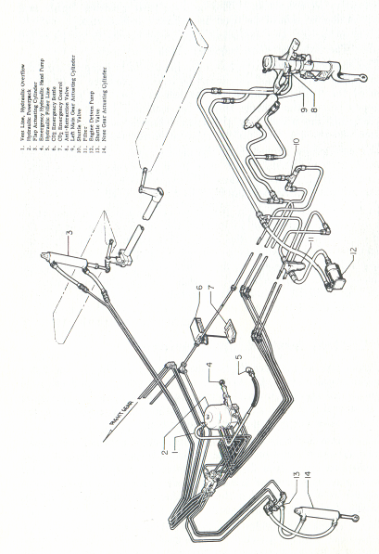
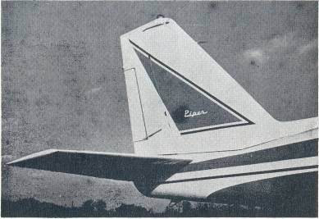

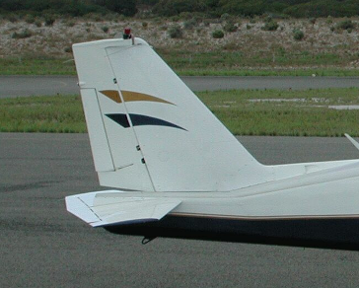

The horizontal tail is a stabilator, with an anti-servo tab which also acts as longitudinal trim tab, actuated by a larger crank adjacent to the rudder tab crank -in the center of the forward cabin ceiling. The stabilator provides extra stability and controllability with less size, drag and weight than with conventional horizontal tail surfaces

VII. Fuel System

Four thirty six gallon nylon and neoprene fuel cells located outboard of the engines provide fuel storage in the Bitser. The cells should be kept full of fuel during storage of the airplane to prevent accumulation of moisture, and to prevent deterioration of the cells. For long term storage without fuel, the cells should be coated with light engine oil to keep from drying out.
The fuel system in the Bitser is simple, but completely effective. Fuel can be pumped from any tank to both engines, through use of the engine driven and/or electric fuel pumps.
For normal operation, fuel is pumped by the engine driven pumps from the tanks directly to the adjacent throttle bodys. The fuel valves can be left on at all times and the crossfeed left in the off

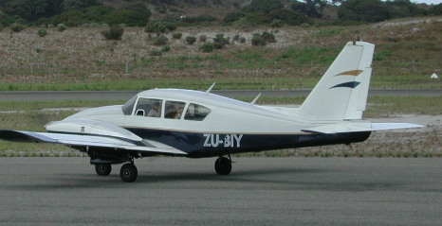

position. Electric auxiliary fuel pumps, located in the engine compartments, are installed in by-pass fuel lines between the tanks and the engine driven pumps. The electric pumps can be used to provide pressure in the event of failure of the engine pumps. They are normally turned on to check their operation before starting the engines, turned off after starting, to check engine driven pumps and left on during take-off and landing, to preclude the possibility of fuel pressure loss due to pump failure at critical times.
If one of the engine driven pumps fails, the electric pumps to that engine can be turned on to supply the fuel. However, if desired, the fuel can be pumped by the operating engine driven pump to the failed pump engine simply by turning on the cross-feed. The good pump will then be supplying both engines from its tank. If this tank runs low on fuel, fuel can be drawn from the opposite tank by turning on the electric pumps on the failed pump side, leaving the crossfeed on, and turning the fuel valve on the empty tank off. Then the electric pumps on the failed pump side will be supplying both engines from its tank.

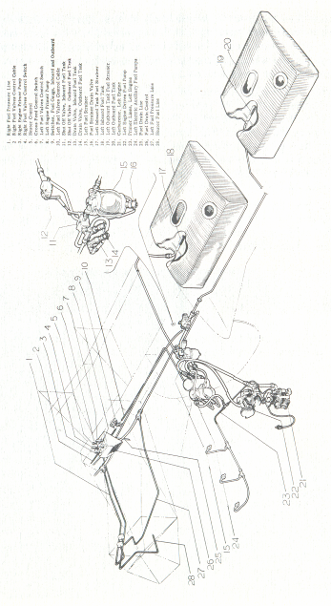
FUEL SYSTEM – Left side and Crossfeed system
Fuel can thus be used from one tank or the other, by shutting off one main valve and turning on the crossfeed, to balance fuel loads or for other purposes. For all normal operation, it is recommended that fuel be pumped directly from the tanks to their respective engines, with the crossfeed off.
The fuel valve controls and crossfeed control are located with the engine primer pumps in fuel control panel between the front seats. Two electric fuel gauges in the engine gauge cluster on the instrument panel indicate the fuel quantity in each tank. (Caution) The electric fuel gauges indicate the fuel quantity in the tank selected by means of the fuel selector handle located in the fuel control box. The electric fuel pump switches are on the lower left side of the instrument panel.
A crossfeed line drain valve control is mounted on the front face of the fuel control panel box. This valve should be opened occasionally, with the crossfeed on, the left electric fuel pump on, and then the right electric fuel pump on to allow any water that

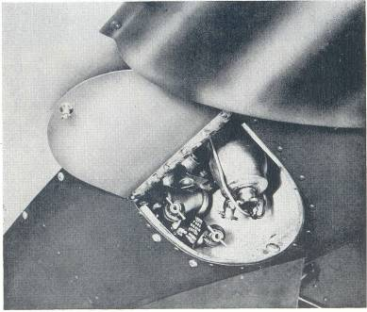

might accumulate at that point to be drained out. The heater fuel control is also placed on the fuel control panel, so that fuel to the heater can be turned off if necessary.
The fuel strainers and fuel line drain valves are located in the inboard sides of the main wheel wells. They are fitted with quick drains and should be drained regularly through their small access ports. In order to check the fuel system for possible moisture content, the inboard fuel cell line quick drain valve should be opened and drained; the outboard fuel cell line quick drain valve should be opened and drained and the quick drain valve on the fuel strainer should be opened and drained. This procedure should be repeated at the three quick drain valves located in the other main wheel well. Fuel screens are provided at the tank outlets, in the throttle bodys and in the fuel pumps.
Idle cut-offs are incorporated in the throttle bodys and should always be used to stop the engines. This is accomplished by pulling the mixture control levels to the rearmost position.

VIII. Electrical System

The master switch for the electrical system is located on the lower left side of the control pedestal, along with the heating and ventilating control panel. Other electrical switches and circuit breakers are grouped on the lower left side of the instrument panel.
The starter switch is located immediately above the parking brake handle on the extreme left side of the instrument panel. This switch is spring loaded and locks in the center "Off" position. To operate, pull out on the switch and hold to left or right as desired. After starting, release the switch and it will return to the off and locked position.
Automatic circuit breakers are provided for all electrical circuits. These units automatically break the electrical circuit if an overload is applied to the system, preventing damage to the wires. To reset the circuit breakers, simply push in the buttons. Continual popping out of a circuit button indicates trouble in the electrical system and should be investigated. The circuit breakers can be manually tripped by pulling on knobs to isolate or determine the source of electrical trouble.
A 12 - volt 33 - ampere hour battery, enclosed in a carbon fiber. battery box, is mounted in the nose section on the right side. (See Section IV, Sub Section III for maintenance.) Two 12 volt 50 ampere generators are installed as standard equipment.
The position and panel lights are operated by a rheostat switch located with the other electrical switches. The position lights are turned on with the first movement of the knob; panel light intensity is increased by further rotation of the control. Also, as optional equipment, individual instrument lights mounted on the instrument cover panel are turned on by the same rheostat, but panel light intensity is controlled by a separate rheostat. A dome light switch is incorporated in the light unit in the center of the cabin ceiling.
Generator switches are mounted on the lower right side of the pedestal. A voltage regulator for each generator is attached to the adjacent firewall. A paralleling relay equally divides the total electrical load between generators. When one engine is stopped a reverse current relay automatically disconnects that generator from the circuit.
As optional equipment an external power receptacle is available.
WARNING - When utilizing external power source, airplane master switch must be in the "OFF" position.

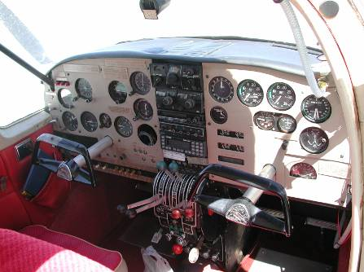

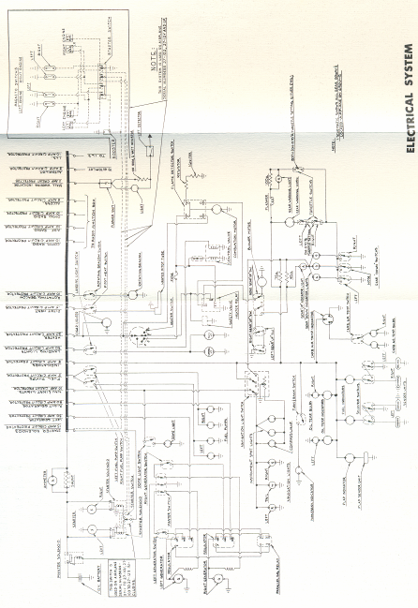
NOTES

ELECTRICAL LOAD ANALYSIS BITSER - 12 VOLT
A. MAXIMUM PROBABLE CONTINUOUS LOAD - (less radio equipment):

 |  | TOTAL CURRENT
ITEM | NUMBER USED | IN AMPERES
 | BVH BITSER
 |  | 12.0 Volts | 14.3 Volts
Flap Gauge | 1
Fuel Gauge | 2
Oil Temperature Gauge | 2
Carb. Temperature Gauge | 1 | .5 | .6
L. G. Indicating Lights | 1 | .08 | .1
Master Contactor | 1 | .6 | .7
Navigation Lights | 3
Instrument Lights | 2
Compass Lights | 1 | 4.6 | 5.5
Turn and Bank | I | .9 | 1.1
Heater (operating) | I | 5.7 | 6.8
Pitot (operating) | 1 | 10.9 | 13.0
Rotating Beacon (Grimes) | 1 | 5.0 | 5.9

B. INTERMITTENT LOADS
Dome
Light Landing Lights
Fuel Pumps
Landing Gear Horn
Starter Solenoids
Cigar Lighter

IX. Finish

All aluminum sheet components of the Bitser are carefully finished inside and outside to assure maximum service life. Both sides of all pieces are alodine treated, and/or sprayed with zinc chromate primer. External surfaces are coated with durable synthetic enamels in attractive high gloss colors. The application of primer to interior surfaces will prevent corrosion of structural and non-structural parts on the inside where there is no access for normal maintenance.
Steel tubular structures are also finished with zinc chromate primer and enamel.

X. Instrument Panel

The instrument panel of the Bitser has been designed to accommodate all of the customary advanced flight instruments on the left side in front of the pilot, and all required engine instruments on the right side. Provision for extra instruments has been made in both sections. The flight instrument group is shock mounted in an easily removed sub-panel. All instruments are accessible for maintenance by removing a portion of the fuselage cowl over the instruments.
The Artificial Horizon and Directional Gyro in the flight group are vacuum operated through use of vacuum pumps installed on both engines. A check valve is installed in the vacuum system so that in case of a pump failure the system will automatically continue to operate in the remaining vacuum source. The Turn and Bank is an electrically operated instrument and serves as a standby for the Gyros in case of vacuum system failure. A switch for the Turn and Bank is included in the switch grouping on the lower left of the panel. The vacuum gauge in the engine instrument group should indicate 3.75 to 4.50 inches of suction, required to operate the gyros.
Two recording Tachometers are provided to eliminate the need for constant reference to aircraft and engine log books. An engine instrument cluster, at the bottom of the engine group, includes two oil pressures, two oil temperatures, two fuel pressures, two fuel quantity gauges; The gauges in this cluster can be replaced individually by removing the column of four gauges in which the defective unit is incorporated, then detaching the proper gauge from this column.

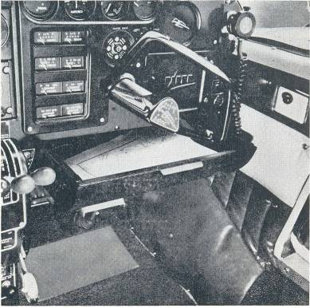

Radio units are installed in the center of the main panel. Radio power supplies are mounted in the forward part of the nose section near the battery.

XI. Seats

All seats in the Bitser are constructed of steel tubing, with no-sag springs and foam cushions. The front seats are adjustable fore and aft through a seven inch range by operation of a release control under the front of each seat. The right front seat is also adjustable aft beyond the normal range to provide ease of entry to the pilot's seat. Both front seats are easily removed by taking out the lower bolts in the stop plates at the rear of the seat structure, swinging the
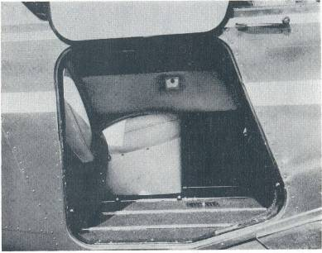

stop plates laterally and sliding the seats forward off their tracks.
The rear seat area is equipped with three individually adjustable and quickly removable seats. To remove these seats, stop plates on the track are taken off, and the seats moved fore or aft as required to disengage from their tracks.
The Bitser has four reclining seats provided with headrests and one non-reclining seat without a headrest.
Arm rests for all seats, coat hangers, ash trays, a cigarette lighter, a spacious map drawer and glove compartment are all standard on the Bitser. The cabin door and baggage doors are equipped with locks operated by the same key. A tow bar is provided with each airplane and, when not in use, is stowed in the baggage compartment.

XII. Radio Equipment

In the standard model of the Bitser, provisions for radio installations include dual microphone and headset jacks, a microphone and headset mounting bracket, a loud speaker, wiring to these units

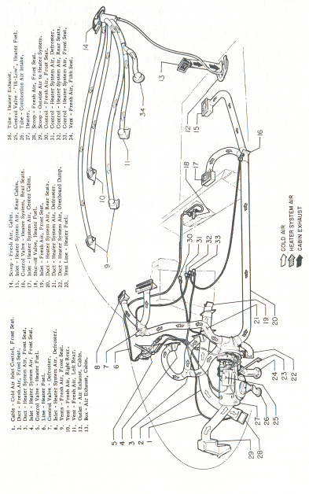
VENTILATING AND HEATING SYSTEM

and panel space for at least four radio sets. Radios, in different combinations, are available and are specifically chosen to provide in the Bitser all of the most recent radio developments normally desired in this type of aircraft.

XIII. Heating and Ventilating

The flow of air for cooling or heating the Bitser cabin may be controlled by the four knobs on the cabin air control panel, and by individual overhead outlets. Air is exhausted through an outlet on the rear trim panel of the cabin.
The left hand control regulates air flowing to the front seat through the heater system and the second knob from the left controls air flowing to the rear seat through this system.
The second knob from the right is the defroster control and the right hand control supplies additional cold air to the front seat through a vent on the firewall.

SECTION TWO
OPERATING INSTRUCTIONS | Page
I. Preflight | 24
II. Starting | 25
III. Warm-Up and Ground Check | 26
IV. Take-Offs Climbs and Stalls | 27
V. Cruising | 28
VI. Approach and Landing | 31
VII. Stopping the Engines | 32
VIII. Emergency Procedures | 32
IX. Ground Handling and Mooring | 37
X. Weight and Balance | 37
XI. Operation Tips | 38
XII Radio Operation | 39
XIII Fuel Injection | 45
XIV Low Power Low RPM Cruise | 46

OPERATING INSTRUCTIONS

I. Preflight

Be sure that you have been thoroughly checked out before operating this aircraft.
The following safety procedure instructions must become an integral part of the pilot's operational routine and/or preflight inspection.

Before each flight, visually inspect the airplane, and/or determine that:
- The tires are satisfactorily inflated and not excessively worn.
- The landing gear oleos and shock struts operate within limits. (3 in. of tube exposed)
- The propellers are free of detrimental nicks.
- The ground area under propeller is free of loose stones, cinders, etc.
- The cowling and inspection opening covers are secure.
- There is no external damage or operational interference to the control surfaces, wings or fuselage.
- The windshield is clean and free of defects.
- There is no snow, ice or frost on the wings or control surfaces.
- The tow-bar and control locks are detached and properly stowed.
- The fuel tanks are full or are at a safe level of proper fuel.
- The fuel tank caps are tight.
- The fuel system vents are open.
- The fuel strainers and fuel lines are free of water and sediment by draining once a day.
- The fuel tanks and throttle body is free of water and sediment by draining sumps once a week.
- There are no obvious fuel or oil leaks.
- The engine oil is at proper level.
- The brakes are working properly.
- The radio equipment is in order.
- The weather is satisfactory for the type of flying you expect to do
- All required papers are in order and in the airplane.
- Upon entering the plane, ascertain that all controls operate normally, that the landing gear and other controls are in proper positions and that the door is locked

II. Starting

Before starting the engine, the pilot should set the parking brake and turn on the master switch and the electric fuel pumps. Each set of pumps should be individually checked for operation. When the engine is cold, (under 5°C.) prime five to six strokes, making sure fuel valves are on, crossfeed off, fuel pressures normal and fuel quantity checked. Push mixture controls to full rich, alternate air off, and open throttles about one-quarter inch. If the engines are extremely cold, they should be pulled through by hand four to six times.
Next turn all ignition switches on and engage starter on left engine first. After engine starts, idle at 800 to 1400 RPM and start right engine. If battery is low, before starting right engine, run left engine over 1200 RPM to cut in the generator. This will produce extra power for starting the right engine. If the engine does not start in the first few revolutions, open the throttle on that engine while the engine is turning over with the ignition on. When the engine starts, reduce the throttle.
If the above procedure does not start the engine, re-prime and repeat the process. Continue to load cylinders by priming or unload by turning the engine over with the throttle open. If the engine still doesn't start, check for malfunctioning of ignition or fuel system.
Priming can be accomplished by pumping the throttle controls; however, excessive pumping may over-prime the engines, making starting difficult.
When the engines are warm, (over 40° F.) two to three strokes of the throttle as the engine is initially rotated by the starter is recommended. The engines should start after rotating through about four compression strokes.
Starter manufacturers recommend that cranking periods be limited to ten to twelve seconds with a five minute rest between cranking periods. Longer cranking periods will shorten the life of the starter.

III. Warm-Up and Ground Check

As soon as the engines start, the oil pressure should be checked. If no pressure is indicated within thirty seconds, stop the engine and determine the trouble. (If a very cold temperature exists (-12°C. or below) a little longer period of time may be necessary.)
Warm-up the engines at 1000 to 1400 RPM for not more than two minutes in warm weather, four minutes in cold weather. Avoid prolonged idling at low RPM as this practice may result in fouled spark plugs. If electrical power is needed from the generator, the engines can be warmed at 2000 RPM at which point the generator is putting out full charge. The magnetos should be checked at 2000 RPM with 15" HG. MP and the propeller in flat pitch, the drop not to exceed 125 RPM. The engines are warm enough for take-off when the throttles can be opened without engine faltering.
Alternate air should be checked during the warm-up to make sure the heat control operation is satisfactory. It should also be checked in flight occasionally when outside air temperatures are between -7°C and 21°C. In most cases when an engine loses manifold pressure without apparent cause, the use of alternate air will correct the condition

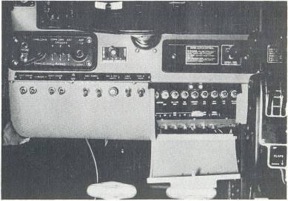

The propeller controls should be moved through their complete ranges during the warm-up to check for proper operation, then left in the full low pitch positions. Full feathering checks on the ground are not recommended, because of the excessive vibration caused in the power plant installations. However, feathering action can be checked by momentarily pulling the propeller controls into the feathering position and allowing the RPM to drop not lower than 1400 RPM, thence returning the controls to a normal operating position.
The electric fuel pumps should be turned off after starting or during warm-up to make sure that the engine driven pumps are operating. Prior to take-off the electric pumps should be turned on again to prevent loss of power during take-off due to fuel pump failure

IV. Take-Offs Climbs and Stalls

Just before take-off the following should be checked:
(1) Seat belts fastened (5) Crossfeed Off
(2) Seats locked in position (6) Primers Locked
(3) Controls Free (7) Electric Fuel Pumps OJ}.
(4) Fuel On (8) Flaps Up

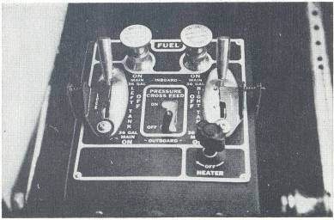
(9) Tabs Set (12) Propellers Set
(10) Alternate Air Off (13) Engine Gauges Normal
(11) Mixtures Rich (14) Door Locked
After the take-off has proceeded to the point where a landing can no longer be made wheels-down in event of power failure, the wheels should be retracted. When the wheels are up, the throttle should be brought back to climbing power, 24" MP, and the RPM reduced to 2400- Minimum single engine speed (70 kts) should be attained before take-off. The best rate of climb is obtained at 90 kts (??), but to give a high forward speed as well as a good rate of climb, a cruising climb speed of 114 kts is recommended. All controls are effective at speeds down through the stalling speed, and stalls are gentle and easily controlled.

STALL SPEED TABLE

Configuration | Power Off
Gear and Flaps Up | 63 K.I.A.S
Gear and Flaps Down | 54 K.I.A.S

These figures are at gross weight of 4800 Ibs. in kts.

V. Cruising

The cruising speed of the Bitser is determined by many factors including power setting, altitude, temperature, load, and equipment installed on the airplane.
The normal recommended economy cruising power setting of the Bitser is at 65% power. At 10,000 feet this gives a True Air Speed of 174 kts. This power setting is obtained under standard conditions at 2400 RPM and 19.9" MP. Fuel consumption is about 12 gallons per hour, or 24 gallons per hour total.
The optimum cruising speed of the Bitser at 7000' is 178 kts. (See Power and Performance charts for power settings and performance under various conditions.)
The Lycoming engines on the Bitser can be cruised at any percent of power from 75% down. 2400 RPM is recommended for maximum cruise performance and lower RPM's, down to 1800, for more economical cruising conditions. Ordinarily an RPM setting
should be selected which will give maximum smoothness. To avoid undesirable stresses on the propeller and the possibility of detonation in the engine, no Manifold Pressure settings over 25" should be used with an RPM of less than 2000.

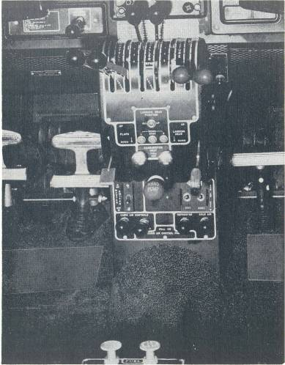
Use of the mixture control in cruising flight reduces fuel consumption at least 10% according to altitude. The fuel consumption data in this manual is for cruising with the mixture leaned.
There is no problem in overheating the engine cylinders on the Bitser by excessive leaning, provided leaning is done only at cruise

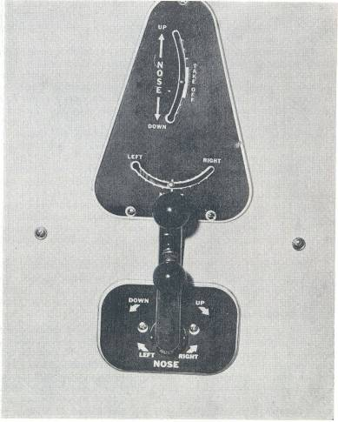

power (75% or less) or at higher powers above 5000'. For this reason no cylinder head temperature gauge is provided. The engines run very rich at the full rich mixture position, and leaning is essential to achieve satisfactory economy of operation.
To lean, pull back the mixture controls to the farthest aft point at which a rapid forward movement of the control does not produce a momentary surge in RPM, indicating that the mixture has been too lean for maximum power. To get optimum leaning, the control must be within Vs" forward of this point, which may be established by using a thumbnail as a temporary marker, or adding a pencil reference line on the quadrant placard.

VI. Approach and Landing

During the approach, the gear can be lowered at speeds under 130 kts, preferably on the downwind leg. Flaps should be lowered in final approach at an airspeed under 108 kts, and the airplane trimmed to a gliding speed of 83 kts. Normally about 12" MP should be maintained to give a reasonable approach angle. RPM should be left at high cruising RPM or approximately 2400. This propeller setting gives ample power for an emergency go-around and will prevent over-speeding of the engines if the throttle 31
is advanced sharply. The mixture control should be kept in full rich position to insure maximum acceleration if it should be necessary to open throttle again.
The amount of flap used during landings and the speed of the airplane at contact should be varied according to the wind, the landing surface, and other factors. It is always best to contact the ground at the minimum practicable speed consistent with landing conditions.
Normally, the best technique for short and slow landings is to use full flap and a small amount of power, holding the nose up as long as possible before and after ground contact. In high wind conditions, particularly in strong crosswinds, it may be desirable to approach the ground at higher than normal speeds, with half or no flaps.
Landing Check List:

(1) Mixtures rich.
(2) Propellers at high cruising RPM.
(3) Electric fuel pumps on.
(4) Fuel on proper tanks.
(5) Landing gear down (under 130 kts), check green indicator lights on, landing gear warning horn off, and flashing red light in gear handle off.
(6) Flaps full down or as desired (under 108 kts).
If, for any reason, it becomes necessary to "go around" apply full power, put the flaps up and retract the landing gear as quickly as possible.

VII. Stopping the Engines

During the landing roll, the flaps should be raised, the heater turned off, and the electric fuel pumps off. After parking, the radios should be turned off, and the engines stopped by pulling the mixture controls aft to idle cut-off. The throttle should be left full aft to avoid engine vibration while stopping. Then the ignition and master switches must be turned off, and the parking brakes set.

VIII. Emergency Procedures

1. ENGINE FAILURE
An engine failure on the Bitser during cruising flight presents very minor operational problems. As the engine loses power, a
slight yaw in the direction of the dead engine will occur, which can be corrected easily with the rudder or the rudder trim tab. While the plane is slowing down to the single engine cruising speed of about 117 kts at low altitudes and at moderate power settings, the propeller on the dead engine should be feathered by pulling the throttle to idling position, and the prop pitch control back fully; then the mixture should be set at idle cut-off, and the ignition off. Best single engine performance will be obtained with the dead engine wing held up about 3 degrees higher than level to help counteract the tendency to turn in that direction.

(Caution) If the left engine has failed, the hydraulic pump will not be functioning. If it is necessary to lower the landing gear or flaps with the left engine dead, the hydraulic hand pump located in the pedestal is used. (See 5, this section.)

2. FEATHERING
The Hartzell feathering propellers can only be feathered while the failed engine is rotating, and not if the engine stops completely, because the centrifugal force due to rotation is necessary to hold out a stop-pin which keeps the propeller from feathering each time the engine is stopped on the ground. Therefore, if an engine freezes up, it will not be possible to feather its propeller. In that case, single engine flight can be maintained with the dead engine propeller unfeathered, although a noticeable decrease in single engine performance will take place.
If an engine failure occurs during take-off run, the power on the good engine should be cut and the airplane stopped straight ahead. If it occurs after leaving the ground, but with sufficient landing area still ahead, a landing should be effected immediately. If no landing can be made directly after the failure, the following steps should be followed:
(1) Apply full power to good engine.
(2) Feather dead engine.
(3) Retract landing gear and flaps, if extended (using hand pump if left engine is out). If enough altitude has been reached before the failure occurred, or if performance is satisfactory for reaching the airport with the gear extended, leave the landing gear in the down position.
(4) Maintain a best climb airspeed of 96 kts.
(5) Trim directionally with rudder trim.
(6) As the airport is re-approached for landing, reduce power on the good engine and gradually re-trim with the rudder tab. When it is obvious that the airport can be reached easily, lower the landing gear and check the indicators to make sure it is down and locked. Maintain a little extra altitude and speed during the approach, keeping in mind that the landing should be made right the first time, and that either undershooting or overshooting may require the use of full power on the good engine, making control more difficult. Lower the flaps at the last moment if desired

3. UNFEATHERING
It is not recommended that propeller feathering and un-feathering be practiced on the ground because of the excessive vibration that occurs in the engine installation. In flight, feathering should be practiced only to familiarize the pilot with the proper procedures. To un-feather a propeller in flight, the following technique is recommended:

(1) Ignition switches on.
(2) Mixture rich.
(3) Pump throttle several times, then close.
(4) Prop control at cruise setting.
(5) Engage starter until engine starts and reaches 500 RPM.
(6) Allow engine to idle at 1000 to 1500 RPM with alternate air "ON" until oil temperature begins to rise. Adjust to cruising power when engine is warm.

The Standard Bitser, operating at gross weight under optimum conditions of turbulence and pilot technique, and under standard conditions of temperature and altitude, has a single engine absolute ceiling of 8800 feet at 4800 lbs. gross weight and maximum obtainable power.
Under ideal conditions, the Bitser can be expected to maintain approximately the stated maximum altitudes. When adverse conditions of turbulence, temperature, altitude, pilot technique, or aircraft condition or equipment are encountered, the absolute ceiling altitude will be reduced. These facets must be taken into consideration in the single engine operation of any twin engine aircraft.
Pilots of this airplane should remain reasonably proficient in single engine flight. In many cases, "simulated" single engine operation (zero thrust condition, approximately 10" MP and 2200
RPM) will be preferable, but actual single engine operation should be practiced occasionally. The following precautions should be exercised in actual single engine flight:

(1) Do not feather a propeller if you have reason to suspect that the starting characteristics of the engine are not normal and that restarting in the air may be difficult or impossible.
(2) Do not feather a propeller in conditions of temperature, altitude, weight or turbulence which may prevent single engine flight at altitudes well above the local ground elevation.
(3) Do not feather a propeller at any time when conditions of terrain or other conditions may prevent the aircraft from reaching an airport easily, in case the dead engine cannot be restarted.
(4) Single engine operation must be practiced only with a well qualified twin engine rated pilot, familiar with Bitser characteristics and procedures, in one of the pilots' seats.

4. EMERGENCY LANDINGS

The Bitser is designed to take gear-up emergency landings without extensive damage to the structure of the airplane. All three wheels protrude about one-third of their diameter when retracted, and structure is provided to. take minor loads in this condition. On a wheels-up landing, since the main wheels are forward of their down position, the airplane will tend to settle down at the rear when the landing speed is decreasing, and full forward control wheel pressure should be used to hold the tail up as long as possible. The flaps should not be extended because they will contact the ground first, causing damage to the flap and the wing. The propellers should be feathered and stopped in a horizontal position. Fuel valves and electrical switches should be turned to off position.
A wheels-up landing should only be made during an emergency when the surface is too soft or too rough to permit a gear-down landing, or when an emergency water landing is necessary.

5. EMERGENCY LANDING GEAR EXTENSION

If the engine driven hydraulic pump fails, or the left engine driving the pump, extension of the landing gear or flaps is accomplished by supplying hydraulic pressure with the manual hydraulic pump. With the gear or flap control in the desired position, 30.40
strokes of the pump handle will raise or lower the landing gear, and 12 strokes will raise or extend the flaps.
In the event of hydraulic system failure caused by a line breaking or the selector valve malfunctioning, the landing gear can be lowered by using the Emergency Gear Extender. The control for the Extender is located beneath a small cover plate under the pilot's seat. When this control is pulled, CO2 flows from a cylinder under the floorboards through separate lines to shuttle valves adjacent to the gear extension cylinders. The gas pressure opens the shuttle valves, allowing CO2 to enter the gear cylinders, extending the gears.
(Warning) The landing gear control on the selector valve must be in the "down" position when the gear extender control is pulled, in order to allow the gear to be extended properly

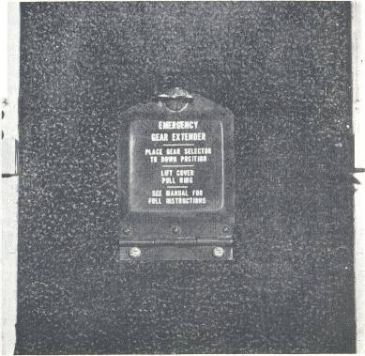

The Emergency Gear Extender should only be used when all other means of lowering the landing gear have failed, and only when the gear can be left down for landing. (Caution) When the Extender has been used, the landing gear or flaps must not be actuated hydraulically in any way until the extension system has been returned to its normal condition.

6. IN-FLIGHT CABIN DOOR CLOSING PROCEDURE
In the event the cabin door is inadvertently unlocked in flight or should the handle not be pushed forward to its full locked position before take-off and becomes dislodged from its latching mechanism, the following procedure has been determined to be practicable for closing the cabin door while in flight, assuming adequate altitude has been attained.
1. Retard throttle
2. Reduce airspeed to 78 kts or less
3. Open storm window (left of pilot) .
4. Close door
5. Recover power and airspeed
Other conditions, take-off, landing approach, and general low altitude flight, will require action at the discretion of the pilot

IX. Ground Handling and Mooring

The Bitser should be moved on the ground with the aid of the nose wheel steering bar provided with each plane and installed in the baggage compartment.
Tie down ropes for mooring the airplane can be fastened to the wing tie down rings and at the tail skid.
The aileron and stabilator controls should be secured by means of a safety belt or control locks to prevent control surface damage. The rudder is held in position by its connections with the steerable nose wheel, and does not need to be secured except under unusually high wind conditions.

X. Weight and Balance

For weight and balance data, see the Weight and Balance Form, which gives the exact weight of the airplane and permissible center of gravity conditions.

XI. Operation Tips

In the operation of the Bitser, as in that of any other type of aircraft, there are a few points of technique and information that apply particularly to this model. The following Operating Tips may be helpful in the operation of the Bitser:
(1) Learn to trim the airplane for take-off so that only a very light back pressure on the wheel is required to lift the ship off the ground.
(2) Due to the very rapid feathering action of the propeller on the Bitser, it will be necessary when feathering during ground check to move the propeller control in and out of feather position very quickly in order to prevent the RPM from dropping below 1400 RPM and causing excessive manifold pressure.
(3) On take.off, do not retract the gear prematurely. The aircraft may settle and make contact with the ground because of lack of flying speed, atmospheric conditions or rolling terrain.
(4) The best speed for take-off is at about 70 kts under normal conditions. Trying to pull the airplane off the ground at too Iowan airspeed decreases the controllability of the airplane in event of engine failure. (Minimum controllable single engine airspeed is 70 kts).
(5) In high density areas where high traffic pattern speeds are necessary or when it is advantageous to extend the gear, it is permissible to extend the landing gear at speeds up to 130 kts; however, it is recommended the landing gear should normally be extended at speeds below 130 kts.
(6) The flaps may be lowered at airspeeds up to 108 kts. To reduce flap operating loads, however, it is desirable to have the airplane at a slower speed before extending the flaps.
(7) Before attempting to reset any circuit breaker, allow a two to five minute cooling off period.
(8) Always ascertain position of landing gear by checking the gear position light.
(9) For convenience and to obtain best service life from the heater components, it is recommended that the heater switch be turned off about two minutes before stopping the engines and shutting off the master switch. This should normally be done during taxiing after landing.
(10) Remember that when the navigation lights are on the gear position lights are very dim.
(11) Before starting the engines ascertain that all radio switches, light switches, and the pitot heat switch are in the off position so as not to create an overloaded condition when the starter is engaged.
(12) The trim tab on the Bitser is very responsive and a small adjustment in trim control gives a rapid trim change attitude.
(13) The Lycoming Engines on the Bitser run very rich at the full rich position of the mixture control, and must be leaned under all cruise conditions to achieve satisfactory economy.

XII Radio Operation

Communication and Navigational equipment controls are locat. ed in the center of the instrument panel. Associated auxiliary switches are located on a separate panel below the altimeter instrument on the lower left side of the Instrument Panel. Circuit breakers are located on the same panel as the other circuit breakers.
All sets may be turned "on" by the switch located on the control head of each particular unit, with the exception of the A. D. F. and marker beacon which has its switch located on the Audio Selector Switch Panel.
After power is supplied, the pilot may wish to operate one of the two transmitters by moving the transmitter selector switch to the proper position. The switch is located on the selector switch panel.
A separate three position audio selector switch is provided for each receiver. Each receiver audio output may be connected to either the speaker or the headset. In addition they may be placed in the "off" or standby position.
A CS-3A omni bearing course indicator selector is incorporated in the Mark V, thus providing dual Omni when incorporated with the Mark VI.
Two or more sets may be simultaneously connected to either the headset or speaker position by placing the selector switches in
the desired combination. For example, the A. D. F. and the Mark V may be selected to operate on the speaker and the Mark VI may be selected for headset operation. If desired the pilot may listen to the speaker and the co-pilot the headset.

XIII Fuel Injection

The Bendix RSA-5 fuel injection system is based on the principle of measuring engine air consumption by use of a venturi tube and using airflow to control fuel flow to the engine. Fuel distribution to the cylinders is accomplished by a fuel flow divider.
Fuel pressure regulation by means of the servo valve causes a minimal drop in fuel pressure throughout the metering system. Metering pressure is maintained above vapor forming conditions while fuel inlet pressure is low enough to allow the use of a diaphragm pump. Vapor lock and associated problems of difficult starting are thus eliminated.
Incorporated in the servo regulator is the airflow sensing system which contains a throttle valve and venturi. The differential pressure between the entrance and the throat of the venturi is the measurement of air entering the engine. These pressures are applied across an air diaphragm in the regulator.
Mounted on top of the engine is the ported fuel flow divider with four nozzles routed to the cylinders. The divider contains a spring loaded positive shutoff valve. Within each cylinder are continuous flow air bleed nozzles with provisions to eliminate the adverse effects of low manifold pressure when idling. Since fuel metering is provided by the servo regulator rather than the nozzles, more uniform cylinder head temperatures result and a longer engine life is possible.
Induction air for the engine enters the opening in the nose cowl and is picked up by a large air duct at the right rear baffle. The air is directed to a filter and on to the servo regulator. An alternate air source for the induction system contains a spring loaded door at the throat of the servo regulator. This door operates automatically if the primary air source is obstructed or manually by the push-pull control left of the throttle quadrant. The primary system should always be used for takeoff.

XIV Low Power Low RPM Cruise

The high price of aviation fuel is causing aircraft owners and pilots to review their operations in search of ways to keep operating costs down. Those operating aircraft with controllable propellers have been requesting information on cruise operation in the low RPM range - 1800 or 1900 RPM for example. The number of queries received indicates great deal of interest, and therefore it seems appropriate to share the information on this subject with all of our readers.
The Textron Lycoming Engine Operator's Manual has performance curves applicable to each engine series. The curve for the IO-540-K series, 300 horsepower engine imprinted here as a reference for this article. The curve does provide data on the maximum manifold pressure (MP), which may be used with any particular RPM at sea level and at altitude. The limiting manifold pressure line clearly restricts high manifold pressures with low RPM settings. There is a good reason for this; high manifold pressure and low RPM is similar to allowing your automobile to lug uphill in fourth gear. The pinging you hear in your automobile tells you that detonation is occurring and you should shift down to a lower gear. In an aircraft, detonation is not likely to be heard as damage occurs in the engine and it is then too late for preventive measures. For this reason, engine operation should be within the limitations established in the Pilot's Operating Handbook (POH).

SECTION THREE
CHARTS | Page
I Performance Charts | 48
II Power Charts | 60

CHARTS

I Performance Charts

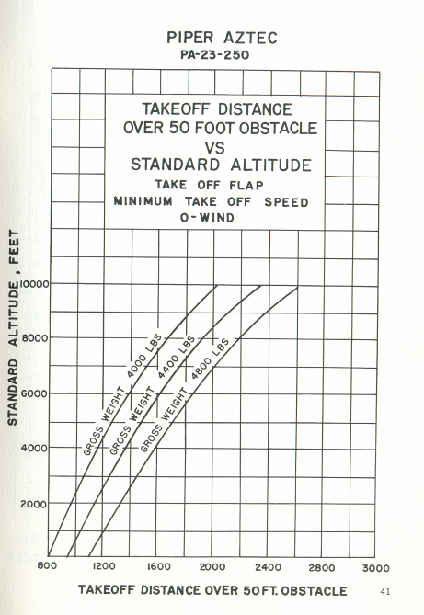
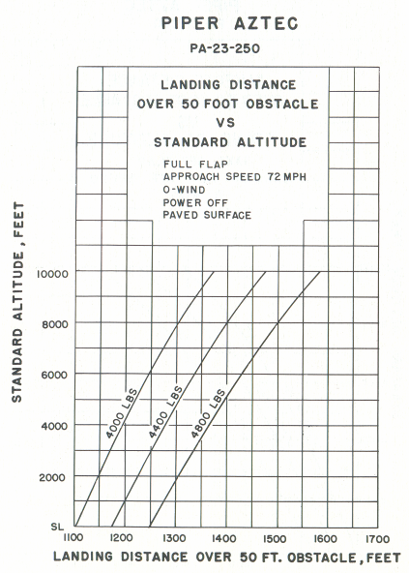
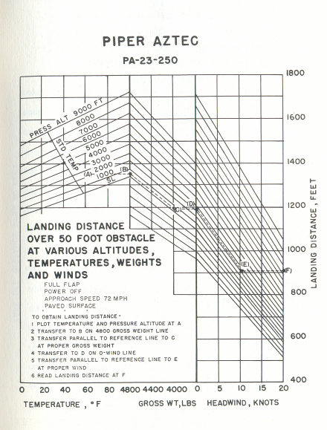
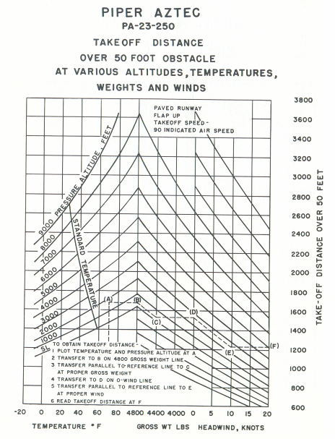
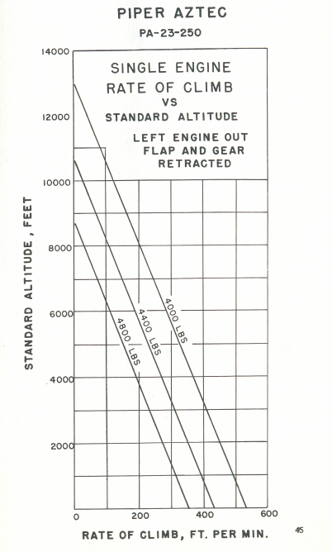
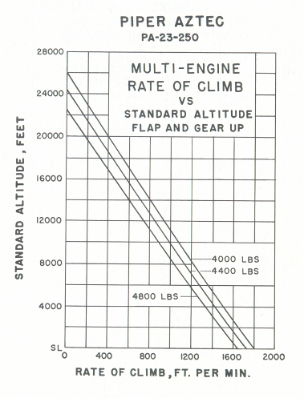
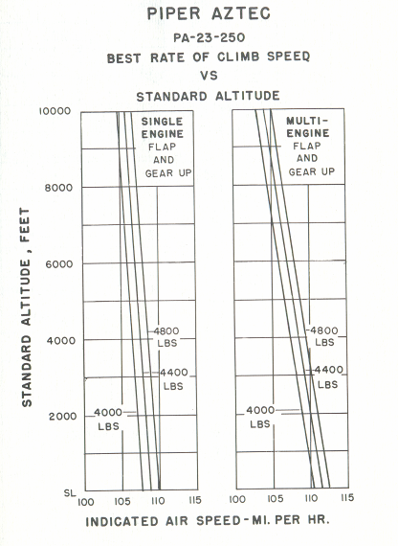
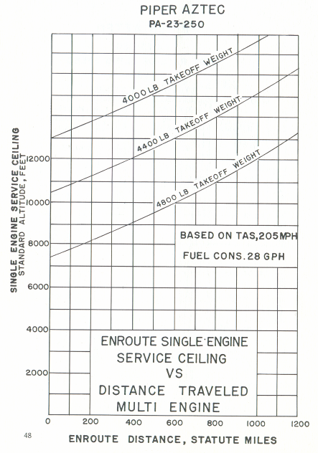
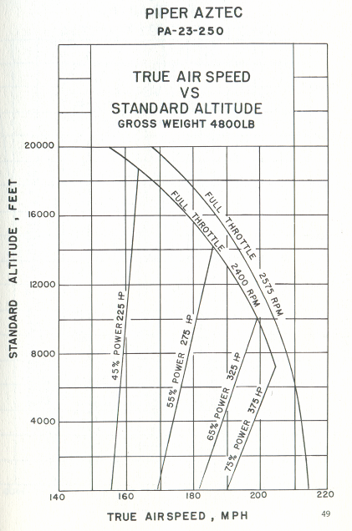
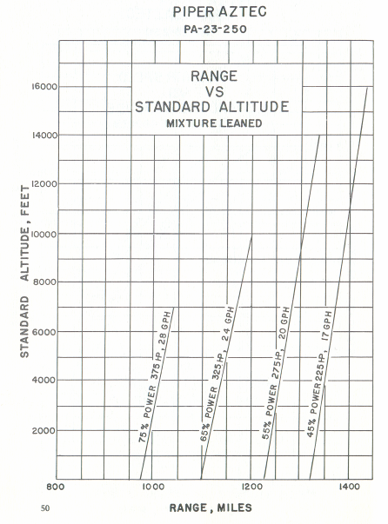
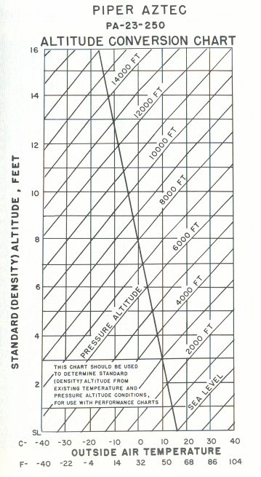

II Power Charts
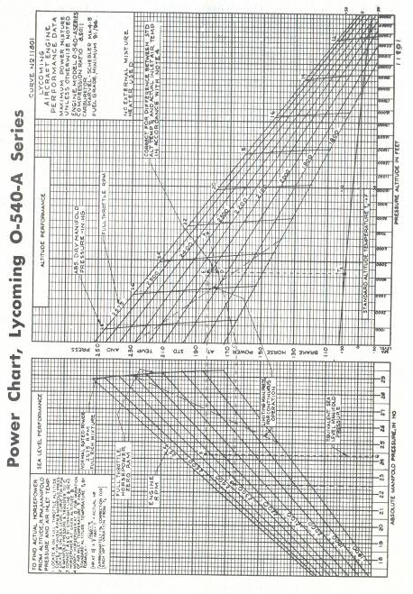
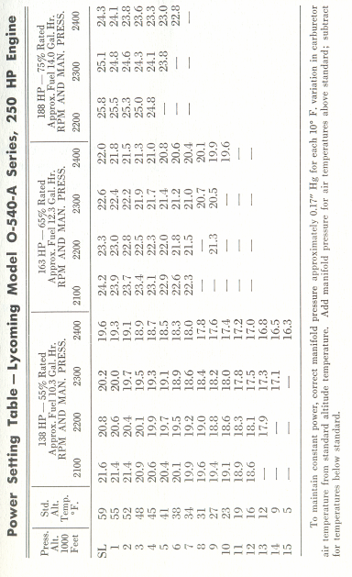

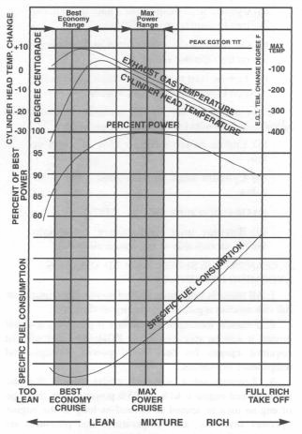

SECTION FOUR
GENERAL MAINTENANCE | Page
I. Leveling and Rigging | 65
II. Tire Inflation | 66
III. Battery Service | 66
IV. Brake Service | 66
V. Landing Gear Service | 68
V. Landing Gear Service | 72
VII. Fuel Requirements | 72
XVII. Care of Air Filter | 74
IX. Care of Windshield and Windows | 74
X. Serial Number Plate | 74

GENERAL MAINTENANCE

I. Leveling and Rigging

Leveling the Bitser for purposes of reweighing or rigging is accomplished as follows:
(1) Partially withdraw the two machine'screws located on the side of the fuselage just forward of the right stabilator. These screws are leveling points, and the airplane is longitudinally level when indicated by the leveling instrument placed on the screws.
(2) Put the airplane on jacks to obtain the longitudinally level position.
(3) To level the airplane laterally, place a bubble-protractor on a straight-edge held along the front spar on the under surface of the wing. Raise or lower the wing by pushing up or down on the tip until five degrees of dihedral is indicated on the protractor. The smooth, easy action of the landing gear oleo units makes it possible to position the wing laterally with very little effort. After checking the first wing at five degrees dihedral, the opposite wing should also be checked to make sure it has equal dihedral.
RIGGING INSTRUCTION:
Although the fixed flight surfaces on the Bitser obviously cannot be adjusted in position for rigging purposes, it may be necessary on occasion to check the positions of these surfaces. The movable control surfaces, with the exception of the flaps, all have adjustable stops, as well as adjustments on their cables or push-pull connections, so that their range of movement can be altered. The positions and travels of the various surfaces are as follows:
(1) Wings: 5 ° dihedral, washout 1 ° in 70" of distance along the front spar. (Total washout approximately 2°).
(2) Stabilator: No dihedral. Incidence is 0 ° in relation to horizontal. (Neutral position).
(3) Fin: Should be vertical and in line with centerline of fuselage.
(4) Ailerons: Travel-30° up, 15° down.
(5) Flaps: Travel-50° down.
(6) Stabilator-go up, go down.
(7) Rudder: Travel-30° left and 35° right.
For the purpose of adjusting the lateral trim on the Bitser, aileron tabs are incorporated on both ailerons. These tabs can be bent to position the aileron in flight, changing the lateral trim as desired.

II. Tire Inflation

For maximum service from the tires, keep the Bitser main wheels inflated to 42 lbs. and the nose wheel to 27 lbs. Reverse the tires on the wheels, if necessary, to produce even wear. All Bitser wheels and tires are balanced before original installation, and the relationship of tire, tube and wheel should be maintained upon reinstallation. Out-of-balance wheels can cause extreme vibration in the landing gear during take-off and landing. In the installation of new components, it may be necessary to rebalance the wheels with the tires mounted.

III. Battery Service

Access to the 12-volt, 33-ampere hour battery is obtained by removing a quickly detachable access plate on the right side of the nose section. The battery is installed in a sealed stainless steel box, opened by removing wing nuts. The box has a plastic drain tube which is normally closed off with a clamp and which should be opened occasionally to drain off any accumulation of liquid.
The battery should be checked frequently for proper fluid level, but must not be filled above the bailie plates. All connections must be clean and tight. The battery and box should be flushed with soda and water in the event of any seepage from the battery.
If the battery is not up to proper charge, recharge starting with a charging rate of 4 amps and finishing with 2 amps. Quick charges are not recommended.

IV. Brake Service

The brake system is filled with Mil-O.5606 (petroleum base red) hydraulic brake fluid. This should be checked at every 100 hours inspection and replenished when necessary.
Do not use vegetable base brake fluids (blue) when refilling the system. When it is necessary to add fluid, open the left nose access panel, exposing the brake reservoir. Then add fluid to the reservoir, bringing the fluid to the indicated level.
If it is necessary to bleed the brake system to get air out of the lines, fluid should be added under pressure at the bleeder attachment on the brake unit.
No adjustment of brake clearances is necessary on the Bitser brakes. If after extended service, braking action requires too much movement of the toe pedal, new brake linings can easily be installed by removing the four bolts which attach the brake units, then replacing the brake linings held in place by brass rivets.
Main wheels are quickly removed by first cutting the safety wire and removing eight bolts to drop the brake lining. Remove the dust cover, cotter pin and axle nut. The wheel will slip off the axle. The nose wheel is removed by taking off the hub nut and withdrawing the axle bolt, the axle retainer cups, and the axle from the nose wheel fork.
Tires are dismounted from the wheels by deflating the tube, then removing the wheel through bolts, allowing the wheel halves

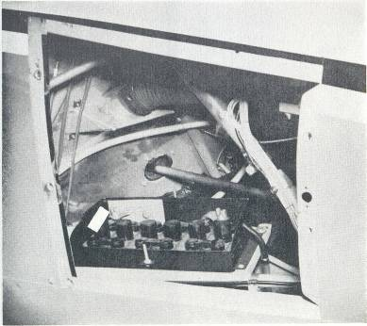

to be separated. In reassembling the wheels, care should be taken to torque the bolts properly, according to instruction on the wheels.

V. Landing Gear Service

In jacking the Bitser up for landing gear and other service, the Jack Kit (available through the BVH Distributor Service Department) should be used. This kit includes two hydraulic jacks and a tail support; the jacks are placed under the jack pads on the front wing spar, and the tail support attached to the tail skid.
Approximately 250 lbs. of ballast should be placed on the base of the tail support to hold the tail down. Then the jacks should be raised until all three wheels are clear of the floor.
The right and left landing gear units on the Bitser are completely interchangeable by reversing the nutcracker units on the gears. The oleo unit on the nose wheel gear contains parts that are also entirely

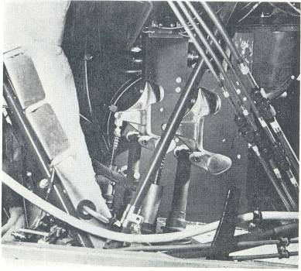
interchangeable with the oleo parts on the main gears, although the oleo housing forging and the fork and axle are different on the nose wheel unit. The nutcracker parts and all inside components are identical on both nose and main gears.,
The operation of the landing gear oleos is standard for the air-oil type; hydraulic fluid passing through an orifice serves as the major shock absorber while air compressed statically acts as a taxiing spring. The piston tube has a total travel of 8", and about 3" of tube should be exposed under normal static loads.
All of the oleos are inflated through readily accessible valves on the top of the unit, at the front. The nose wheel unit is steer able through the rudder pedals, and incorporates a shimmy dampening device at the bottom of the outer housing. All major attachment and actuation bearings are equipped with grease fittings for lubrication of the bearing surfaces, and should be lubricated periodically with medium lubricating grease.
To add air to the oleo struts, a strut pump is attached at the air valve and the oleo pumped up until 3" of piston tube is exposed with normal static weight on the gears. To add oil, first release all the air through the valves, allowing the oleo to compress fully. Next remove the air valve core and fill the unit through this opening, extending the strut by rocking the airplane while adding fluid. Compress the oleo again to within 14" of full compression, allowing excess oil to overflow and working out any trapped air. Then reinsert the valve core and pump up the strut.
If a landing gear oleo has been completely emptied of oil during servicing, the following procedure should be used to refill it, to make sure that no air remains trapped in the unit. First, a clear plastic tube should be attached to the valve stem, from which the core has been removed. The other end of the tube should be placed in a container of hydraulic fluid. When the oleo is extended, fluid will be sucked into the oleo cylinder. The oleo should be compressed and extended until it is full of fluid and no more air bubbles appear in the plastic tube. About one pint of fluid is required to fill the oleo.
To check shimmy of the nose wheel, if it should develop, tighten the bolt on the dampening device at the base of the nose wheel forging. The bolt should be tightened just enough to keep the nose wheel from moving freely, but not enough to require excessive pressure to move the wheel by hand. It may be necessary to remove shims from the shimmy dampening collar to permit tightening of the device.
The steering arms from the rudder pedals to the nose wheel steering torque §.haft arm are adjusted at the rudder pedals or at the torque shaft rollers by turning in or out the threaded rod end bearings. Adjustment is normally accomplished at the forward end of the rods, and should be done in such a way that the nose wheel is in line with the fore and aft axis of the plane when the rudder pedals and rudder are centered. Alignment of the nose wheel can be checked by pushing the airplane back and forth with the rudder centered to determine that the plane follows a perfectly straight line. The turning arc of the nose wheel is 15 degrees in either direction and is factory adjusted at stops on the bottom of the forging. The turning radius is twenty-eight feet.
In adjusting the steering arm stops, care should be taken to see that the nose wheel reaches its full travel just after the rudder hits its stops. This guarantees that the rudder will be allowed to move through its full travel.
Adjustable rod end bearings are present on each of the hydraulic cylinders that actuate the landing gear legs. These rod ends should be set so that the cylinders move the landing gear retracting links just far enough to engage the spring loaded down locks and make contact at the stops. Too much extension of the adjusting screws will overload the links, and too little extension will prevent the links from going to the required past-center position.
At each of the landing gear legs, micro-switches are installed so as to close after full movement of the gear in either direction. The down switches are connected individually with green indicator lights on the pedestal, and the up switches are in series so that all three contacts must be made before the amber "gear up" light on the pedestal lights up. The micro-switches must be adjusted carefully so that contact is made just as the gear reaches the required position of extension or retraction.
Other micro-switches on the landing gear warning system are installed inside the control pedestal at the throttles. The warning horn is also located here, and the landing gear knob flasher unit is attached to the left side of the pedestal forward of the instrument panel.
The main landing gear legs are dismounted from the airplane by
(1) removing the top engine nacelles, (2) detaching the lower end of the lever retracting link from the gear leg, (3) detaching the brake line at the lower end of the flexible line, and (4) withdrawing the half-inch landing gear attachment bolts.
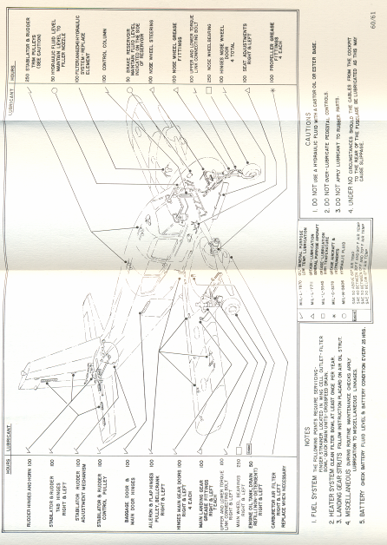
The nose gear unit is dismounted by (1) removing the nose access panels and the canvas boot covering the top of the nose gear, (2) detaching the lower retracting link, and (3) extracting the landing gear bolts.
Disassembling of the landing gear oleos is done as follows:
(1) Release air from air valve at top of unit and remove core.
(2) Detach lower end of oleo torque link assembly (nut cracker) from fork.
(3) Remove snap ring, located inside and at bottom of forging, with small-nosed pliers.
(4) Slide piston tube and bearing assemblies out of forging.Oleo fluid will flow from the forging and much of it can be caught in a container and if clean reused.
(5) Remove the upper bearing retainer pins and slide both upper and lower bearings from the strut. The “O” rings and wiper strips are then exposed for inspection.
To reassemble the oleo unit, reverse the above procedure, being very careful to see that the snap ring and the upper bearing retainer pins are properly reinstalled.
In the event that the oleo strut slowly loses pressure and extension, the most probable source of trouble is the air valve attachment to the leg, or the core of the air valve. These parts should be checked first to determine whether or not air leaks are occurring. If hydraulic fluid is evident on the exposed chrome-plated oleo strut, the "O" rings on the piston tube bearing units may need to be replaced.

VI. Hydraulic System Service

The hydraulic system is filled through a filler tube located inside the left nose access panel. Only petroleum base hydraulic fluid, Mil-0-5606, should be used.
To add fluid to the system, remove the cap from the filler neck and fill the system completely while holding the filler tube extension level. Then turn the elbow on the filler tube down until the excess oil has drained out. (See separate instructions for filling and cleaning the complete hydraulic system).

VII. Fuel Requirements

Aviation grade 91/96 (minimum) octane should be used in the Bitser. The use of lower grades of fuel can cause serious engine
damage in a very short period of time, and is considered of such importance that the engine warranty is invalidated by such use.
The oil capacity of the Lycoming 0.540 engine is 12 liters. It is recommended that engine oil be changed every 50 flying hours, sooner under unfavorable conditions. The minimum safe quantity of oil required is 3 liters. The following grades are required for the specified temperatures:

Temperatures above 15°C  Temperatures between 0°C and 30°C  Temperatures between -30°C and 20°C  Temperatures below 30°C | SAE 50  SAE 40  SAE 30  SAE 20

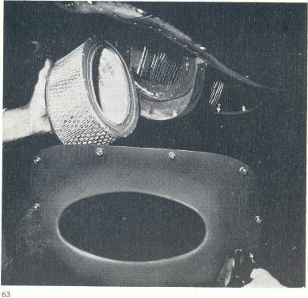

XVII. Care of Air Filter

The throttle body air filters must be cleaned at least once every fifty hours and depending on the type of condition existing, it may be necessary to clean the filters daily or every five hours. Extra filters are inexpensive and should be kept on hand and used for rapid replacement.
The following cleaning procedure is recommended by the manufacturer of the filter:
(1) Remove filter, inspect, and clean by tapping it against a hard surface to remove grit, sand and dirt. (Do not blow out with an air hose, soak in oil, or cleaning fluid).
(2) If the filter is found to be in good condition and is not obstructed after being properly cleaned, reinstall filter.

IX. Care of Windshield and Windows

The windshield and windows are made of Plexiglas and a certain amount of care is required to keep them clean and clear. The following procedure is suggested:
(1) Flush with clean water and dislodge excess dirt, mud, etc., with your hand.
(2) Wash with mild soap and warm water. Use a soft cloth or sponge. (Do not rub)
(3) Remove oil, grease or sealing compounds with a cloth soaked in kerosene.
NOTE: Do not use gasoline, alcohol, benzene, carbon tetrachloride, lacquer thinner or window cleaning sprays.
(4) After cleaning, apply a thin coat of hard polishing wax. Rub lightly with a soft dry cloth.
(5) A severe scratch or mar can be removed by using jewelers rouge to rub out scratch, smooth on both sides and apply wax.

X. Serial Number Plate

The serial number plate on the Bitser is located on the top of the tail stinger, underneath the rudder. The serial number of the plane should always be used in referring to the airplane in service or warranty matters.

CHECKLISTS

BEFORE STARTING ENGINES
- Baggage - SECURE
- Mass & balance - CHECK
- Performance - CHECK
- Documentation - CHECK
- Maps & charts - CHECK
- Cabin door - LOCKED
- Seat belts - SECURE
- Seats -LOCKED AND SECURE
- Park brake - ON
- Altimeter - SET
- Controls - FREE
- Fuel - ON
- Circuit breakers - CHECK
- Avionics - OFF
STARTING ENGINES - COLD
- Master - ON
- Magnetos - ON
- Cowl flaps - SET
- Throttle - FULL OPEN
- Pitch - FULL FINE
- Mixture - FULL RICH
- Fuel pump - ON until indication on fuel flow gauge
- Fuel pump - OFF
- Throttle - 1/2 inch open
- Propeller - CLEAR
- Starter - ENGAGE
- Oil pressure - CHECK

STARTING ENGINES - HOT
- Master - ON
- Magnetos - ON
- Cowl flaps - SET
- Throttle - 1/2 inch open
- Pitch - FULL FINE
- Mixture - IDLE CUT-OFF
- Fuel pump - ON
- Propeller - CLEAR
- Starter - ENGAGE
- Mixture ADVANCE
- Oil pressure - CHECK
STARTING ENGINES - FLOODED
- Master - ON
- Magnetos - ON
- Cowl flaps - SET
- Throttle - FULL OPEN
- Pitch - FULL FINE
- Mixture - IDLE CUT-OFF
- Fuel pump - OFF
- Propeller - CLEAR
- Starter - ENGAGE
- Throttle - RETARD and Mixture - ADVANCE
- Oil pressure - CHECK

TAXI
- Radio - SET
- Park brake - OFF
- Brakes - TEST
- Lights - AS REQUIRED
- Flight Instruments - CHECK

PRE TAKEOFF
- Park brake - ON
- Fuel - CHECK
- Hatches and Harnesses - SECURE
- Engine - RUN-UP
a) Mixture - RICHEN
b) Pitch - FULL FINE
c) Throttle - 2200 RPM
d) Magneto - CHECK - (drop 175 diff 50 RPM)
e) Pitch - EXERCISE
f) Instruments - GREEN
- Trim - SET
- Test - Controls
- Magnetos - BOTH
- Fuel pump - ON
- Flaps - RETRACTED
- Gear - CHECK
- Instruments - CHECK
- Attitude Indicator - SET
- Altimeter - SET
- Autopilot - OFF

Engine failure after takeoff briefing:
Undercarriage - RETRACTED
All engine controls - FORWARD
Airspeed - BLUE LINE
Aviate - FLY THE PLANE
Dead engine:
Identify - Dead leg = Dead engine
Verify - Retard throttle
Feather - Dead engine
TAKEOFF
- Transponder and Radar - ON
- Power - FULL POWER
- Rotate 69kts (Vr)
- Accelerate to 70kts (Vmc_{a})
- Positive ROC- Toe brakes
- Undercarriage - RETRACT
- Accelerate to 100kts (Vy)
- Power - CLIMB POWER
a) Throttle - 25'
b) Pitch - 2500 RPM
c) Mixture - 20 GPH
- Fuel pumps - OFF one at a time

AIRFIELD JOINING
- Fuel - SELECT
- Radio's - SET
- Engine - SET
- DI - Align
- Altimeter - SET
- Approach - REVIEW
- Security - Harnesses secure
- Speeds - REVIEW
CIRCUIT
- Brakes - ON and OFF
- Undercarriage - EXTEND below 130 kt,
Check 3 green
- Mixture - SET
- Pitch - SET
- Throttle - 18"
- Fuel pumps - ON
- Flaps - SET
a) 1/4 Flap 140 kt
b) 1/2 Flap 120 kt
c) Full Flap 100 kt

FINAL APPROACH
- Pitch - FULL FINE
- Undercarriage - CONFIRM DOWN AND LOCKED
- Flaps - FULL

POST LANDING
- Flaps - IDENTIFY LEVER and RETRACT
- Fuel pumps - OFF

PARKING
- Electrics - OFF
- Magneto's - CHECK DEAD CUT
- Mixture - IDLE CUTOFF
- Magneto's - OFF
- Master OFF
- Fuel - OFF

