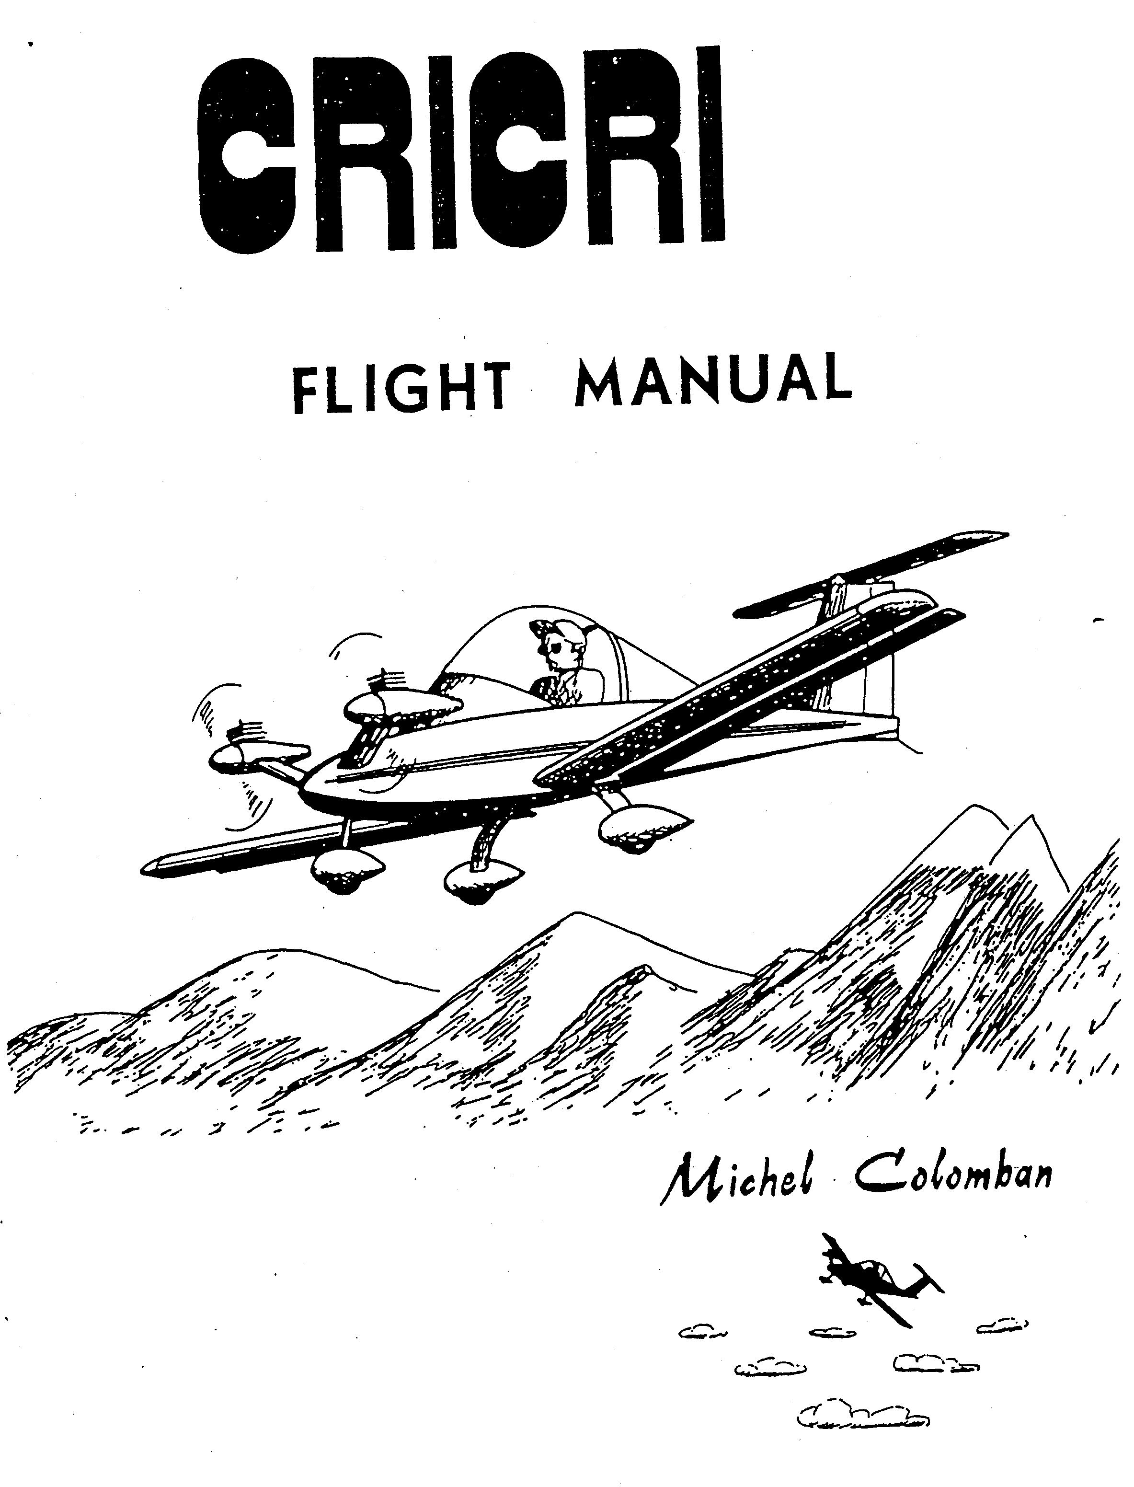

PUBLICATIONS DEPARTMENT
BVH Aerospace
Issued:
Revised: 2013-06-01

CRICRI MC 15

FLIGHT AND MAINTENANCE MANUAL

SUMMARY

1 General
2 Operating limitations
3 Use
6 Emergency procedures
5 Performance
6 Maintenance

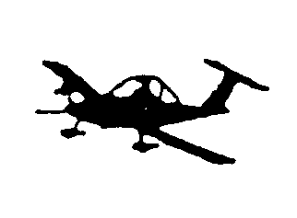

Copyright (c) Michel COLOMBAN 1983

Published: Jun 2013
1.1

1 GENERAL

1.1 Dimensions
- Wing span 4.90 m
- Length 3.90 m
- Wing area 3.10 m²
- Aspect ratio 7.8

1.2 Weight
- Empty equipped 93 kg
- Maximum at take—off 200 kg

1.3 Category
- Utilitarian, or aerobatic.

1.4 Engines
- Two Limbach L275E engines. 15 kW at 7200 rpm.

1.5 Propellers
- Two 2-blade composite.

1.6 Fuel Tank
- A 23 lit fuselage tank.

1.7 Fuel
- Either premium grade automobile gasoline or 100-130 airplane fuel with 2% (1:50) Castrol TTS or XTS synthetic two-stroke oil.

1.8 Landing gear
- Principal: Composite blade. Total stroke: 160 mm. Tire pressure: 1.8 bar
- Forward: Telescopic with elastic suspension. Total stroke: 130 mm. Wheel interlocked with the rudder bar: Tire pressure: 0.8 bar.

1.9 Controls and cabin equipment
- Elevator control system: Central stick. Artificial stress from rubber bands. Trim on the right side.
- Aileron control: Artificial stress from rubber bands. Trim on the rear surface of the stick.
- Rudder control: Adjustment in flight. Artificial stress from rubber bands.
- Flaps: Control on the left side. Three positions: cruising, take—off and landing.
- Engine contacts: left side.
- Drum brakes with cables on the main wheels. Central brake grip on the stick.
- Ventilation: 2 scoops at the bottom of the fuselage in front of frame 4.

1.10 Disassembly
- Quick assembly and disassembly of the wings using the two main pins, 4 secondary pins and 2 rod ends located on opposite sides of the cabin at wing level.

2.1

2 OPERATING LIMITATIONS

2.1 Design speeds

- Vne : Speed never to exceed : 140 kts.
- Va : Maximum maneuvering speed : 100 kts.

At this speed, the controls and in particular the ailerons, can be deflected to extreme positions, provided however you don't exceed the load factors set forth farther on. Beyond this speed, reduce progressively the deflection so that you don't exceed the angular acceleration produced at Va.

- Vf: Maximum speed flaps down
- take-off deflection (12°): 70 kts.
- Landing deflection (27°): 70 kts.
- Maximum cross wind: 10 kts.

2.2 Weight

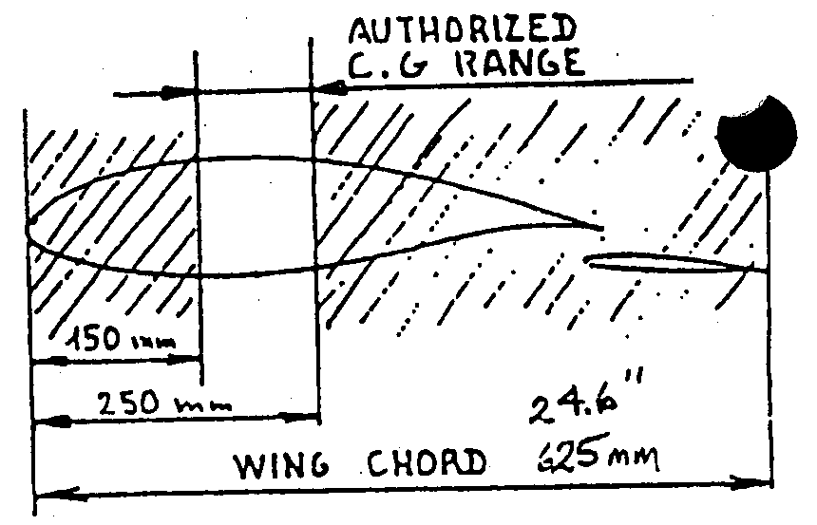
- Maximum weight at take-off: 200 kg (441 lbs)
- Maximum fuel for aerobatic use: 15 liters (4 US gallons)

2.3 Center of gravity limitations

- Forward limit: 24 % of the wing chord
or 150 mm behind the leading edge.
- Rear limit: 40 % of the wing chord, or
250 mm behind the leading edge.

2.4 Limit load factors in symmetrical maneuvers

Limit load factors are those beyond which certain elements of the structure begin to undergo permanent deformation. They should never be exceeded and should be approached only accidentally.

If you reach these factors, stop the plane and inspect the structure.
- Flaps up, positive + 5.0 G
- Flaps up, negative - 2.5 G
- Flaps down + 1.7 G

2.5 Maximum load factors in symmetrical maneuver use

For an "experimental plane", the load use factors have voluntarily been limited to half the breaking load.

They consequently represent the maximum values which can be reached in aerobatic use, provided, however, you don't exceed the fatigue life of the plane (see following chapter).

- Flaps up, positive + 3.8 G
- Flaps up, negative – 1.9 G

2.2

The flight envelope MC 15 symmetrical manoeuvres, corresponding to these two cases, are represented on Chart I.

On dissymmetrical manoeuvre use, the max load factors should be reduced to 2/3 of the above values.

2.6 Fatigue life

An ultimate load factor "7.6 G" means that the structure should break at a load factor of 7.6 G the first time it reaches this value. The same structure subjected many times to repeated loads, even if these loads never exceed the limit, can eventually break; alternating loads markedly reduce resistance to static fracture. This phenomenon is attributable to "structural fatigue"

An estimate of the fatigue life of MC 15s used in aerobatics his. led to the results below. This estimate has been made taking into account,. along with normal correction factors, a margin of safety of 207. with regard to the residual resistance of a "fatigued" structure. It is valid for a plane built according to tolerances and with Construction Manual but should be considerably reduced in the case of faulty work (marred metal misdirected scoring, nicked rivet hole, etc.)

Load factor at | Estimated Ultimate fatigue life cycles | Estimated  Useful fatigue life cycles
+4.2 -2.1 | 8,000 | 1,000
+3.4 -1.7 | 56,000 | 10,000
+2.5 -1.2 | 630,000 | 130,000
+1.7 -0.8 | 1,200,000 | 300,000

As you can see, a regular increase, even though modest, of the load factor causes a considerable reduction in the fatigue life. Generally speaking, each time the usage limit is increased 1 G the fatigue life is shortened about ten times.

When the wing spar is reinforced with the aid of "optional stiffener" 10106 the above fatigue life is multiplied by about ten.

Since the wing spar is the part which is subjected to the most fatigue in this plane, it would be prudent to change the flying surfaces (f1aps not included) at the end of the fatigue life.

2.7 Engines

- Speed never to be exceeded 7200 rpm.
- Maximum power use full engine throttle only for take—off, climb and aerobatics. (Because of engine life potential).
- Maximum continuous power at Z = 0: 80% of maximum power. This power is obtained :
Either by reducing the maximum speed by 300 rpm at a given airspeed.
Or, in level flight, by bringing back the throttles until the airspeed stabilizes 10% below the maximum airspeed obtained at full throttle in level flight
2.3

- Maximum continuous power at 6000ft.
Beyond an altitude of 2000m you can leave the engines at full throttle (power lower than 12hp)
- Maximum temperature: limit the temperature at the cylinder head (thermoculasse) to 250°C (5 minutes) 230 C (continuos).

2.8 Usable fields

The CRICRI wheels, being of small diameter, function best, obviously, on hard surfaces.

Nevertheless, thanks to the flexibility of the suspension, this plane seems to do well also on properly levelled fields of short grass.

It would be wise to avoid fields that are too bumpy or rocky.

2.9 Temperature limit

A metal assembly glued with epoxy is comparable to a "plastic" assembly. You should consequently reduce a bit the use limits under very warm conditions.

3.1

3 USE

3.1 Transport

Plane anchored and protected in its trailer.
Accelerometer locked.
Wing pin box, on board.

3.2 Assembly

- Plane on the ground, fit the wings in place, flaps in flight position.
- Put the two main pins in place and lock
- Put the four secondary pins in place and lock
- Attach the flap linkages and check the correct locking of the ball joint tips.
- Unlock the accelerometer.

3.3 Center of gravity

Check that the C.G. stays within the limits set out in the paragraph "operating limitation". For that use the table in Chart 3, starting with the center of gravity and weight of your plane equipped but empty.

3.4 Fuelling

Prepare in a jerrycan a mixture of gasoline (premium automobile or 100-130 airplane gasoline) to which you add 2% (50:1) prescribed (Castrol TTS or XTS synthetic or equivalent) two stroke oil. Shake well. Transfer to fuel tank. Screw in the cap all the way (seal). In aerobatics, fuel should be limited to l5 liters. (See Ch.2.2)

3.5 Pre-flight check

- Cockpit. Contact off. Fuel tank cap screwed in. Instruments set at zero. Seat attachments and harness checked.
- Fuel tank vent clean and open.
- Fuselage: general condition.
- Total and static pressure points clean and open.
- Horizontal tail: general condition, joints and rod connections.
- Vertical tail: general condition, rudder, joints and cable attachments
- Wing surface: general condition. Fittings and flap articulations. Seal of wing-fuselage junction.
- Main landing gear: condition of support fittings and of silent-block.
- Brakes. Tire condition and 1.8 bar pressure. Fairing attachment.
- Nose gear: normal flexibility of the suspension, condition of tire and 0.8 bar pressure. Fairing attachment. .
- Engines: check the flexibility of the suspension and its centering.
- Condition of arm fairing. Condition and attachment of engine fairing.
- Sparkplug wire in proper position and condition. Systematically glance at the tightening marks of all visible bolts (drop of paint visible). Identify source of any abnormal oil leakage.
- Carburettor. Clean. General condition. Bolts. No change in position of richness screw. Throttle cable attachment. Condition of fuel line.
3.2

- Propellers and Spinners: Clean. General condition. Bolts.
- Canopy: Clean. General condition. Hinges. Latches. Seal.

3.6 Pilot entry

Standing on the seat, support yourself on the edges of the fuselage around the main frame. Slide your legs in. Adjust the rudder bar. Attach the harness. Tighten the straps.

3.7 Starting the engines

Gasoline valves R and L open. Contact off. Brakes on. The engines are started by an assistant. Inject 5 cc of gasoline into the priming tube. Push in the decompression valve. Turn the propeller to draw up gasoline (about 10 half turns). Wind the cord around the starting cord pulley. Push the throttle control a little (about l/4 to 1/3 open). Contact on. Pull the cord. As soon as the engine starts, keep a speed of about 3500-4000 rpm beyond rough running for about 20-30 seconds in order to allow it to warm up a bit. After that it should idle smoothly.

Once the engine is warm, it is not necessary to draw up gasoline. If the engine is barely warm, prime and draw up gasoline very little. (2 cc gasoline and one or two turns only) Check the speed and smoothness of the idle (1600-1800 rpm). Check the full throttle speed (5500-5900 rpm). Do not go to the power check beyond a cylinder head temperature of 220-230°C. Check that a rapid increase in engine speed is possible without gap or hesitation.

3.8 Taxiing

Close and lock the canopy. Flaps in take—off position (12°). Adjust ventilation. Release brake. Taxi slowly and try the brakes. Turns are made only with pedals (steerable nose wheel). The difference in engine speeds is unimportant. It will have no effect.

Rapid taxiing is not a problem. The airplane is stable and visibility is perfect. But beware, it is sensitive. Avoid braking as much as possible. You will save the tires, the brakes and fuel.

Crosswinds (maximum 10 kts) don't pose any particular problems.

3.9 Take-off

Before taking off, check the instruments, then:

- Landing gear, altimeter.
- Controls free. Correct carburetion.
- Propellers.
- Gas flow open. Tank adequately filled. Cap screwed in.
- Harness attached. Once again, wing pins and ball joint tips and flap rods. Flaps at take-off position. Canopy locked.
- Exterior. No approaching airplane.
- Adjustment of take-off tab position according to C.G. position.

In order to take off: get lined up, full throttle. At about 50 kts (about 10 seconds) pull gently on the stick (Warning: artificial effort gives an impression of firmness. It is always such during low speed flights). On rough ground, taxi with the stick a bit back and take-off at about 40-45 kts.
3.3

In a crosswind (max 10 kts) or irregular winds (gusts) increase these speeds a bit.

3.10 Climb

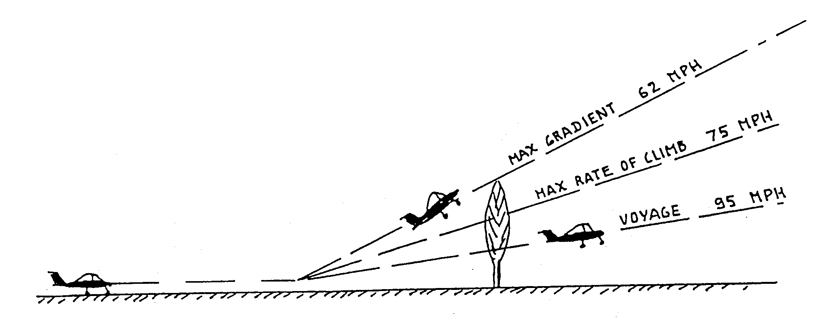
- Full throttle.
- Flaps brought back to cruising position (slowly because sensitive) beyond Z = 150 ft and before reaching Vi = 70 kts.
- Max gradient speed (obstacle): 54 kts.
- Max rate of climb speed: 65 kts.
- Climbing speed "voyage" (distance): 83 kts.
- Maximal temperatures of cylinder heads: 230°C – 250°C
- (250°C only 5 minutes, otherwise increase speed)
- Normal full throttle is approximately 5500 rpm.
- Trim adjusted accordingly, stick released,

3.11 Flight in calm atmosphere

- Maximal speed in level flight: Full throttle. Engine speed approximately 7200 rpm. Faired airplane Vi about 117 kts.
- Fast cruising: Bring the throttle levers back so that the speed is equal to 90% of the maximal level flight speed.
From an altitude of 6500 ft on, full throttle should be used all the time: engine power becoming less than 12 HP.
- "Long distance" cruising: Power needed to bring the indicated airspeed back to about 80 – 85 kts.
- Maximum flight time: Power for Vi = 70 kts.
- Full throttle diving speed: Never exceed speed: 140 kts
Limit power to 7200 rpm (max power).

Caution: Because of artificial stress on the controls, stick load becomes very light at over-speed. Do not forget this, particularly in case of aerobatic flight manoeuvres and begin very slowly.

3.12 Flight in gusty atmosphere

In extremely gusty weather the airplane can reach its max. load factor at a speed of 100 kts. It is therefore best never to exceed this speed in such a case. Also, be aware that a speed which is too slow (comfort) exposes one to stalls at gusts. In the above case, always use a 85 – 100 kts speed range.

In aerobatic flight gust load factors are added to manoeuvring ones. In order not to exceed the established load factors (Chart 1) the higher the gust load factors the more the manoeuvring loads should be decreased. Better still, put off aerobatic flight during very gusty weather.
3.4

3.13 Stall

Idling in horizontal flight (Variometer 0 ft/min).

- Cruising configuration Vs = 49 kts.
- Take off configuration Vs = 44 kts.
- Landing configuration Vs = 39 kts.

Stall warning signs are fairly subtle. Stall can be a little dissymmetrical. The nose down attitude noticed after stall is about 20 to 30°. Immediate recovery if the stick is eased forward. Slight loss of altitude.

Here again, the airplane is at low speed and the pulling effort to bring the airplane to stall, stick practically at the extreme back position, is relatively great (artificial effort). Same explanation for the feeling of heaviness during the following recovery.

3.14 Spin

It is very hard to get the CRICRI to spin. When one succeeds, the exit manoeuvre is simple: Bring the controls back to centerline or better still, slightly past it. All controls can also be let go. Spin exit in less than one turn.

3.15 Approach

- Let the airplane decelerate to Vi = 70 kts before bringing the flaps to take-off (l2°) or landing configuration (27°).
- Normal approach speed = 60 kts.
- Trim adjusted accordingly.
- If need be, be aware that the greatest lift to drag approach ratio is obtained with flaps in take-off position (12°) at Vi = 60 kts.
- Return to full throttle is possible whatever the flap deflection.

Caution: Slotted flaps covering the entire span are very efficient. Do not handle them roughly. Never raise the flaps near the ground whatever the speed may be.

3.16 Landing

- Approach speed Vi = 55 - 60 kts.
- Round off progressively without trying to stall. Be careful of the unusual low position of the seat. Do not round off too high.
- Touch down very slightly nose up at Vi = 46 to 49 kts.

If the landing is missed, return to full throttle before slowly raising the flaps.

In cross-winds, approach slightly banked or at a diagonal. Rectify just before impact. Afterwards, direct with the pedal. In this case, as well as in irregular winds, increase the above speeds a little. To keep running bring flaps back up (3°), Avoid hard and long braking when the fuel level is low: risk of un-priming sinking hose pipes.
3.5

3.17 Stopping the engines

Switch off the contacts

3.18 Moving the airplane on the ground

Push the airplane by the horizontal tail. If need be, push down on the tail to raise the front wheel for easier handling.

3.19 Mooring

On horizontal ground: face the wind, flaps up 3°. Brake. Fasten by the holes of the flap support arms.

If possible protect with a padded covering: On such low airplanes dropping cameras, handbags and other tools is not infrequent.

3.20 Storing

The best way to store the airplane, whatever the length of time, is to place it in its trailer sheltered from bad weather, dust, shocks etc; and preferably in a dry garage.

lf possible, clean and dry the airplane before closing the trailer.

In order to avoid condensation in the tank it is best to fill it up before storing.

3.21 Operating the MC 15 in aerobatic flight

Thanks to the way the engines are fed and lubricated they can operate
non-stop in any position.

- Fuel: 15 lit maximum.
- Power rating: Full throttle. But 7200 rpm maximum rating.
- Inverted flight: Do not go under an indicated airspeed of Vi = 78 kts.
- Slow, fast, hesitation rolls and rolling turns ; Same minimum Vi as above: 78 kts.
Do not practice sharp deflections to the extreme position over Vi = 100 kts. From this speed on, either limit the amplitude or the deflection speed so that the rate of roll does not exceed the maximal value obtained at 100 kts.
- Loops: Minimum entrance speed: Vi = 130 kts. Load factor: 4 "G".
- Half Cuban and reverse half Cuban: Vi = 130 kts. 4 "G".
- Stall turn: Not recommended because very difficult to perform.
- Snap roll: Forbidden ("T" tail)

Notice: Considering the slight stick load rating in overspeed it is indispensable to use an accelerometer for aerobatic flight in CRICRIS.

4.1

4 EMERGENCY PROCEDURES

4.1 Engine fire

- Close the gas.
- Go full throttle until the engine stops.
- Cut the contact.

4.2 Icing

Until now no icing tendency has been noticed on these types of engines.
However, if a power drop occurs in icy weather, the only answer would be to hit the throttle lever a few times at full throttle.

4.3 Engine failure

If an engine fails keep the cruising configuration if the indicated airspeed Vi is over 60 kts.

Upon approach and at landing remember that the flaps deflection accentuates the yaw caused by the engine dissymmetry. Therefore, with flaps in landing configuration restore power to an engine very progressively.

4.4 Restarting an engine in flight

- Open the decompression valve (if the engine is equipped with a control system).
- Push the throttle control a little (as for starting on the ground).
- Keep contact switch on.
- Increase speed until the engine starts.

4.5 Makeshift landing

If both engines are irremediably out of order:

- Close both fuel valves.
- Turn the contacts switch off.
- Tighten the harness straps.

Highest lift to drag ratio; flaps at l2° configuration and Vi = 60 kts.

Land in landing configuration, flaps down at 27°. If the runway is unsure refuse the ground until stall.

5.l

5 PERFORMANCE

The performances are given for an airplane which corresponds in all respects to the definition in the set of plans and at a total maximum power of 30 HP.

5.1 Stalling speeds "Vs"

Figuring on chart 2a they are in relation to weight and the three flaps deflections: cruising 3°, take-off l2°, landing 27°.

These are indicated speeds, therefore unrelated to altitude and temperature. They are obtained by allowing the airplane to decelerate with the variometer at 0 ft/min.

5.2 Take-off runs

Figuring on chart 2b they are in relation to weight and altitude. Given in standard atmosphere in zero wind and on a hard horizontal runway. For a grassy runway increase the distances by 25 to 30% The airplane is in take-off configuration flaps at l2°.

5.3 Take-off distances to 50 ft

Figuring on chart 2c, under the same conditions as above. The 50 ft. clearance speed is 1.3 times the stalling speed in take—off configuration.

5.4 Maximum rates of climb

Figuring on chart 2d they are in relation to altitude and airplane weight. The airplane in cruising configuration. Standard atmosphere. The indicated speed corresponding to the maximum rate of climb is approximately 65 kts.

5.5 Maximum speeds in linear horizontal flight

Figuring on chart 2e they are in relation to altitude and weight. Cruising configuration, engines full throttle.

5.6 Landing distances from 50 ft

Figuring on chart 2f they are in relation to altitude and airplane weight. The 50 ft. clearance speed is l.4 times the stalling speed in landing configuration. Average deceleration considered during landing run = 0.3 G.

6.l

6 MAINTENANCE

The aim of MC l5 maintenance is to keep it in good working condition for as long as possible.

This good condition may be altered in several ways:

- Through wear: (tires, pistons, diaphragms...etc.). In this case replace worn parts,
- Through fatigue: This is the case of elements subjected to high rates of vibration (linking bar, engine mount, resonator, propellers...etc.) or a large number of cycles under heavy stress (wing spar in aerobatic flight for example). These parts must be inspected frequently in the places receiving the most stress and in particular around holes, angles, section breaks, scratches, welding, assembly parts...etc. Cracks show up at an advanced state of fatigue. These fatigue cracks are not always visible to the naked eye. They can only be detected using a magnifying glass at the minimum, or better using fluorescent penetrant inspection or X-ray. lf a fatigue crack appears on a non critical part which is clearly visible (canopy, fairing...etc.) drill a _ small hole about 0.l inch at its far end to stop its development. Then keep watch. If, on the other hand, it appears on a vital part (linking bar, spar, bell crank...etc.) it is urgent and imperative to replace it.
- Through abrasion: This is the case of leading edges and in particular those of the propeller blades. In this case re-do the surface using fine abrasive paper and renew the protection if necessary.
- Through corrosion: This principally depends on the type of atmosphere the airplane is kept in. In case of corrosion traces strip the surface and protect it accordingly, Try to keep it in a more favourable atmosphere.
- Through aging: This is the case of elastomers in general, bonding...etc. (bungee cords hose pipes...). Arrange for their periodic replacement.
- Diverse accidents, shocks, scratches: Repair according to ans and allowances. For light scratches on the canopy use an appropriate polish and even very fine abrasive paper if the scratch is deep.
- Diverse deposits: Dirt, mud, carbonization, clogged filters air vent or airspeed indicating system obstruction. Check, clean, unclog.
Maintain outside surfaces like those of a car: wash with soapy water, rinse, dry, Avoid water penetrating into joints and diverse circuits.
In case of condensation or closing up of the airspeed indicating system, disconnect it on the instrument side and blow into the other end.

6.2

The following list gives an idea of the maintenance to be carried out.

Item | When Needed | 25H | 50H | 100H
6.l wings  - Flap support arm: checking of attachments.  - Assembly pins; fitting and lubrication.  - Spherical bearings: cleaning, lubrification.  - Rod ends: cleaning, lubrification. | x | x  x |  | x
6.2 Flaps  - Flap-to flap attachment: checking.  - Fixing of ball joint on root side.  - Fixing of lover hinge fittings. |  |  | x  x | x
6.3 Horizontal tail  - Hinge ball joint: fitting, play and lubrification. |  |  | x
6.1 Vertical tail  - Spar: condition at hinge fittings and on top of frame 13 (last rivet) |  |  | x
6.5 Rudder  - Joints and starting point of cables: checking |  |  | x
6.6 Canopy  - Hinges: checking, cleaning, lubrification.  - Latch: checking, cleaning, lubrification.  - Sealing: checking, cleaning, lubrification. |  | x  x | x  x
6.7 Main landing gear  - Tires: state and pressure 1.8 bar.  - Brakes: checking, cleaning.  - Brake cables: checking, tension, lubrification.  - Fiberglass leg: checking.  - Clamp: checking.  - Lower rod: checking, cleaning, lubrification.  - Nuts and bolts: checking. | x  x  x | x | x | x  x
6.8 Nose gear  - Tire: state and pressure 0.8 bar.  - Outer sliding tube: cleaning, lubrification,  - Inner sliding tube: cleaning, lubrification,  - Bearing block: checking for wear.  - Interlinking cables: tension, lubrification.  - Guide pulley: cleaning lubrification  - Nuts and bolts: checking. | x  x |  | x  x  x  x | x
6.9 Flying control  - Control linkage 1 joints, bell-cranks: cleaning.  - Checking condition of fittings, lubrification.  - Nuts and bolts: checking | X |  | x | x
6.3

Item | When Needed | 25H | 50H | 100H
6.10 Motor suspension  - Centering and attachments of motor suspension: checking.  - Linking bar; look for cracks where spindles 50119 pass through holes.  - Linkage piece 50016: condition and tightness. |  | x | x  x
6.11. Engines  - Chamber combustion and top of piston: decarbonizing. (1)  - Exhaust: overall state, gasket: decarbonizing. (1)  - Nuts and bolt: general checking (paint marks).  - Wiring and connections: checking -  - Spark plug: cleaning and electrode gap adjustment  (0.7mm). (1)  : systematic replacement  - Spark advance: (0.10" - 0.11") (1)  - Carburettor: overall cleaning.  : gas filter.  : idle: adjustment. | x  x  x | x | x  x  x | x
6.12 Fuel system  - Sinking hose pipes and filters: checking.  - Fuel lines: condition and attachment.  - Fuel tank: condition and attachment.  - Fuel tank air vent: checking. |  | x | x  x | x
6.13 Propellers  - Spinners: state (cracks) and attachment.  - Blades: overall state. | x | x
6.14 Airspeed indicating system  - System: cleanliness, condition and sealing. |  | x

6.15 Special conditions

Spark plug: respect the stipulated type: BOSCH WS 7 F (WK 175 T6). A poorly adapted spark plug may not only cause functioning troubles but may also give out without warning.

Every 25 hours check the cleanliness and the color of the electrodes and liners: black, greasy, sooty indicates a mixture that is too rich. Light coffee color, clean shows proper carburation. white indicates a mixture that is too lean. ·

After cleaning (wire brush) adjust electrode spacing between 0.7mm. Coat the thread with a little graphite lubricant and tighten without excess 24Nm. Replace ignition cable and be sure it is fully inserted.

(1) See § 6.15

6.4

To be sure of proper functioning it is best to replace the spark plugs every 50 to 80 hours even if they still seem to be accomplishing their task.

Breaker: Every 50 hours check state of breaker points. In case of slight deterioration face them with the help of a small, fine, flat file or with very fine (n° 600 - 800) abrasive paper, then, clean perfectly using a brush or a spray of compressed air. Check the spacing of the breaker points and eventually readjust them between 0.0l4" and 0.0l6".

Lubricate the cam felt and breaker pin: l or 2 drops of fluid graphite oil maximum.

Spark advance: At the same time, check chat the spark advance is still 0.l0" - 0.ll".

To do this insert a sheet of cigarette paper between the contacts. Place the crankshaft 30 to 40° before dead top center and turn slowly in the normal direction of rotation pulling lightly on the cigarette paper. when it begins to slip the piston should be 0.0l0" — 0.011" below dead top center.

Engine decarbonizing: between 25 and l00 hours according to the quality and % of oil. Wait until the cylinder head is completely cool before removing. Decarbonize the chamber
combustion and piston top.

Check the state of the cylinder gasket. A certain number of functioning disorders are caused by its non-impenetrability.

In case of disassembly lubricate the cylinder walls well. Tighten the four nuts regularly, l/4 turn by l/4 turn in the form of a cross until reaching a 23Nm torque. If the joint is new re-check the nuts after one hour of functioning.

Exhaust decarbonizing: id engine in relation to mixture. The section of little outlet holes is conditioned by noise and power, watch that it remains open as time goes on.

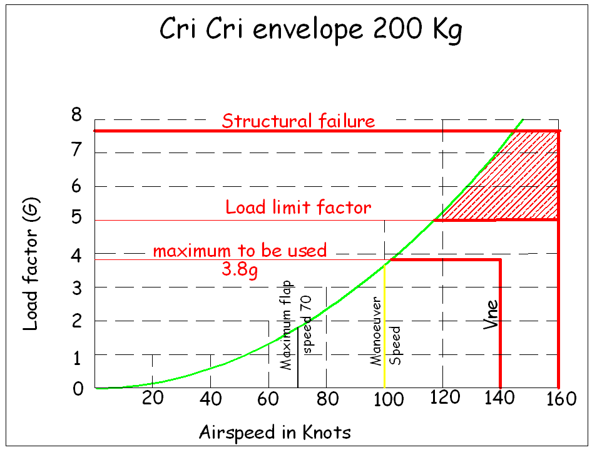

Cri Cri fuel consumption with 2 x Limbach L275E
 |  |  |  |  |  |  |  | Single Eng.
RPM | SFC (g/HPh) | HP | Liters/Hour for 2xEngines | Speed knots | Range -nm (23 lit) | Range 45 res. -nm  (23 lit) | Speed - knots | Range - nm (23L) | Range 45 res. - nm (23L)
4000 | 480 | 12 | 8.0 | 75 | 215.14 | 158.89
4500 | 510 | 14 | 10.2 | 80 | 180.25 | 120.25
5000 | 490 | 16 | 10.9 | 85 | 178.75 | 115
5500 | 470 | 17 | 11.4 | 90 | 182.05 | 114.55
6000 | 370 | 18 | 9.7 | 95 | 225.33 | 154.08 | 65 | 308.34 | 259.59
6500 | 362 | 20 | 10.3 | 100 | 222.84 | 147.84 | 70 | 311.97 | 259.47
7000 | 373 | 22 | 11.4 | 105 | 211.09 | 132.34 | 75 | 301.56 | 245.31



Operating Manual
L 275 E

Limbach Flugmotoren GmbH & Co. KG
KotthausenerStr. 5
53639 Königswinter
Germany
Tel.: 02244/9201-0
Fax: 02244/9201-30
Email: sales@limflug.de
www.limflug.de
Edition: 01.08.2005

TABLE OF CONTENTS

1. Introduction
2 The Engine
2.2.1 General Information on the Engine
2.2.1.1 Direction of rotation
2.2.2 Components
2.2.2.1 Crankcase
2.2.2.2 Crankshaft
2.2.2.3 Connecting rods
2.2.2.4 Piston
2.2.2.5 Cylinder
2.2.2.6 Induction system
2.2.2.7 Ignition system
2.2.3 Requirements
2.2.3.1 Fuel
2.2.3.2 Cooling air
2.2.3.3 Electrical power
2.2.3.4 Starting system
2.2.4 Pre-flight Preparation of the Engine
2.2.4.1 Fuelling
2.2.4.2 Starting
2.2.5 In-flight operation
2.2.5.1 Take-Off
2.2.5.2 Climbing, cruising and descent
2.2.6 Stopping the engine
3 Maintenance
3.3.1 General Information on maintenance
3.3.1.1 Spark-plugs
3.3.1.2 Ignition-Timing
3.3.1.3 Carburettors
3.3.1.4 Basic Adjustment:
3.3.1.5 Hints for Carburettor Adjustment:
3.3.1.6 Fuel-tank and filters
3.3.2 Storage
4 Technical Data
5 Trouble Shooting List
5.5.1 Engine
5.5.2 Ignition System
5.5.3 Carburettors
6 Graphs
6.6.1 Power Curves
6.6.1.3 Generator Current
6.6.2 Installation Drawings
6.6.2.3 Generator System
6.6.3 Wiring Diagram (Ignition)

1. Introduction

This manual contains information on the L 275 E engine.
Subject to change without notice!
User input is appreciated.

2. The Engine

2.1. General Information on the Engine

1. L 275 E

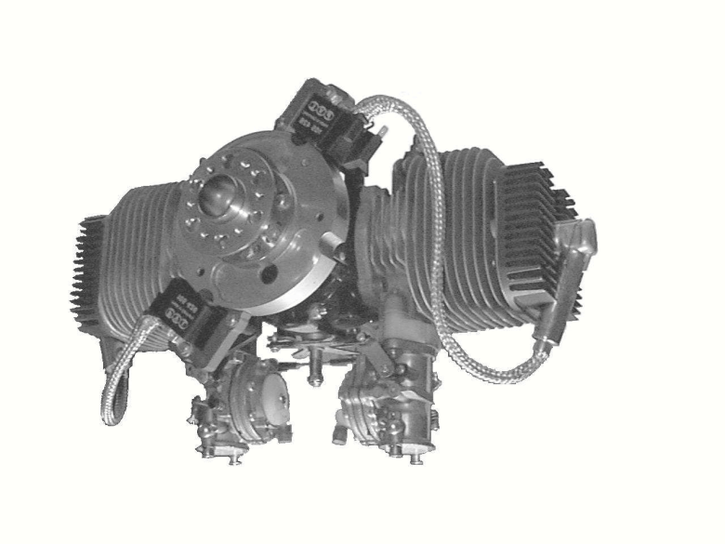
The L 275 E is an aircooled, two-cylinder, horizontally opposed, two-cycle aircraft engine, with direct drive. Power-take-off is possible on both the front and the rear end of the crankshaft. A variety of crankshafts is available for different auxiliary power take-offs, in or der to suit the specific needs of the OEM. If not otherwise specified, the L 275 E will come with our standard propeller hub (50mm bolt circle). The following accessories are part of the engine:

- Magneto ignition
- Induction system
- Carburettor linkages

2.1.1. Direction of rotation

If not otherwise specified the L 275 E will be delivered with clockwise rotation, if viewed from the propeller side.

2.2. Components

2.2.1. Crankcase

The crankcase is diecast out of a high strength aluminium alloy and heat treated for extra strength. It is vertically split for easy assembly and repairs.

Four 6mm threads on the top and bottom of the crankcase allow for attachment of accessories.

2.2.2. Crankshaft

The crankshaft is made out of one piece of drop-forged steel and then case hardened. It runs in 3 roller bearings, one of which serves as a thrust bearing for both pusher and tractor installations.

The propeller hub is connected by means of an interference fit and two parallel keys. Up to 10 times the nominal torque may be transmitted by this special connection.

2.2.3. Connecting rods

The connecting rods feature a split big end and go together with split needle bearings also.

2.2.4. Piston

Pistons are made out of cast aluminium and then cam ground to a spherical form within close tolerances. They have two compression rings out of a very elastic cast iron with a black phosphate coating to minimize sticking. The top ring is a half-keystone design to minimize carbon build-up. The floating wrist pin is secured with two circlips and runs in a needle bearing.

2.2.5. Cylinder

Aluminium-alloy cylinders with Nikasil coated liner surfaces ensure the best possible cylinder life.

2.2.6. Induction system

Two resp. four all position diaphragm-type carburettors with integrated fuel pumps allow for aerobatic flight manoeuvres. Both carburettors are connected with a linkage for synchronous operation.

2.2.7. Ignition system
A solid state magneto ignition system ensures good starting characteristics even at low temperatures. For special applications, all components may be radio suppressed.

2.3. Requirements

2.3.1. Fuel

The L 275 E needs 90 octane fuel, mixed with two-cycle oil to the ratio of 1 : 50 (2%). Do not use outboard-motor oil, since this is intended for use on engines with lower operating temperatures.

Use Castrol TTS or XTS synthetic two-stroke oil or equivalent.

Aviation fuel AVGAS 100 LL may be used for operation at high outside temperatures. The two-stroke oil may not be compatible with those fuels and lead to higher than usual carbonizing of the engine.

2.3.2. Cooling air

At full power a minimum of 400 lit/sec for L 275 E of air are needed for cooling. The figures do not contain any provisions for leakage. Depending on the design of the cooling system the amount of air flowed through the cooling system may be much higher. Please consider the worst case for the engine. (steep climb at low indicated airspeed). The better way to reduce temperatures is to use a pressure cowling, which will also reduce the drag of the aircraft.

2.3.3. Electrical power

The magneto ignition system does not require any power supply.

2.3.4. Starting system

An external starter with approx 1.4kW at 1000rpm is required.

2.4. Pre-flight Preparation of the Engine

2.4.1. Fuelling

Warning: Switch off the ignition!

If your engine has any protective covers which must be removed before flight (consult the manual of your equipment), take them off. Inspect the engine for loose or missing parts. Reinstall any covers which had to be taken off for pre-flight inspection.

The L 275 E engine uses an oil-gasoline mixture for fuel. The required mixture ratio is 1:50 (one part of oil to 50 parts of gasoline) with synthetic oil as detailed in para 2. Use brand-name regular gasoline and two-cycle engine oil only.

Do not use outboard engine oil!

Warning: Gasoline is an extremely flammable fuel. Use extreme caution when handling gasoline or fuel mix. Do not smoke or bring any fire or flame near the fuel also do not allow any other person to do so, while handling the gasoline.

Caution: Be sure to use an oil-gasoline mixture as fuel only. It is good practice to use only freshly mixed fuel. If stored for any length of time oil and gasoline might sperate again. Therefore the fuel tank of your equipment should be drained after each day of flight. Also be sure to use only such fuel, which you personally have mixed.

Use regular gasoline only, as higher grade fuels might contain chemicals which might permanently damage rubber or plastic components inside the engine, resulting in an unsafe operating condition!

Shake the fuel container thoroughly before refilling the fuel tank.

When refuelling, pour the fuel through a filter. Do not use metal fuel cans. They are subject to corrosion. Particles of rust, which enter the fuel system might block the fuel supply, resulting in an unsafe operating condition also the engine might be permanently damaged. Be sure to clean your fuel container every time you go for fresh gasoline for the same reasons. Buy your fuel from brand name companies and at highly frequented gasoline stations only. Fuel out of underground storage tanks might contain water, if the tanks are not filled very often. Water in the fuel system has the same effect as dirt.

2.4.2. Starting

Warning: Be sure, that no other persons are near the aircraft when starting the engine. Take special care that nobody is standing in the propeller blast area.

If your aircraft has brakes, be sure to put them on before starting.

1. Turn the fuel cock to the “OPEN” position.

Warning: The engine needs the oil contained in the gasoline-oil mixture for lubrication. If you fail to open the fuel cock permanent damage might occur to the engine resulting in a hazardous operating condition.

In some cases, the amount of fuel contained in the fuel lines themselves might be sufficient to operate the engine for a short time with the fuel cock closed. If not recognized this might permit just enough time to attempt take-off, resulting in an engine failure in the take-off run.

2. Engines with choke shutters:

The cold engine is started with closed choke shutter. To do so pull the choke shutter to the “CLOSED” position.
The warm engine or one, which has been stopped only for a short time is started with fully opened choke shutter. To do so set the choke shutter to the “OPEN” position.

Engines without choke shutters

The cold engine requires some priming prior to starting. A small amount of fuel may be sprayed into the engine with a small pump spray can, either into the carburettors or into the exhaust, whichever is more suitable.

Warning: Do not prime the engine with to much fuel. A hydraulic lock may occur, damaging the engine beyond repair!

3. Set the ignition switch to the “ON” position.

4. Open the throttle halfway.

5. To start press the starter button. After the engine has started, release the starter button. (Type and design of the starter will vary with the type of aircraft)

6. Engines with choke shutters:
Move the choke shutter to the “OPEN” position.

7. Move the throttle back and forth until the engine runs smoothly, then set the throttle to the idle position.

Additional information on starting

The choke shutter must be closed, when starting a cold engine only until the engine fires for the first time. Then open the choke shutter fully - move to the “OPEN” position, even if the engine stops again and you have to continue your starting attempts. If the choke shutter stays closed, the combustion chamber will be flooded.

If the engine should fail to start after you have opened the choke shutter and if the engine still does not start after several starting attempts, then the combustion chamber is already flooded. In this case the spark plug has to be removed and dried.

At low temperatures open the choke shutter only half after starting and warm up the engine by short throttling. Then open choke shutter fully.

A new engine or one which has not been used recently will require several starting attempts, until the diaphragm pumps in the carburettor has drawn enough fuel.

2.5. In-flight operation

2.5.1. Take-Off
For Take-off smoothly open the throttle to full power. If your equipment has any engine monitoring instruments observe them carefully. Refer to the owner’s manual of your equipment for operating limits.

Keep the full power setting for the initial climb and then reduce power adequately for sustained climbing to the desired flight altitude.

2.5.2. Climbing, cruising and descent

In flight the engine is set to the power setting required for climb, cruise or descent. Again carefully observe any engine monitoring instrument your equipment might carry.

Warning: Do not close the throttle when performing a steep dive with the propeller windmilling. The engine will not be sufficiently lubricated in this condition.
Do not over-speed the engine during descent

2.6. Stopping the engine

In normal operation the engine is stopped right after landing by setting the throttle to the “IDLE” position and the ignition switch to the “OFF” position. During the previous descent before touch down the engine is cooled down enough to allow doing so. After long or high-power taxiing you should let the engine cool down, by moving the throttle to the “IDLE” position and let the engine idle for a few minutes before switching off the ignition.

Warning: Do not leave your equipment with the engine still running. After stopping the motor secure your equipment against unauthorized use.

Refer to the owner’s manual for further information on this subject.

3. Maintenance

3.1. General Information on maintenance

The LIMBACH L 275 series engines need only a small amount of periodic maintenance. It is done every 25hrs.

Warning: Before attempting to touch any part of the engine or propeller, be sure to switch off the ignition. Then remove all spark-plug connectors. The engine might start during hand propping or turning and cause serious injury.

3.1.1. Spark-plugs

Disconnect spark-plug connector and unscrew the plugs. Check spark-plug for excessive carbon build-up and/or wear. Discard spark-plug if this is found to be true. Otherwise re-gap the plug (0.7mm or 0.5mm for magneto ignition systems). Check both the cylinder and the spark- plug for worn or damaged threads. Apply anti-seize compound to the threaded portion only, as these compounds often contain graphite which will short circuit the spark plugs. Screw in the spark plugs by hand only until they are firmly seated on the gasket. Check for binding spots while turning the plug. Then torque to 24Nm.

3.1.2. Ignition-Timing

The timing is set to 30 degrees BTDC. Due to the different installation situations no timing mark has been fixed to the engine. To check the timing a suitable pointer should be fastened to the engine in such way that it may be inspected with a strobe light.

Warning: When checking the ignition timing use extreme care not to be injured by the propeller. Any equipment temporarily attached to the engine must be securely fastened.

3.1.3. Carburettors

The carburettors two adjustments:

L = Low speed adjustment screw
H = High speed adjustment screw

Since fuel consumption and engine performance are affected by the engine installation and propeller choice correct carburettor adjustment needs the attention of the airframe designer.

3.1.4. Basic Adjustment:

The carburettors have been adjusted at the factory as follows:
1. L 275 E
L = Low speed adjustment screw

1/2 to 3/4 turn open

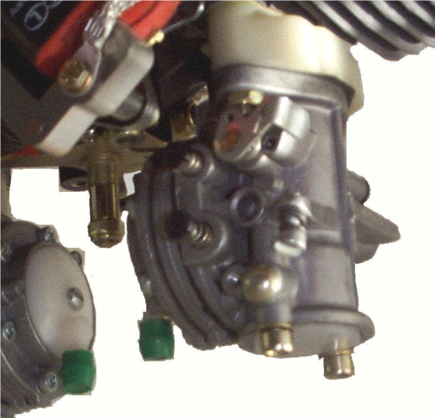
H = High speed adjustment screw

1 1/2 turn open

Take the basic adjustment as a guide when readjusting the carburettors.
L

H

Carefully screw in both adjusting screws on each carburettor until a snug fit. Do not force the screws into their seats!

Then turn both screws counter-clockwise into the desired position counting the number of turns. When making adjustments, do not turn the needles more than 1/8 turn per step.
Position of Adjustment Screws L 275

DANGER! DO NOT MAKE ANY ADJUSTMENTS TO THE CARBURETORS WITH THE ENGINE RUNNING!

3.1.5. Hints for Carburettor Adjustment:

Engine stops when idling: L275: Warm up engine, turn both idle speed adjusting screws (located on the throttle levers do not mistake with Low speed mixture adjusting screw “L”) clockwise until engine idles satisfactory. The minimum idle speed depends on the type of propeller and generator equipment used on the engine and may range between 1000 and 3500 rpm.

Engine idles to fast: Turn idle speed adjusting screws counter-clockwise.

Engine runs irregularly at idle: Adjust Low speed adjusting screws “L”. Clockwise = leaner mixture
Counter-clockwise = richer mixture

(The low speed adjustment will also affect the high speed adjustment. Check engine temperatures after leaning.)

Excessive fuel consumption: Adjust high speed adjusting screws “H”.
Clockwise = leaner mixture

Engine runs too hot: Adjust high speed adjusting screws “H”.
Counter-clockwise = richer mixture

Note: The engine reacts very sensitive to carburettor adjustments. In finding the correct adjustment we recommend not to adjust the carburettors more than 1/8 at a time. Allow the engine to operate for a while on the setting and judge the spark-plug colour (light brown) for correct adjustment. A temperature probe located in the exhaust (approx. 70-100mm downstream of the exhaust flange) will give valuable information on the mixture quality. Temperatures of 650°C in the exhaust gas at wide open throttle are indication of correct carburettor adjustment.

Caution: You will most likely find that the optimum adjustment for ground testing and flight operation are different as the aircraft aerodynamics and power requirements have a significant influence on the carburettor function. Most probably the carburettor setting required for satisfactory ground operation is much richer than needed in flight. Should minimum fuel consumption be of any concern we recommend the use of additional fans to improve the engine cooling during ground operations.

Incorrect adjustment of the carburettors may lead to power loss, higher operating temperatures and insufficient lubrication. Each of which can result in hazardous operating conditions.

The carburettors contain materials with limited life such as gaskets and diaphragms. If you have any problem starting the engine this indicates a possible failure of the abovementioned materials.

3.1.6. Fuel-tank and filters

The fuel-tank and filters should be cleaned frequently. Use only clean gasoline-oil mixture for these purposes.

Warning: Use of any other solvent or fluid than gasoline-oil mixture might cause permanent damage both to the fuel system and the engine, resulting in a dangerous operating condition.

3.2. Storage

The L 275 E engine contains numerous parts, which cannot be protected against corrosion for technical reasons. If the engine is stored for any length of time, you should take the following precautions against internal corrosion and unauthorized use:

1. Disconnect the spark plug leads.

2. Store the engine in a heated and dry place.

3. Keep the exhaust and air inlet plugged with a lint-free rag, which was soaked in oil before.

4. If storing for longer than 3 weeks, remove the air cleaner element and the spark-plugs. Spray a generous amount of clean corrosion protecting oil in both carburators and both spark-plug openings while slowly hand-cranking the engine. Reinstall the air cleaner element and the spark-plugs and plug the exhaust and air cleaner element as described in step 3.

5. For use after storage unscrew the spark-plugs, take out the rags for blocking the exhaust and air cleaner inlets and hand crank the engine a few times. Then perform all maintenance tasks!

Warning: Do not soak the air cleaner element with oil! Wherever hand cranking is required, do not use the electric or recoil start. Serious injury can occur if being hit by the propeller or if being caught by other moving parts in this process.

4. Technical Data

4.0.1. L 275 E

Type: L 275 E
Displacement: 274 cm3 (16.72 cu. inches)
Operating principle: 2 - cycle
No. of cylinders: 2
Arrangement: Opposed
Cooling: Aircooled
Bore: 66mm (2.60 inch)
Stroke: 40mm (1.57 inch)
Output: 22 HP at 7200 rpm
Weight:: 7.5 kg
Crankcase: Aluminium, diecast
Crankshaft: Drop forged, case hardened, one piece utilizing 2 split connecting rods with needle bearings
Pistons: Cam ground, cast aluminium alloy
Cylinders: Cast aluminium, Nikasil coated barrel
Ignition: Solid state magneto ignition, (optionally radio suppressed)
Timing: 28-30 BTC at 7200 rpm
Spark plugs: BOSCH WS 7 F (WK 175 T6)
Spark plug gap: 0.7mm (0.24 inch)
Induction system: 2 all position, diaphragm - type carburettors
Fuel: 90 octane (regular) gasoline, mixed with a suitable two-cycle oil to the ratio of 50:1 (2%) with synthetic oil Castrol TTS or XTS

5. Trouble Shooting List

Important

First check fuel supply, battery, carburettor, air filter and ignition system before looking for faults on the engine.

5.1. Engine

Fault | Cause | Remedy
Engine does not start | No fuel | Fill up fuel tank
 | Fuel line or filter plugged | Clean fuel line and/or filter
 | Ignition switch off or shorted | position of switch, check operation Check of switch with ohmmeter. Check cable to switch for damaged insulation. For further hints see “Ignition system” and “Carburettors”
 | Piston seizure | Replace piston(s) and cylinder(s). Check carburettor settings and ignition timing. Check for secondary air seepage. See trouble shooting for carburettors.
Engine does not start easily, stalls at idle speed, but operates normally at full throttle | Oil seals in crankcase leaking | Replace oil seals
 | Crankcase cracked | Replace crankcase
 | Induction system leaking | Seal or replace induction system
Engine does not deliver full power or runs erratically | Secondary air seepage into engine through poorly mounted or faulty induction system | Mount carburettors correctly and/or replace worn or damaged parts
 | Piston rings leaking or broken | Replace piston rings. If new piston rings are sticking, replace piston also. If cylinder scored, replace piston and cylinder
 | Piston seizure | Replace piston(s) and cylinder(s). Check carburettor settings and ignition timing.  Check for secondary air seepage. See trouble shooting for carburettors.
Engine overheating | Insufficient cylinder cooling, through poorly mounted or damaged baffle system. | Check baffle system for leaks and/or cracks remount or replace.
 | Faulty ignition system | See trouble shooting for ignition system.
 | Faulty induction system | Check for secondary air seepage as above See trouble shooting for carburettors.

5.2. Ignition System

Troubleshooting on the ignition system should always begin at the spark plug.

 | Condition of insulator nose | Some associated operating conditions
Normal | grey/yellow to brown, dry | Engine OK; spark plug heat range is correct
Sooted | Velvet like, dull black coating of soot | Mixture too rich, lack of air (dirty air filter, choke valve partly closed etc.) electrode gap too large, heat range too high.
Smeared with oil | Coating of damp oil, carbon and soot | Too much oil in fuel mix
Overheated | Welding beads on insulator nose, eroded electrodes | Mixture too lean (secondary air seepage, maladjusted or malfunctioning carburettor, fuel tank ventilation plugged, fuel lines or cock clogged) spark plug loose, heat range too low.

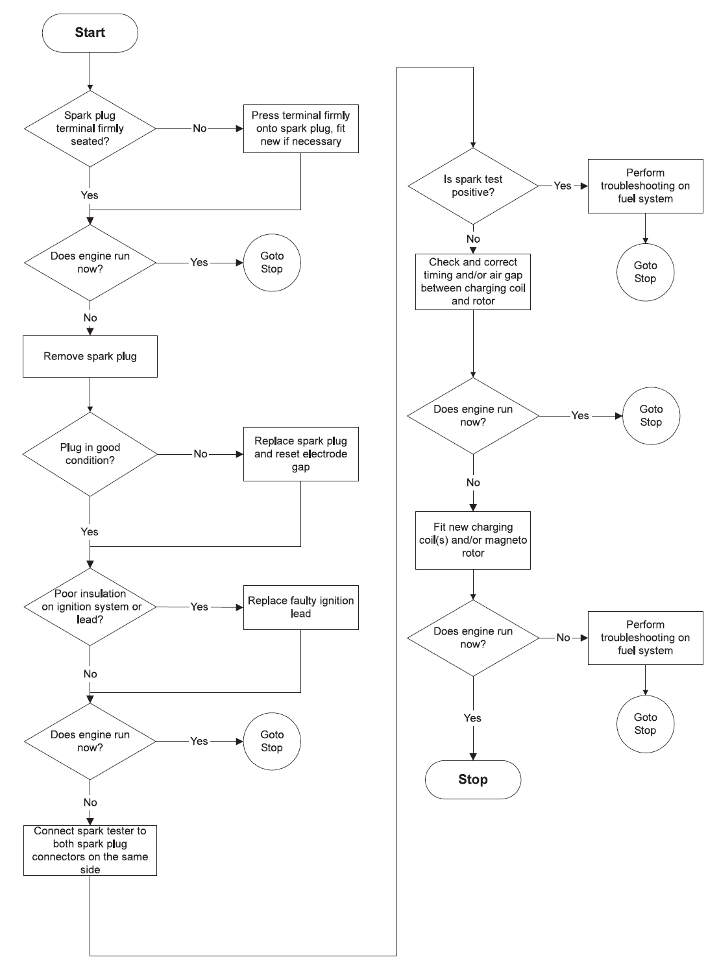

5.3. Carburettors

Fault | Cause | Remedy
Carburettor floods; engine stalls | Inlet valve not sealing. Foreign matter in valve seat or seat damaged | Remove and clean or renew inlet needle
 | Helical spring not properly located on dimple of inlet control lever | Remove inlet control lever and refit correctly
 | Perforated disc on diaphragm is deformed and presses constantly against inlet control lever | Fit new metering diaphragm
 | Inlet control lever to high (relative to design position) | Set inlet control lever flush with top edge of plate
 | Fuel pump pressure too high | Check electric fuel pump, reduce pressure
Engine does not respond properly to throttle | Idle jet “too lean” | Back off low speed adjustment screw slightly (see carburettor adjustment)
 | Inlet control lever too low (relative to design position) | Set inlet control lever flush with top edge of plate
 | Vent bore to atmosphere blocked | Clean bore
 | Diaphragm gasket leaking | Fit new diaphragm gasket
 | Metering diaphragm damaged | Fit new metering diaphragm
Engine will not idle | Throttle valve opened too far by idle speed adjustment screw | Readjust idle speed adjustment screw
Engine stalls at idle speed | Idle jet bores or ports clogged | Clean jet bores and blow out with compressed air
 | Idle jet “too rich” | Tighten low-speed adjustment screw slightly (see carburettor adjustment)
 | Idle speed adjustment screw incorrectly set - throttle valve completely closed | Set idle speed adjustment screw correctly
Engine speed drops off quickly under load - low power | Air filter plugged | Clean air filter
 | Tank breather faulty | Clean tank breather or replace if necessary
 | Leak in fuel line from tank to fuel pump | Seal or renew connections and fuel line
 | Pump diaphragm damaged | Fit new pump diaphragm
 | Electric fuel pump clogged or defective | Check electric fuel pump, clean or replace
 | Main jet bores or ports clogged | Clean bores and ports
 | Fuel strainer plugged | Clean fuel strainer

6. Graphs
6.1. Power Curves
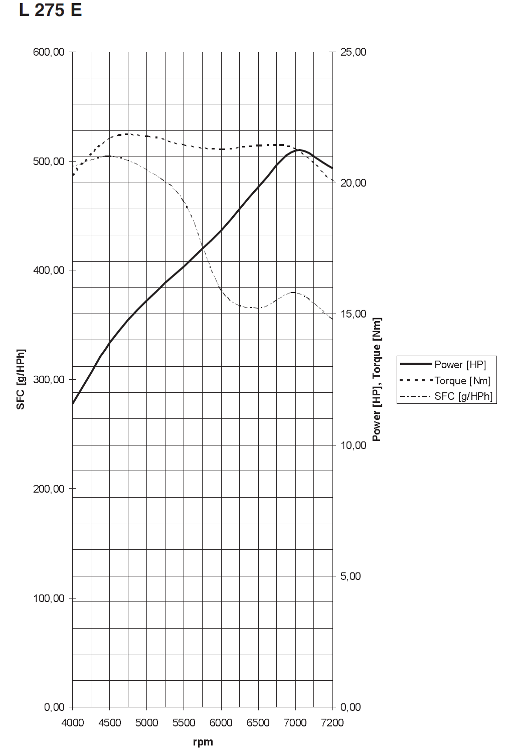

6.1.3. Generator Current

N/A

6.2. Installation Drawings
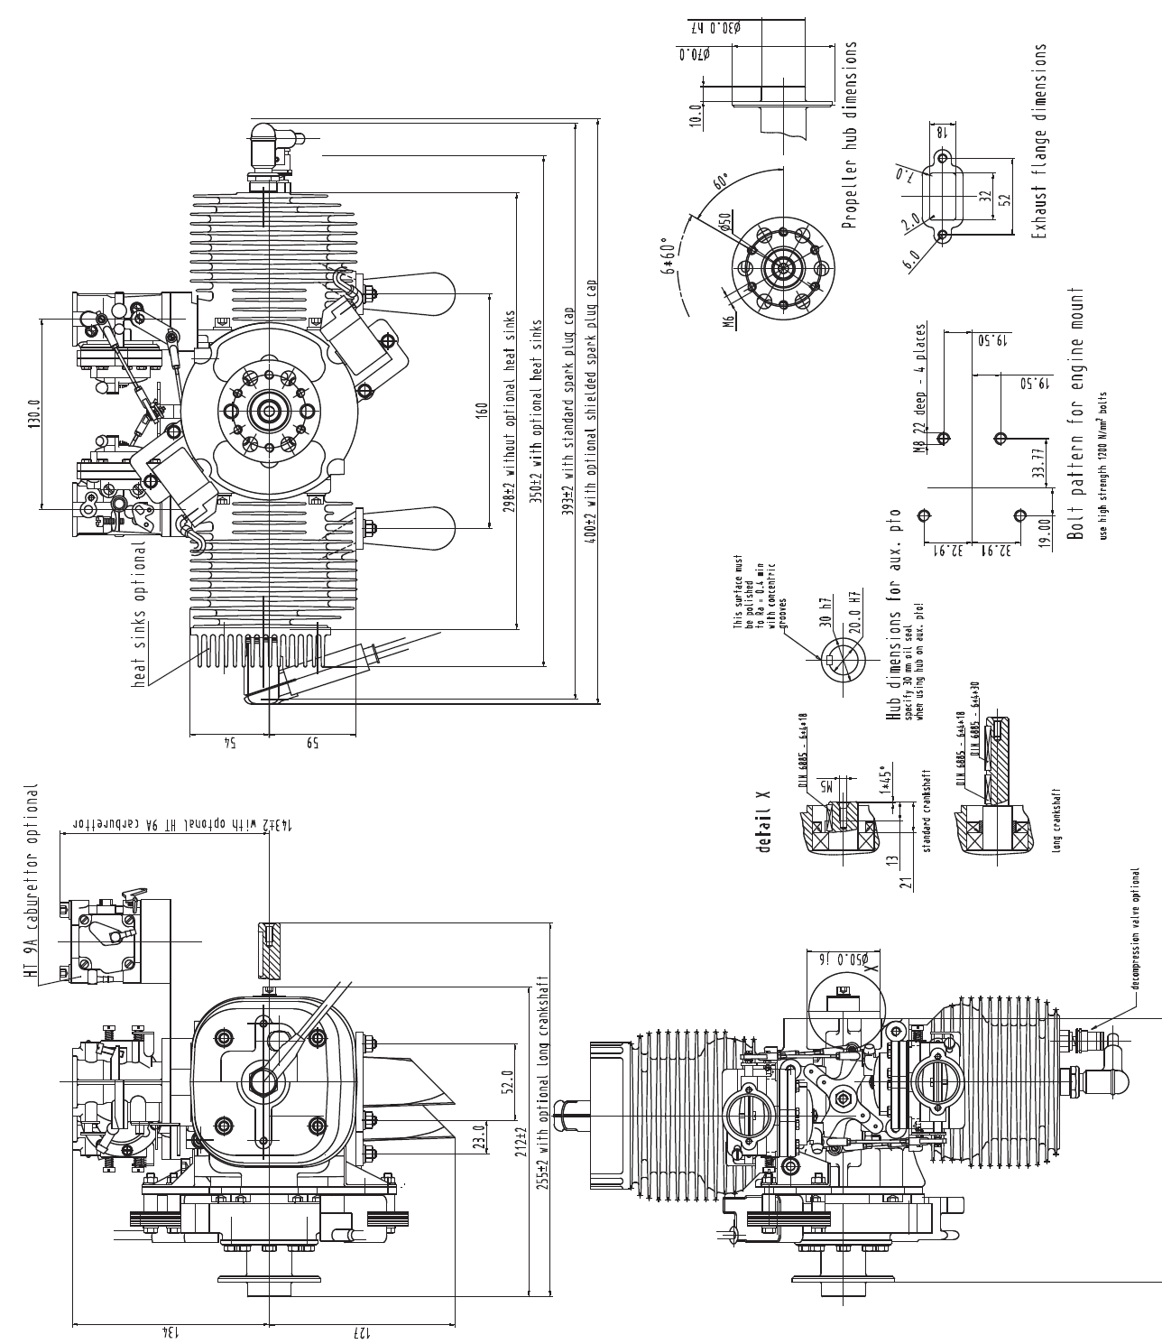

6.3. Wiring Diagram (Ignition)


