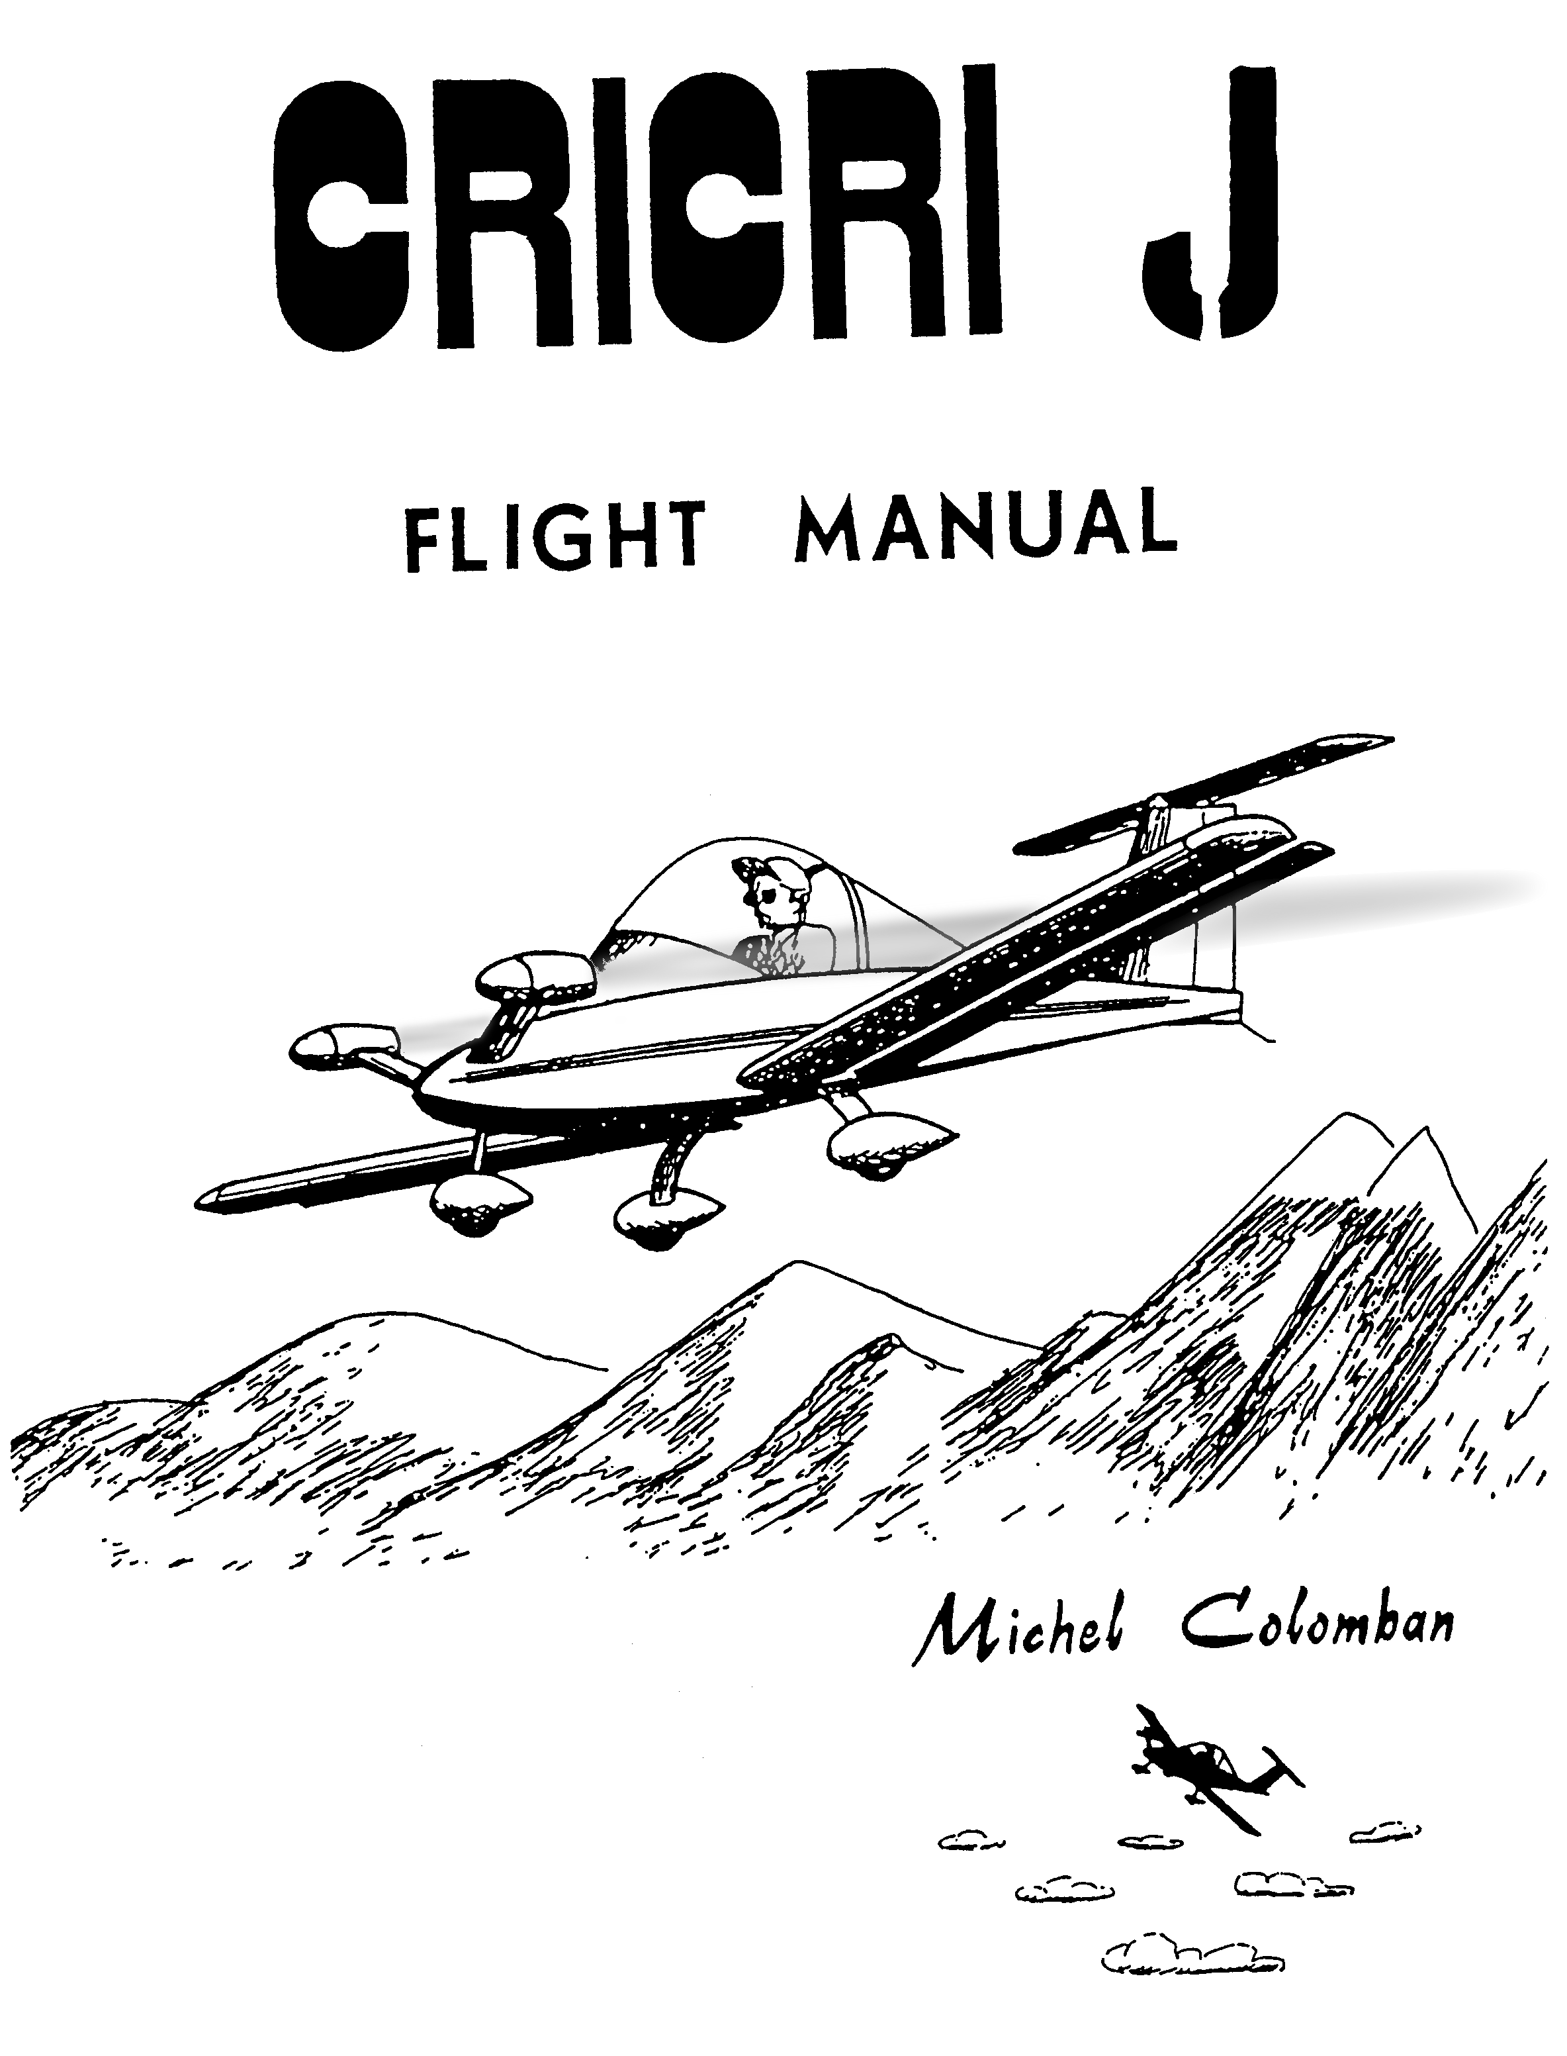

PUBLICATIONS DEPARTMENT

BVH Aerospace

Issued:

Revised: 2015-09-28

CRICRI MC 15J

FLIGHT AND MAINTENANCE MANUAL

SUMMARY

1 General

2 Operating limitations

3 Use

6 Emergency procedures

5 Performance

6 Maintenance

7 Charts

8 Engine

Copyright (c) Michel COLOMBAN 1983

1.1

# 1 GENERAL

## 1.1 Dimensions

* Wing span 5.3 m
* Length 3.9 m
* Wing area 3.4 m2
* Aspect ratio 8.5

## 1.2 Weight

* Empty equipped 82.6 kg
* Maximum at take—off 200 kg

## 1.3 Category

* Utilitarian, or aerobatic.

## 1.4 Engines

* Two PBS TJ20A turbojets. 210N thrust at 100% N2.

## 1.5 Propellers

* N/A.

## 1.6 Fuel Tank

* A 23 lit fuselage tank.
* Two 10 lit wingtip tanks.

## 1.7 Fuel

* Either JET A-1 or Diesel fuel with 4% (1:25)MII-L-23699 turbine oil.

## 1.8 Landing gear

* Principal: Composite blade. Total stroke: 160 mm. Tire pressure: 1.8 bar
* Forward: Telescopic with elastic suspension. Total stroke: 130 mm. Wheel interlocked with the rudder bar: Tire pressure: 0.8 bar.

## 1.9 Controls and cabin equipment

* Elevator control system: Central stick. Artificial stress from rubber bands. Trim on the right side.
* Aileron control: Artificial stress from rubber bands. Trim on the rear surface of the stick.
* Rudder control: Adjustment in flight. Artificial stress from rubber bands.
* Flaps: Control on the left side. Three positions: cruising, take—off and landing.
* Engine contacts: left side.
* Drum brakes with cables on the main wheels. Central brake grip on the stick.
* Ventilation: 2 scoops at the bottom of the fuselage in front of frame 4.

## 1.10 Disassembly

* Quick assembly and disassembly of the wings using the two main pins, 4 secondary pins and 2 rod ends located on opposite sides of the cabin at wing level.

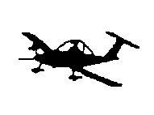

2.1

# 2 OPERATING LIMITATIONS

## 2.1 Design speeds

* Vne : Speed never to exceed : 140 kts.
* Va : Maximum maneuvering speed : 100 kts.

At this speed, the controls and in particular the ailerons, can be deflected to extreme positions, provided however you don't exceed the load factors set forth farther on. Beyond this speed, reduce progressively the deflection so that you don't exceed the angular acceleration produced at Va.

- Vf: Maximum speed flaps down

* take-off deflection (12°): 70 kts.
* Landing deflection (27°): 70 kts.

- Maximum cross wind: 10 kts.

## 2.2 Weight

* 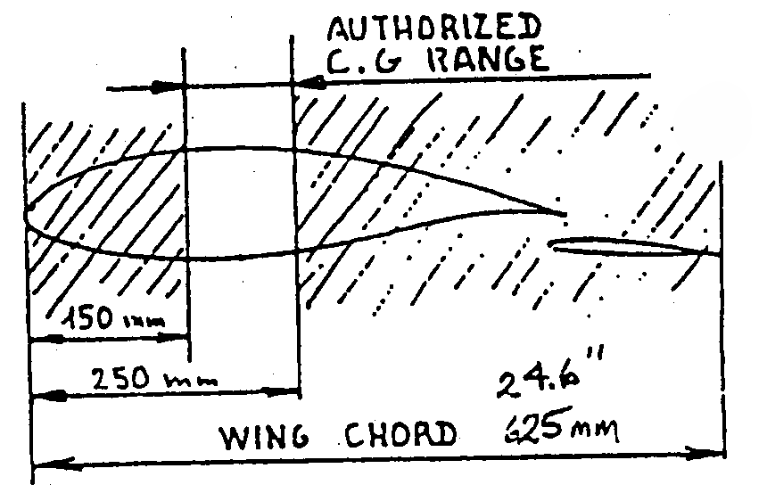Maximum weight at take-off: 200 kg (441 lbs)
* Maximum fuel for aerobatic use: 15 liters (4 US gallons)

## 2.3 Center of gravity limitations

* Forward limit: 24 % of the wing chord   
  or 150 mm behind the leading edge.
* Rear limit: 40 % of the wing chord, or   
  250 mm behind the leading edge.

## 2.4 Limit load factors in symmetrical maneuvers

Limit load factors are those beyond which certain elements of the structure begin to undergo permanent deformation. They should never be exceeded and should be approached only accidentally.

If you reach these factors, stop the plane and inspect the structure.

* Flaps up, positive + 5.0 G
* Flaps up, negative - 2.5 G
* Flaps down + 1.7 G

## 2.5 Maximum load factors in symmetrical maneuver use

For an "experimental plane", the load use factors have voluntarily been limited to half the breaking load.

They consequently represent the maximum values which can be reached in aerobatic use, provided, however, you don't exceed the fatigue life of the plane (see following chapter).

* Flaps up, positive + 3.8 G
* Flaps up, negative – 1.9 G

2.2

The flight envelope MC 15J symmetrical manoeuvres, corresponding to these two cases, are represented on Chart I.

On dissymmetrical manoeuvre use, the max load factors should be reduced to 2/3 of the above values.

## 2.6 Fatigue life

An ultimate load factor "7.6 G" means that the structure should break at a load factor of 7.6 G the first time it reaches this value. The same structure subjected many times to repeated loads, even if these loads never exceed the limit, can eventually break; alternating loads markedly reduce resistance to static fracture. This phenomenon is attributable to "structural fatigue"

An estimate of the fatigue life of MC 15’s used in aerobatics has led to the results below. This estimate has been made taking into account, along with normal correction factors, a margin of safety of 20% with regard to the residual resistance of a "fatigued" structure. It is valid for a plane built according to tolerances and with Construction Manual but should be considerably reduced in the case of faulty work (marred metal misdirected scoring, nicked rivet holes, etc.)

|  |  |  |
| --- | --- | --- |
| Load factor at | Estimated Ultimate fatigue life cycles | Estimated  Useful fatigue life cycles |
| +4.2 -2.1 | 8,000 | 1,000 |
| +3.4 -1.7 | 56,000 | 10,000 |
| +2.5 -1.2 | 630,000 | 130,000 |
| +1.7 -0.8 | 1,200,000 | 300,000 |

As you can see, a regular increase, even though modest, of the load factor causes a considerable reduction in the fatigue life. Generally speaking, each time the usage limit is increased 1 G the fatigue life is shortened about ten times.

When the wing spar is reinforced with the aid of "optional stiffener" 10106 the above fatigue life is multiplied by about ten.

Since the wing spar is the part which is subjected to the most fatigue in this plane, it would be prudent to change the flying surfaces (f1aps not included) at the end of the fatigue life.

## 2.7 Engines

* Speed never to be exceeded 120,000 rpm.
* Maximum power use full engine throttle only for take—off, climb and aerobatics. (100% N2, 120,000 rpm can be used for only 5 minutes).
* Maximum continuous power at Z = 0: 80% of maximum power. This power is obtained:  
    
  Either by reducing the maximum speed to 96,000 rpm at a given airspeed.  
  Or, in level flight, by bringing back the throttles until the airspeed stabilizes 10% below the maximum airspeed obtained at full throttle in level flight

2.3

* Maximum continuous power at 6000ft.
* Maximum temperature: limit the temperature at the exhaust (thermoculasse) 600 to 880°C (default is 880 ⁰C).

## 2.8 Usable fields

The CRICRI wheels, being of small diameter, function best, obviously, on hard surfaces.

Nevertheless, thanks to the flexibility of the suspension, this plane seems to do well also on properly levelled fields of short grass.

It would be wise to avoid fields that are too bumpy or rocky.

## 2.9 Temperature limit

A metal assembly glued with epoxy is comparable to a "plastic" assembly. You should consequently reduce a bit the use limits under very warm conditions.

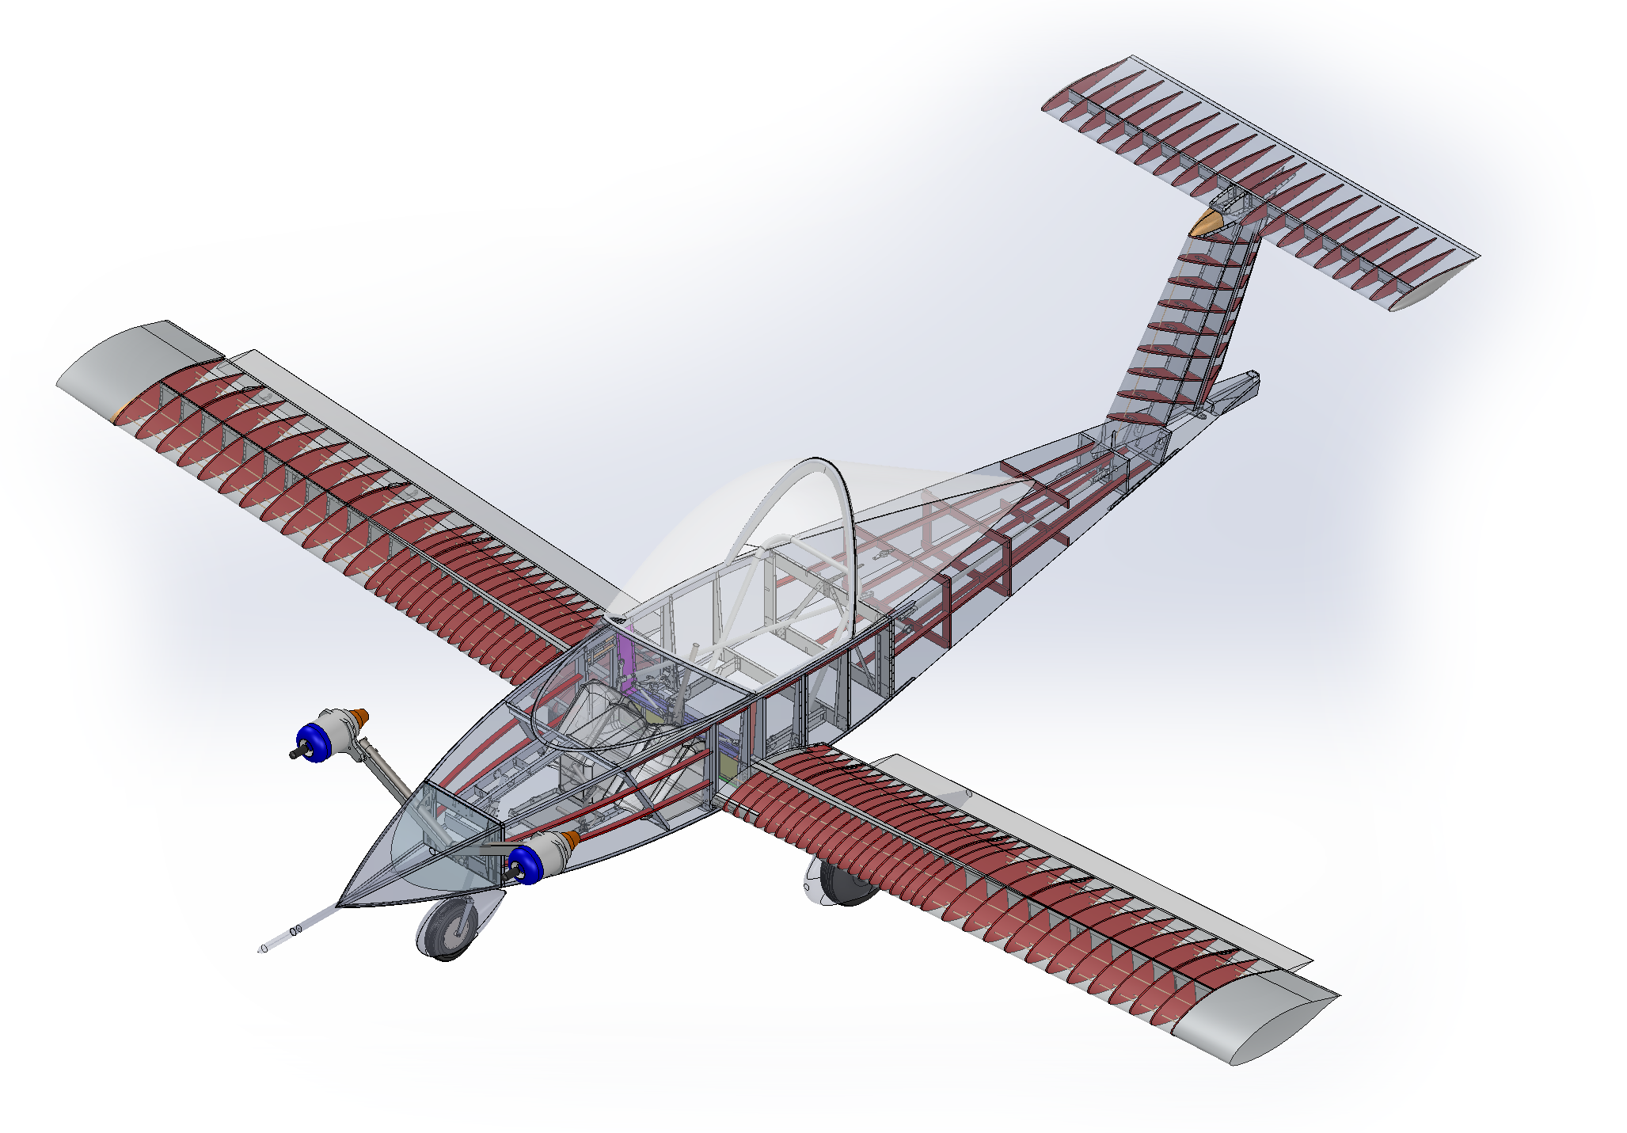

3.1

# 3 USE

## 3.1 Transport

Plane anchored and protected in its trailer.

Accelerometer locked.

Wing pin box, on board.

## 3.2 Assembly

* Plane on the ground, fit the wings in place, flaps in flight position.
* Put the two main pins in place and lock
* Put the four secondary pins in place and lock
* Attach the flap linkages and check the correct locking of the ball joint tips.
* Unlock the accelerometer.

## 3.3 Center of gravity

Check that the C.G. stays within the limits set out in the paragraph "operating limitation". For that use the table in Chart 3, starting with the center of gravity and weight of your plane equipped but empty.

## 3.4 Fuelling

Prepare in a jerrycan a mixture of fuel (JET A-1 or Diesel fuel with 4% (1:25) MII-L-23699 turbine oil. Shake well. Transfer to fuel tank. Screw in the cap all the way (seal). In aerobatics, fuel should be limited to l5 liters. (See Ch.2.2)

## 3.5 Pre-flight check

* Cockpit. Contact off. Fuel tank cap screwed in. Instruments set at zero. Seat attachments and harness checked.
* Fuel tank vent clean and open.
* Fuselage: general condition.
* Total and static pressure points clean and open.
* Horizontal tail: general condition, joints and rod connections.
* Vertical tail: general condition, rudder, joints and cable attachments
* Wing surface: general condition. Fittings and flap articulations. Seal of wing-fuselage junction.
* Main landing gear: condition of support fittings and of silent-block.
* Brakes. Tire condition and 1.8 bar pressure. Fairing attachment.
* Nose gear: normal flexibility of the suspension, condition of tire and 0.8 bar pressure. Fairing attachment. .
* Engines: check the flexibility of the suspension and its centering.
* Condition of arm fairing. Condition and attachment of engine fairing.
* Fuel Filter. Clean. General condition. Bolts. Throttle cable attachment. Condition of fuel line.

3.2

* Canopy: Clean. General condition. Hinges. Latches. Seal.

## 3.6 Pilot entry

Standing on the seat, support yourself on the edges of the fuselage around the main frame. Slide your legs in. Adjust the rudder bar. Attach the harness. Tighten the straps.

## 3.7 Starting the engines

* Push the START/STOP button. The display will indicate STOP.
* Set throttle to IDLE. The display will indicate IDLE.
* Set the throttle to 100%. The display will indicate ТH: -REL   
  If TH: +RUN is indicated, the whole actuating procedure must be repeated.
* Within 6 seconds, set the throttle to IDLE.

During the device test, the display will indicate TEST in Menu A. After successful test, the engine will be started in idle speed. During the engine start, the display indicates FIRE and START. After starting and on reaching idle speed, the display indicates IDLE in Menu A.   
  
NOTE: If the throttle is not set to IDLE within 6 seconds, the engine will switch to STOP mode and the display will indicate STOP in Menu A. To start the engine, the whole procedure must be repeated.

## 3.8 Taxiing

Close and lock the canopy. Flaps in take—off position (12°). Adjust ventilation. Release brake. Taxi slowly and try the brakes. Turns are made only with pedals (steerable nose wheel). The difference in engine speeds is unimportant. It will have no effect.

Rapid taxiing is not a problem. The airplane is stable and visibility is perfect. But beware, it is sensitive. Avoid braking as much as possible. You will save the tires, the brakes and fuel.

Crosswinds (maximum 10 kts) don't pose any particular problems.

## 3.9 Take-off

Before taking off, check the instruments, then:

* Landing gear, altimeter.
* Controls free. Correct flap setting.
* Fuel selectors flow open. Tank adequately filled. Cap screwed in.
* Harness attached. Once again, wing pins and ball joint tips and flap rods. Flaps at take-off position. Canopy locked.
* Exterior. No approaching airplane.
* Adjustment of take-off tab position according to C.G. position.

In order to take off: get lined up, full throttle. At about 50 kts (about 10 seconds) pull gently on the stick (Warning: artificial effort gives an impression of firmness. It is always such during low speed flights). On rough ground, taxi with the stick a bit back and take-off at about 40-45 kts.

3.3

In a crosswind (max 10 kts) or irregular winds (gusts) increase these speeds a bit.

## 3.10 Climb

* Full throttle.
* 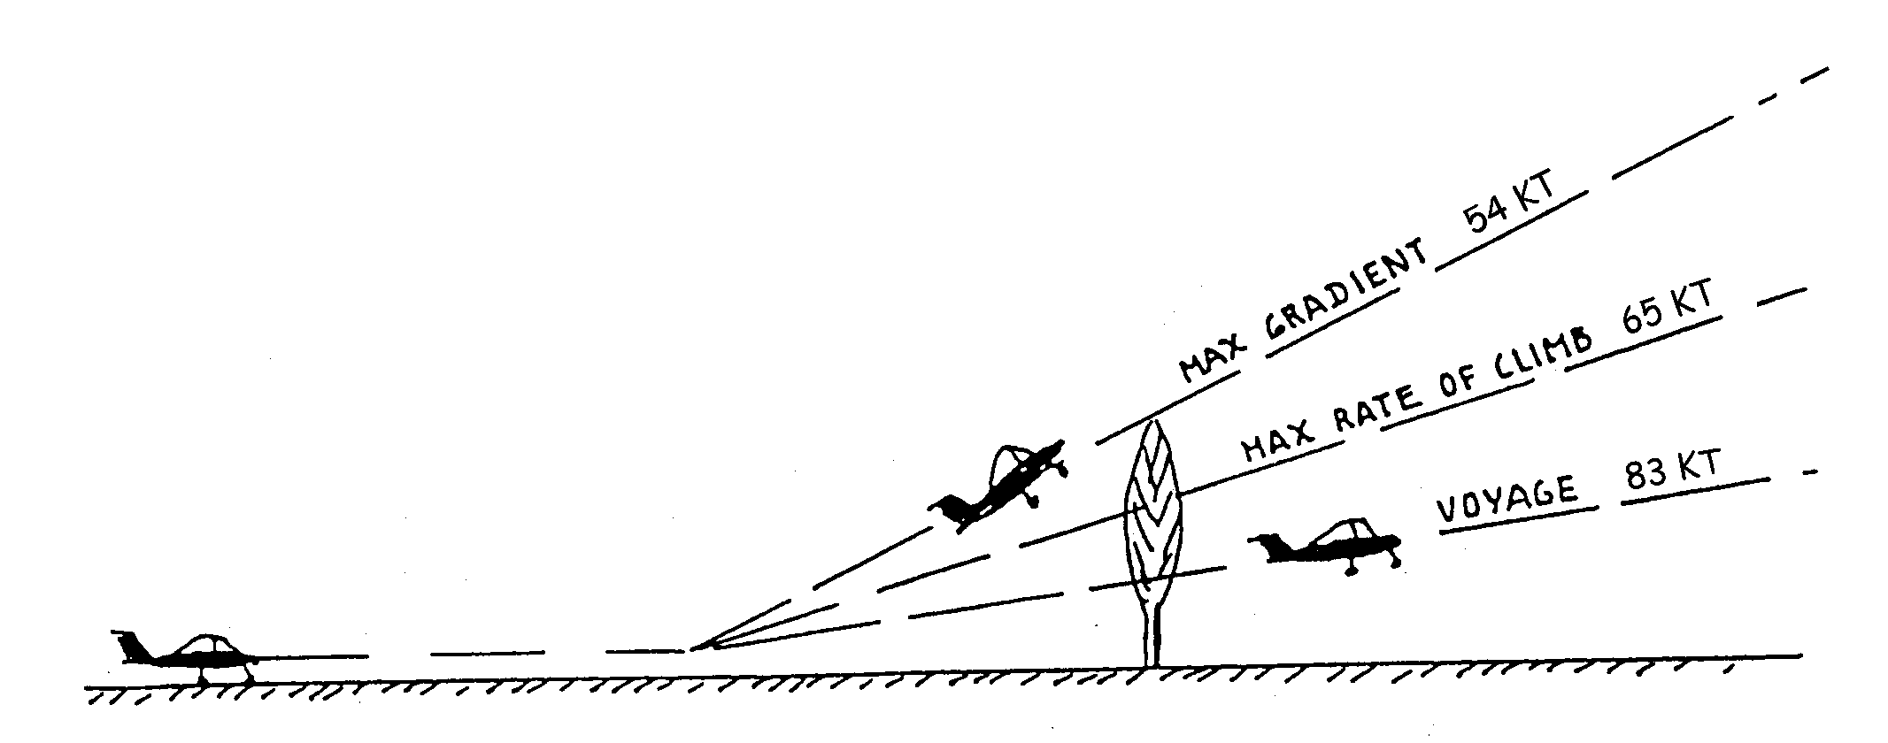Flaps brought back to cruising position (slowly because sensitive) beyond Z = 150 ft and before reaching Vi = 70 kts.
* Max gradient speed (obstacle): 54 kts.
* Max rate of climb speed: 65 kts.
* Climbing speed "voyage" (distance): 83 kts.
* Maximal temperatures of exhaust gas: 600°C – 880°C
* (250°C only 5 minutes, otherwise increase speed)
* Normal full throttle is approximately 96,000 rpm.
* Trim adjusted accordingly, stick released,

## 3.11 Flight in calm atmosphere

* Maximal speed in level flight (5 min max): Full throttle. Engine speed approximately 100% (120,000 rpm). Faired airplane Vi about 117 kts.
* Fast cruising: Bring the throttle levers back so that the speed is equal to 90% (105.000 rpm) of the maximal level flight speed.
* "Long distance" cruising: Power needed to bring the indicated airspeed back to about 80% (96,000 rpm).
* Maximum flight time: Power for Vi = 70 kts.
* Full throttle diving speed: Never exceed speed: 140 kts  
  Limit power to 120,000 rpm (max power).

Caution: Because of artificial stress on the controls, stick load becomes very light at over-speed. Do not forget this, particularly in case of aerobatic flight manoeuvres and begin very slowly.

## 3.12 Flight in gusty atmosphere

In extremely gusty weather the airplane can reach its max. load factor at a speed of 100 kts. It is therefore best never to exceed this speed in such a case. Also, be aware that a speed which is too slow (comfort) exposes one to stalls at gusts. In the above case, always use a 85 – 100 kts speed range.

In aerobatic flight gust load factors are added to manoeuvring ones. In order not to exceed the established load factors (Chart 1) the higher the gust load factors the more the manoeuvring loads should be decreased. Better still, put off aerobatic flight during very gusty weather.

3.4

## 3.13 Stall

Idling in horizontal flight (Variometer 0 ft/min).

* Cruising configuration Vs = 49 kts.
* Take off configuration Vs = 44 kts.
* Landing configuration Vs = 39 kts.

Stall warning signs are fairly subtle. Stall can be a little dissymmetrical. The nose down attitude noticed after stall is about 20 to 30°. Immediate recovery if the stick is eased forward. Slight loss of altitude.

Here again, the airplane is at low speed and the pulling effort to bring the airplane to stall, stick practically at the extreme back position, is relatively great (artificial effort). Same explanation for the feeling of heaviness during the following recovery.

## 3.14 Spin

It is very hard to get the CRICRI to spin. When one succeeds, the exit manoeuvre is simple: Bring the controls back to centerline or better still, slightly past it. All controls can also be let go. Spin exit in less than one turn.

## 3.15 Approach

* Let the airplane decelerate to Vi = 70 kts before bringing the flaps to take-off (l2°) or landing configuration (27°).
* Normal approach speed = 60 kts.
* Trim adjusted accordingly.
* If need be, be aware that the greatest lift to drag approach ratio is obtained with flaps in take-off position (12°) at Vi = 60 kts.
* Return to full throttle is possible whatever the flap deflection.

Caution: Slotted flaps covering the entire span are very efficient. Do not handle them roughly. Never raise the flaps near the ground whatever the speed may be.

## 3.16 Landing

* Approach speed Vi = 55 - 60 kts.
* Round off progressively without trying to stall. Be careful of the unusual low position of the seat. Do not round off too high.
* Touch down very slightly nose up at Vi = 46 to 49 kts.

If the landing is missed, return to full throttle before slowly raising the flaps.

In cross-winds, approach slightly banked or at a diagonal. Rectify just before impact. Afterwards, direct with the pedal. In this case, as well as in irregular winds, increase the above speeds a little. To keep running bring flaps back up (3°), Avoid hard and long braking when the fuel level is low: risk of un-priming sinking hose pipes.

3.5

## 3.17 Stopping the engines

Push the engine STOP button. Only switch off the engine contacts when after-cooling cycle is complete.

## 3.18 Moving the airplane on the ground

Push the airplane by the horizontal tail. If need be, push down on the tail to raise the front wheel for easier handling.

## 3.19 Mooring

On horizontal ground: face the wind, flaps up 3°. Brake. Fasten by the holes of the flap support arms.

If possible protect with a padded covering: On such low airplanes dropping cameras, handbags and other tools is not infrequent.

## 3.20 Storing

The best way to store the airplane, whatever the length of time, is to place it in its trailer sheltered from bad weather, dust, shocks etc; and preferably in a dry garage.

lf possible, clean and dry the airplane before closing the trailer.

In order to avoid condensation in the tank it is best to fill it up before storing.

## 3.21 Operating the CRICRI in aerobatic flight

Thanks to the way the engines are fed and lubricated they can operate non-stop in any position.

* Fuel: 15 lit maximum.
* Power rating: Full throttle. But 96,000 rpm maximum continuous rating.
* Inverted flight: Do not go under an indicated airspeed of Vi = 78 kts.
* Slow, fast, hesitation rolls and rolling turns; Same minimum Vi as above: 78 kts.  
    
  Do not practice sharp deflections to the extreme position over Vi = 100 kts. From this speed on, either limit the amplitude or the deflection speed so that the rate of roll does not exceed the maximal value obtained at 100 kts.
* Loops: Minimum entrance speed: Vi = 130 kts. Load factor: 4 "G".
* Half Cuban and reverse half Cuban: Vi = 130 kts. 4 "G".
* Stall turn: Not recommended because very difficult to perform.
* Snap roll: Forbidden ("T" tail)

NOTE: Considering the slight stick load rating in overspeed it is indispensable to use an accelerometer for aerobatic flight in CRICRI.



4.1

# 4 EMERGENCY PROCEDURES

## 4.1 Engine fire

* Close the throttle.
* Close both fuel valves.
* Push the STOP button.
* Switch off the Turbine Master.

## 4.2 Icing

Until now no icing tendency has been noticed on these types of engines.

However, if a power drop occurs in icy weather, the only answer would be to hit the throttle lever a few times at full throttle.

## 4.3 Engine failure

If an engine fails keep the cruising configuration if the indicated airspeed Vi is over 60 kts.

Upon approach and at landing remember that the flaps deflection accentuates the yaw caused by the engine dissymmetry. Therefore, with flaps in landing configuration restore power to an engine very progressively.

## 4.4 Restarting an engine in flight

* Set throttle to IDLE.
* Push STOP/START button.
* Set throttle to 100% power.
* Set throttle to IDLE.

## 4.5 Makeshift landing

If both engines are irremediably out of order:

* Close both fuel valves.
* Turn the engines off.
* Tighten the harness straps.

Highest lift to drag ratio; flaps at l2° configuration and Vi = 60 kts.

Land in landing configuration, flaps down at 27°. If the runway is unsure refuse the ground until stall.



5.l

# 5 PERFORMANCE

The performances are given for an airplane which corresponds in all respects to the definition in the set of plans and at a total maximum power of 30 HP.

## 5.1 Stalling speeds "Vs"

Figuring on chart 2a they are in relation to weight and the three flaps deflections: cruising 3°, take-off l2°, landing 27°.

These are indicated speeds, therefore unrelated to altitude and temperature. They are obtained by allowing the airplane to decelerate with the variometer at 0 ft/min.

## 5.2 Take-off runs

Figuring on chart 2b they are in relation to weight and altitude. Given in standard atmosphere in zero wind and on a hard horizontal runway. For a grassy runway increase the distances by 25 to 30% The airplane is in take-off configuration flaps at l2°.

## 5.3 Take-off distances to 50 ft

Figuring on chart 2c, under the same conditions as above. The 50 ft. clearance speed is 1.3 times the stalling speed in take—off configuration.

## 5.4 Maximum rates of climb

Figuring on chart 2d they are in relation to altitude and airplane weight. The airplane in cruising configuration. Standard atmosphere. The indicated speed corresponding to the maximum rate of climb is approximately 65 kts.

## 5.5 Maximum speeds in linear horizontal flight

Figuring on chart 2e they are in relation to altitude and weight. Cruising configuration, engines full throttle.

## 5.6 Landing distances from 50 ft

Figuring on chart 2f they are in relation to altitude and airplane weight. The 50 ft. clearance speed is l.4 times the stalling speed in landing configuration. Average deceleration considered during landing run = 0.3 G.



6.l

# 6 MAINTENANCE

The aim of MC l5 maintenance is to keep it in good working condition for as long as possible.

This good condition may be altered in several ways:

* Through wear: (tires, hoses, diaphragms ... etc.). In this case replace worn parts.
* Through fatigue: This is the case of elements subjected to high rates of vibration (linking bar, engine mount, resonator etc.) or a large number of cycles under heavy stress (wing spar in aerobatic flight for example). These parts must be inspected frequently in the places receiving the most stress and in particular around holes, angles, section breaks, scratches, welding, assembly parts...etc. Cracks show up at an advanced state of fatigue. These fatigue cracks are not always visible to the naked eye. They can only be detected using a magnifying glass at the minimum, or better using fluorescent penetrant inspection or X-ray. lf a fatigue crack appears on a non critical part which is clearly visible (canopy, fairing...etc.) drill a _ small hole about 0.l inch at its far end to stop its development. Then keep watch. If, on the other hand, it appears on a vital part (linking bar, spar, bell crank...etc.) it is urgent and imperative to replace it.
* Through abrasion: This is the case of leading edges and in particular those of the turbine impellor.
* Through corrosion: This principally depends on the type of atmosphere the airplane is kept in. In case of corrosion traces strip the surface and protect it accordingly, Try to keep it in a more favourable atmosphere.
* Through aging: This is the case of elastomers in general, bonding...etc. (bungee cords hose pipes...). Arrange for their periodic replacement.
* Diverse accidents, shocks, scratches: Repair according to ans and allowances. For light scratches on the canopy use an appropriate polish and even very fine abrasive paper if the scratch is deep.
* Diverse deposits: Dirt, mud, clogged filters air vent or airspeed indicating system obstruction. Check, clean and unclog.   
    
  Maintain outside surfaces like those of a car: wash with soapy water, rinse, dry, Avoid water penetrating into joints and diverse circuits.  
    
  In case of condensation or closing up of the airspeed indicating system, disconnect it on the instrument side and blow into the other end.

6.2

The following list gives an idea of the maintenance to be carried out.

|  |  |  |  |  |
| --- | --- | --- | --- | --- |
| Item | When Needed | 25H | 50H | 100H |
| 6.l wings  * Flap support arm: checking of attachments. * Assembly pins; fitting and lubrication. * Spherical bearings: cleaning, lubrification. * Rod ends: cleaning, lubrification. | x | x  x |  | x |
| 6.2 Flaps  * Flap-to flap attachment: checking. * Fixing of ball joint on root side. * Fixing of lover hinge fittings. |  |  | x  x | x |
| 6.3 Horizontal tail  * Hinge ball joint: fitting, play and lubrification. |  |  | x |  |
| 6.1 Vertical tail  * Spar: condition at hinge fittings and on top of frame 13 (last rivet) |  |  | x |  |
| 6.5 Rudder  * Joints and starting point of cables: checking |  |  | x |  |
| 6.6 Canopy  * Hinges: checking, cleaning, lubrification. * Latch: checking, cleaning, lubrification. * Sealing: checking, cleaning, lubrification. |  | x  x | x  x |  |
| 6.7 Main landing gear  * Tires: state and pressure 1.8 bar. * Brakes: checking, cleaning. * Brake cables: checking, tension, lubrification. * Fiberglass leg: checking. * Clamp: checking. * Lower rod: checking, cleaning, lubrification. * Nuts and bolts: checking. | x  x  x | x | x | x  x |
| 6.8 Nose gear  * Tire: state and pressure 0.8 bar. * Outer sliding tube: cleaning, lubrification, * Inner sliding tube: cleaning, lubrification, * Bearing block: checking for wear. * Interlinking cables: tension, lubrification. * Guide pulley: cleaning lubrification * Nuts and bolts: checking. | x  x |  | x  x  x  x | x |
| 6.9 Flying control  * Control linkage 1 joints, bell-cranks: cleaning. * Checking condition of fittings, lubrification. * Nuts and bolts: checking | x |  | x | x |

6.3

|  |  |  |  |  |
| --- | --- | --- | --- | --- |
| Item | When Needed | 25H | 50H | 100H |
| 6.10 Motor suspension  * Centering and attachments of motor suspension: checking. * Linking bar; look for cracks where spindles 50119 pass through holes. * Linkage piece 50016: condition and tightness. |  | x | x  x |  |
| 6.11. Engines  * Visually check of compressor wheel and turbine before flight. * Check impeller blade. * Manually check that the compressor wheel and turbine can turn freely. * Exhaust: overall state, attachment. (1) * Nuts and bolt: general checking (paint marks). * Wiring and connections: checking - * Fuel system: overall cleaning. * Fuel filter: cleanliness, condition and sealing. * Overhaul: engine (50 hr or 500 starts) | x  x  x  x | x | x  x  x  x | x |
| 6.12 Fuel system  * Sinking hose pipes and filters: checking. * Fuel lines: condition and attachment. * Fuel tank: condition and attachment. * Fuel tank air vent: checking. |  | x | x  x | x |
| 6.13 Turbine wheel  * Spinners: state (cracks) and attachment. * Blades: overall state. | x | x |  |  |
| 6.14 Airspeed indicating system  * System: cleanliness, condition and sealing. |  | x |  |  |

## 6.15 Special conditions

Visually check the fuel filter for contamination before every flying day. A contaminated fuel filter must be cleaned or replaced.

After cleaning or replacing a fuel filter, all air bubbles must be flushed from the fuel line. By using the 55:FUELPUMPING register prime the fuel feed to remove air bubbles. Watch the fuel until it reaches the engine and turn off priming. Do not pump the fuel into the engine.



7.1

# 7 CHARTS

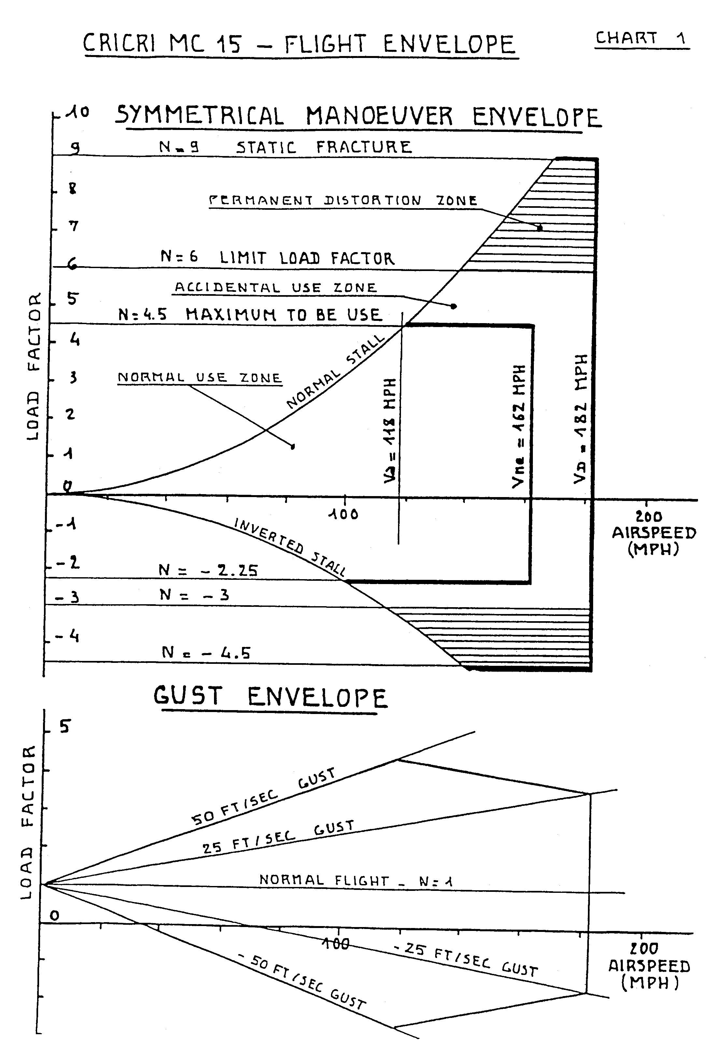

7.2

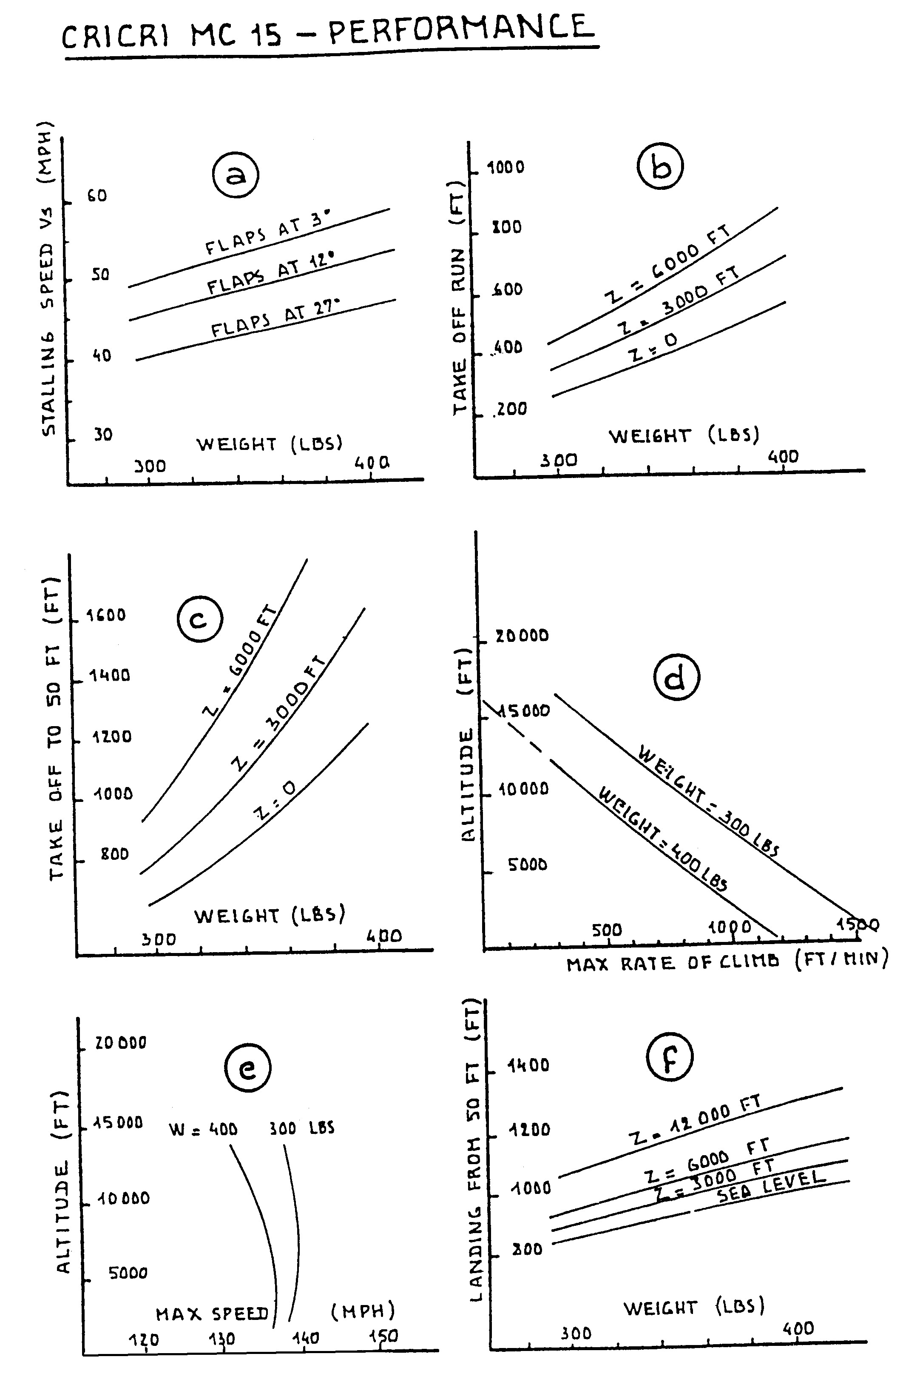

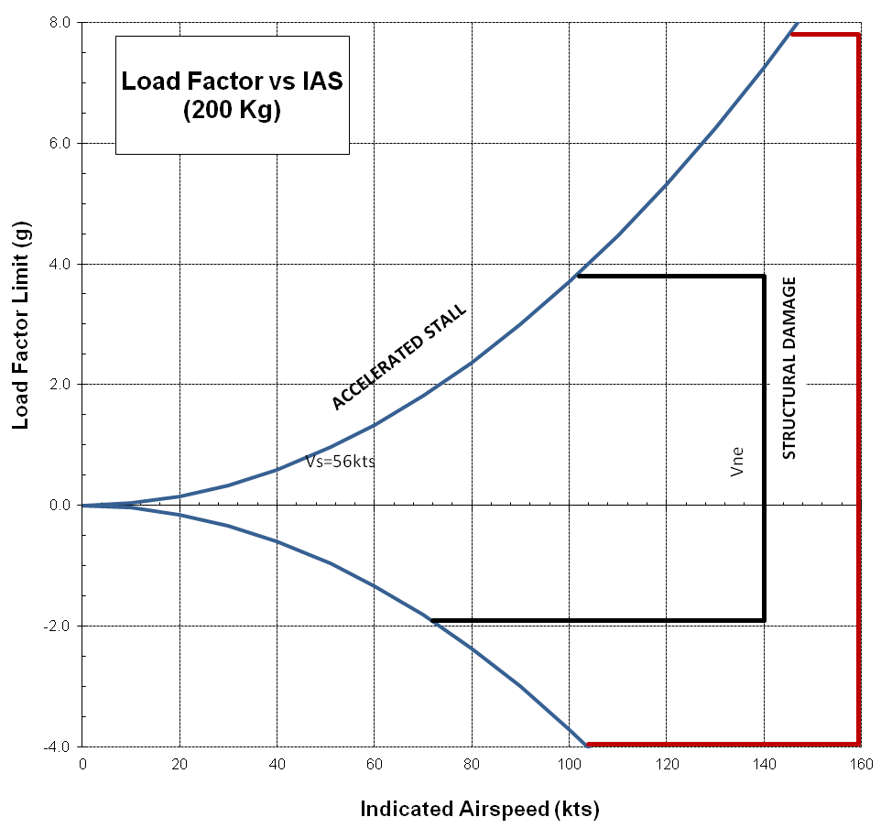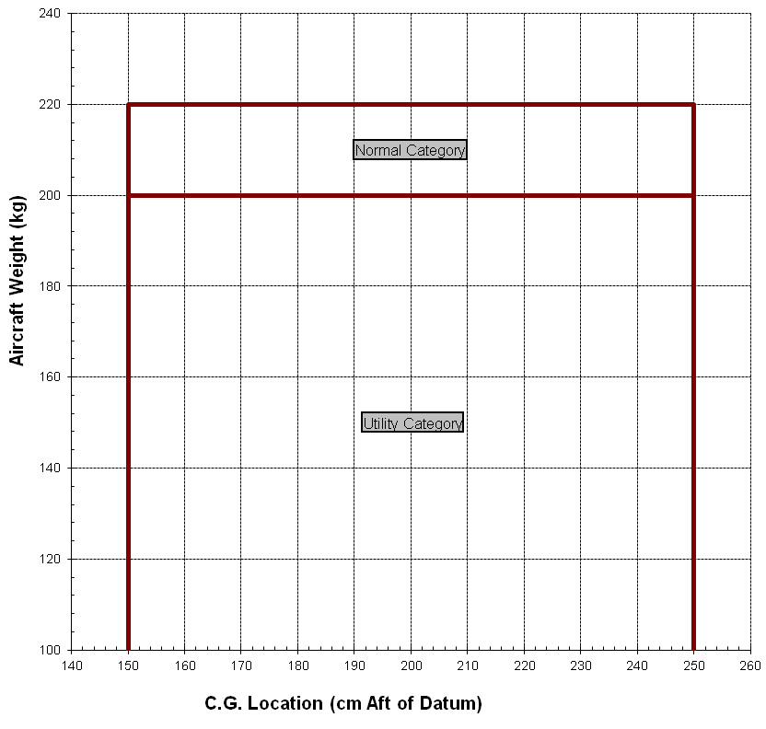

Cri Cri fuel consumption with 2 x PBS TJ20A

|  |  |  |  |  |
| --- | --- | --- | --- | --- |
|  | **% power** | **fuel cons. l/h** | **speed kt** | **Nautical Miles / Liter** |
| Both Engines | 75 | 63 | 107 | 1.7 |
|  | 64 | 58 | 97 | 1.7 |
|  | 51 | 52 | 85 | 1.6 |
|  | 40 | 45 | 73 | 1.6 |
|  | 32 | 41 | 65 | 1.6 |
| Single Engine (other shut down) | 87 | 36 | 78 | 2.2 |
| Single Engine (other at idle) | 87 | 44 | 78 | 1.8 |

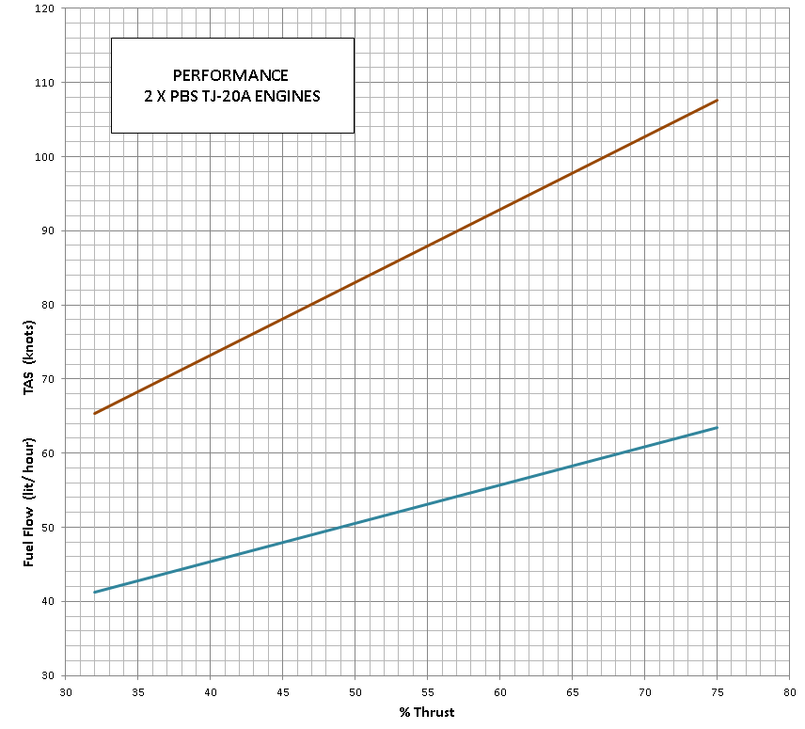

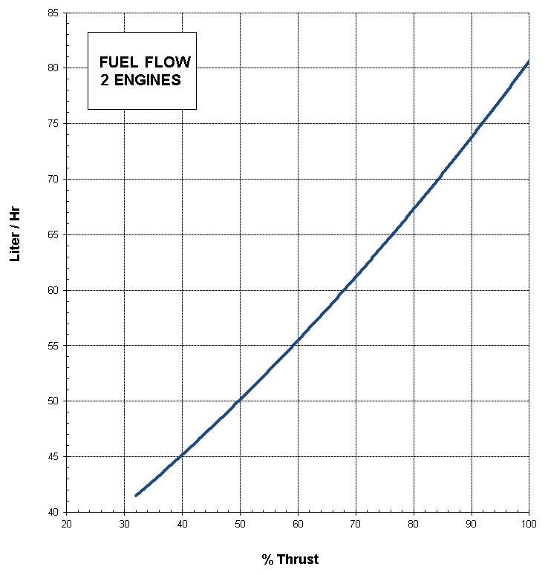

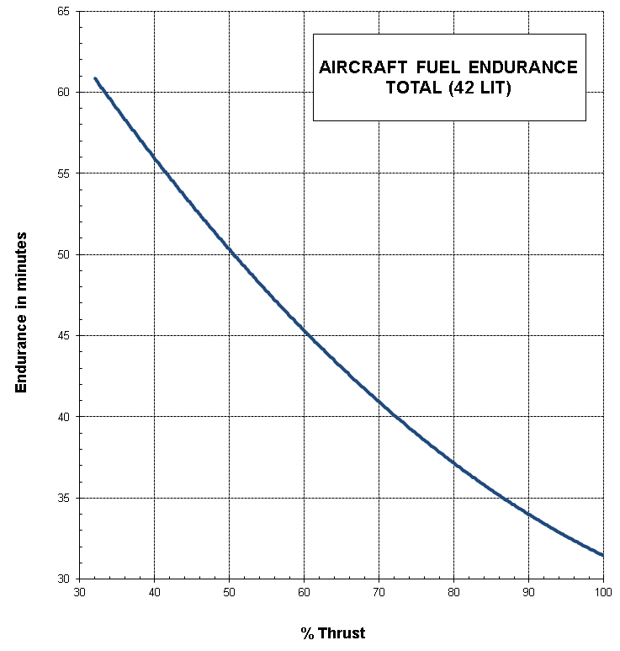

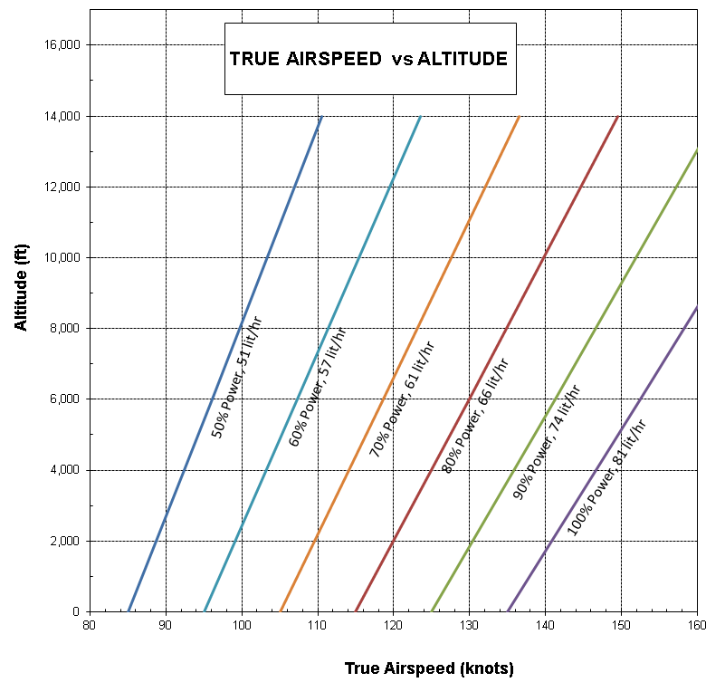

8.1

# 8 ENGINE

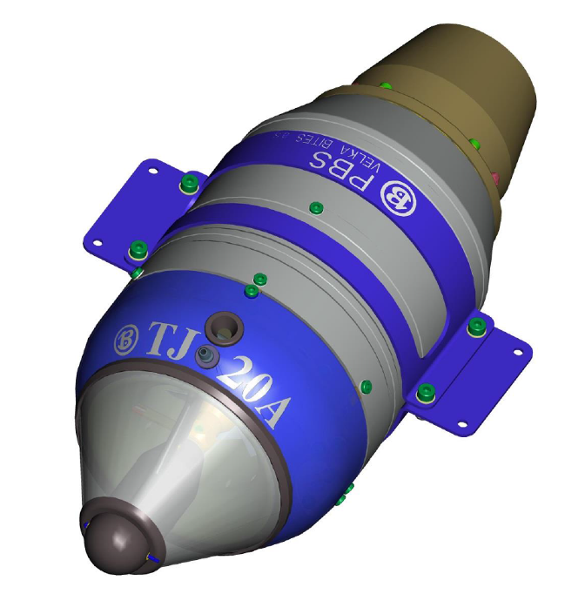

The PBS TJ20A turbojet is a single-shaft engine with single-stage radial compressor, annular combustion chamber, single-stage axial turbine and output nozzle.

A booster with break-in clutch enabling starting of this engine from the cockpit net is located at the compressor section.

Inducted air is compressed by the radial compressor wheel, pass through radial and axial diffuser to the combustion chamber. Here it is blended with fuel vapor by the evaporating piping. Hot gases caused by fuel burning in the combustion chamber expand through single-stage axial turbine and exhaust at high speed from output nozzle to the atmosphere creating the thrust of the engine. The axial turbine, in turn, drives the compressor via the engine shaft. The engine shaft in held in place by two axial bearings and is lubricated by the fuel.

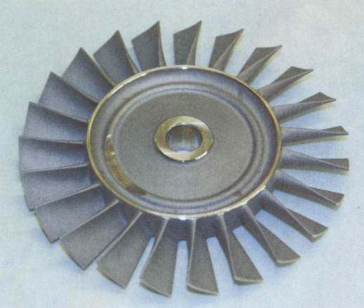The engine contains an on-board electronic control unit. The control unit processes data from the speed sensor, exhaust gas temperature sensor and input air temperature sensor. Engine operation is exclusively controlled by control unit.

After receipt of START command, the control unit checks all connected accessories and performs the start of the engine automatically. The control unit has full authority control of the starter, fuel sensor, starting and main fuel valve based on data from all sensors. After engine shutdown the control unit automatically starts after-cooling by switching on the starter as long as temperature of exhaust gases remains above the pre-set value (normally 100 °C EGT).

The control unit conforms to the normal principles of RC model technology (variable width of pulse, 1 – 2 ms with recurrent frequency 50 Hz).

8.2

## 8.1 Starting instructions

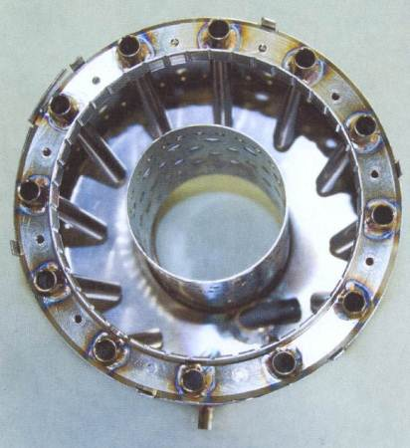

Connect the engine to the EDT, fuel supply and power supply. The control signals (stop, idle thrust, maximum) must be set in the engine control unit using the EDT.

Switch on master switch and set RC signals in the R/C SETTINGS menu.

The fuel supply line must be entirely filled and all air removed before the first start. Use Menu 55: FUEL PUMPING to fill the fuel line. Watch the fuel line filling and once it reaches the engine stop the FUEL PUMPING.

NOTE: Do not pump the fuel into the engine.

Engine is ready for use after disconnection of the EDT.

During start-up of the engine, take care to keep the engine in a horizontal position.

Normal engine start procedure

- Push the START/STOP button. The display will indicate STOP in Menu A.

- Set throttle to idle. The display will indicate IDLE in Menu A.

- Set the throttle to 100%. The display will indicate ТH: -REL in Menu A.  
 If TH: +RUN is indicated, the whole start procedure must be repeated.

- Within 6 seconds, set the throttle to IDLE.

The device test, during which the display indicates TEST in Menu A, will follow and, after successful test, the engine will be started in idle speed. During the engine start, the display indicates FIRE and START in Menu A and, after reaching idle speed, the display indicates IDLE in Menu A.   
  
If the throttle is not set to IDLE within 6 seconds, the engine will switch to STOP mode and the display will indicate STOP in Menu A. To start the engine, the whole procedure must be repeated.

NOTE: Ensure the battery is optimally charged to provide enough power for the start of the turbine, which is very demanding.

Engine aborts starting sequence if voltage drops under 10 V during start.

## 8.3

## 8.2 Danger zone

Only ***operators*** with ***adequate hearing protection*** may be present in the area indicated below. All other persons must remain outside the area.



## 8.3 Engine Specifications

Model PBS TJ20A

Max Thrust 200N

Weight 2.2 kg

RPM range 35,000 to 122,000 rpm

Compression 3.5

Air intake 0.4 kg/sec

SFC at max thrust 0.165 kg/Nh

Fuel consumption (idle) 127 ml/min

Fuel consumption (100%) 650 ml/min

Fuel Jet-A1 + 4% turbine oil

Fuel spec GOST 17216-71 (10-11) or NAS 1638 (7-8)

Max temp (intake air) 780 ⁰C

Supply Voltage 12 V DC

Ambient operating temperature -20 to 50 ⁰C

Flight speed range 0 to 0.6 Mach

Altitude range 0 to 20,000 ft

Time between overhaul 50 hours or 500 starts (whichever happens first)

## 8.4

## 8.4 Engine connections

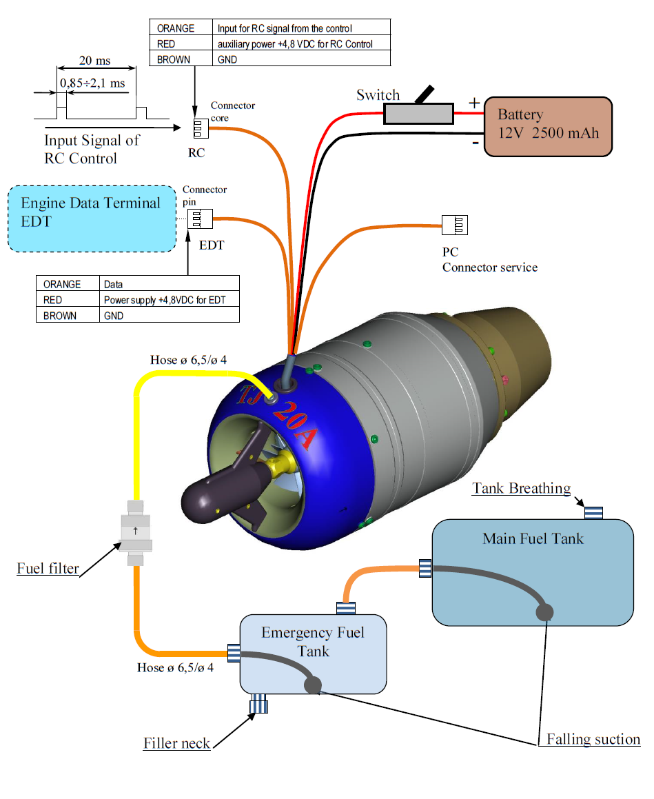

## 8.5 Engine Data Terminal (EDT)

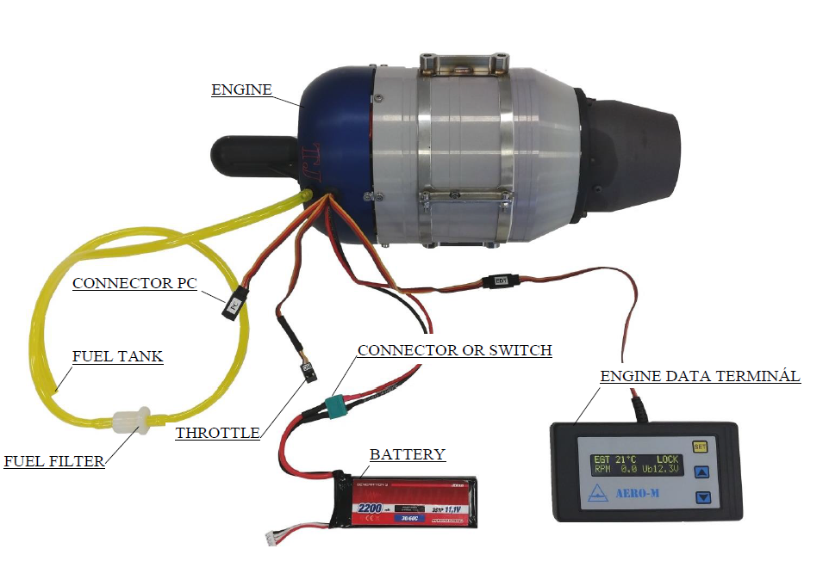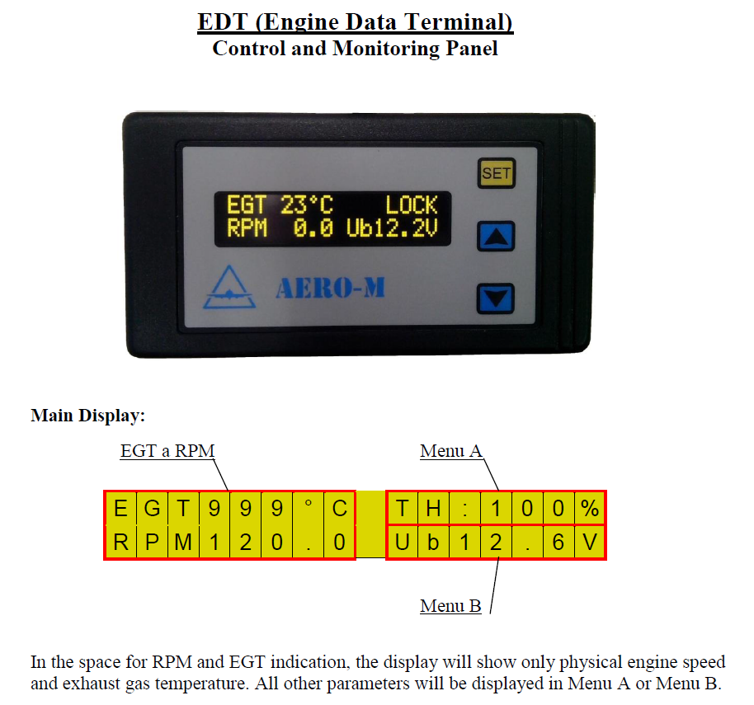

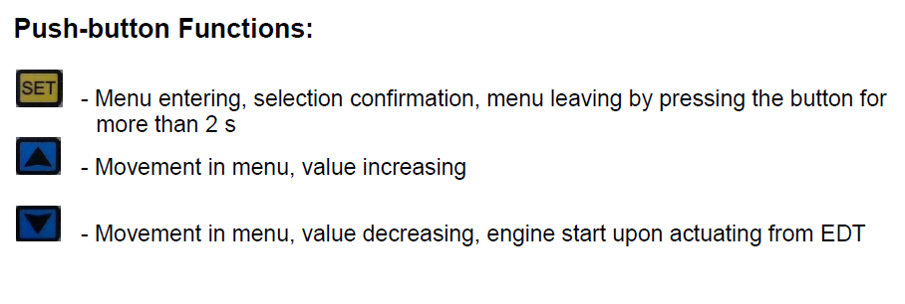

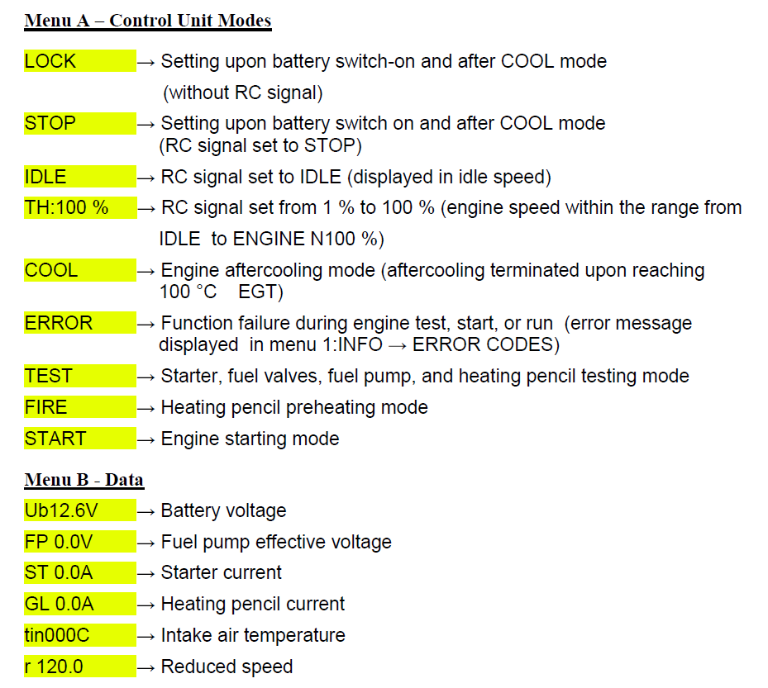

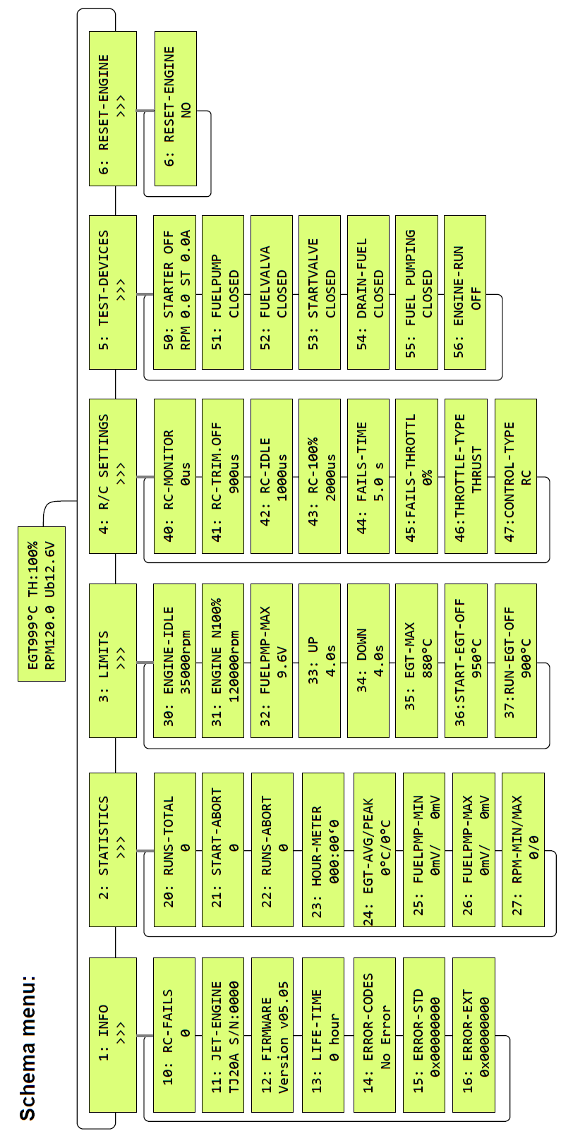

## Menu 1:INFO

10: R/C-FAILS Number of RC connection fails during the last engine run.

11: JET-ENGINE Engine type and serial number.

12: FIRMWARE Firmware version.

13: LIFE-TIME Maximum time to the engine GO.

14: ERROR-CODES Defects causing engine switch-off.

15: ERROR-STD Detailed code of failure causing shutdown.

16: ERROR-EXT Detailed code of failure causing shutdown.

## ERROR Codes

RC FAILS Loss of RC signal during engine run will set 45:FAILS-THROTTL speed for the 44:FAILS-TIME period and, after this period lapses, the engine switches off.

TIME Failure to reach idle speed (IDLE) since the engine start beginning. If the engine fails to reach IDLE within 60 s after the start, starting is aborted.

LOW BATT Low battery voltage. Upon battery voltage drop below 10 V in STOP mode, TEST mode, and START mode, the engine switches off immediately. Upon battery voltage drop below 9 V in Engine Run mode and in COOL mode the engine switches off immediately.

HIGH BATT High battery voltage. Should the battery voltage rise above 15 V, the engine switches off immediately.

BAD STARTER Failure of starter during device test or engine start

BAD GLOW Failure of heater plug during device test or engine start

BAD PUMP Failure of fuel pump during device test or engine start

BAD EGT Failure of exhaust gas temperature sensor during device test or engine start

MAX EGT High exhaust gas temperature during engine start and run. Should temperature during engine start exceed the value 39: START-EGTOFF for a period longer than 3 seconds, the engine switches off. Should temperature during engine run exceed the value 3A: RUN-EGT-OFF for a period longer than 3 seconds, the engine switches off.

MIN RPM Speed drop during engine run. Should the engine speed drop below 25,000 rpm, the engine switches off. In device test or engine start modes, it may be caused by starter or clutch malfunction.

OVER RPM Overspeed during engine run. Should the engine speed rise over 124,000 rpm, the engine switches off.

GENERAL ERROR Electronics malfunction. Restart the engine (switch the engine power supply off and on again) or, if engine restart does not help, reset the engine (in Menu 6: RESET-ENGINE) back to the factory settings

## Menu 2: STATISTICS

20: RUNS-TOTAL Total number of engine starts and runs.

21: START-ABORT Total number of engine failed starts.

22: RUNS-ABORT Total number of engine failed runs.

23: HOUR-METER Total hours worked by the engine (total time of the fuel pump operation)  
Units – HH.MM’SS.

24: EGT-AVG/PEAK Average and maximum exhaust gas temperature during the last engine run.

25: FUELPMP-MIN Effective voltage of the fuel pump in idle speed (IDLE) of the engine during the last and last but one engine run.

26: FUELPMP-MAX Effective voltage of the fuel pump at 95 % of ENGINE N100 % speed during the last and last but one engine run.

27: RPM-MIN/MAX Minimum and maximum speed during the last engine run.

## Menu 3: LIMITS

30: ENGINE-IDLE Engine idle speed. Setting range from 33,000 to 40,000 rpm in 100 rpm steps. 35,000 rpm by default.

31: ENGINE N100 % Maximum reduced engine speed. Setting range from 100,000 to 120,000 in 100 rpm steps. The maximum speed can be lowered or raised by the engine manufacturer, because of the setting of engine parameters. 120,000 rpm by default.

32: FUELPMP-MAX Maximum effective voltage of the fuel pump. Setting range from 2,4 to 10.7 V in 0.1 V steps. 9.6 V by default.

33: UP The acceleration ramp from IDLE to ENGINE N100% speed. Setting range from 4 to 10 s in 0.1 s steps. 4.0 s by default.

34: DOWN The deceleration ramp from ENGINE N100% to IDLE. Setting range from 4 to 10 s in 0.1 s steps. 4,0 s by default.

35: EGT-MAX Maximal regulated temperature of exhaust gases. Setting range from 600 to 880 °C in steps of 5 °C. We recommend to not change the setting. By default 880°C.

36: START-EGT-OFF Maximum exhaust gas temperature during start. If 950 °C is exceeded for a period longer than 3 s, the engine switches off., Cannot be changed.

37: RUN-EGT-OFF Maximum exhaust gas temperature during run. If 900 °C is exceeded for a period longer than 3 s, the engine switches off. Cannot be changed.

## Menu 4: R/C SETTINGS

40: R/C-MONITOR Current value of RC signal

41: RC-TRIM.OFF RC signal value for STOP. Push the SET push-button (the > and < starts flashing). Set the RC transmitter signal for STOP and confirm it by the SET push-button (the > and < stops flashing and it is entered in the engine memory). 0.9 ms by default.

42: RC-IDLE RC signal value for IDLE. Push the SET push-button (the > and < starts flashing). Set the RC transmitter signal for IDLE and confirm it by the SET push-button (the > and < stops flashing and it is entered in the engine memory). 1.0 ms by default.

43: R/C-100 % RC signal value for ENGINE N100 %. Push the SET push-button (the > and < starts flashing). Set the RC transmitter signal for 100 % and confirm it by the SET push-button (the > and < stops flashing and it is entered in the engine memory). 2.0 ms by default.

44: FAILS-TIME Time that starts running upon RC signal loss and after which lapse the engine is switched off. Upon RC signal loss, the speed is set to 45:FAILS-THROTTL. Setting range from 0 to 60 s in 1 s steps. 5 s by default.

45: FAILS-THROTTL Engine speed that will be set upon RC signal loss. Setting range from IDLE to ENGINE N100 % in 100 rpm steps   
0 % - engine stop   
1 – 100 % - engine speed IDLE to 100 %  
0 % by default.

46: THROTTLE-TYPE Linear function for setting engine speed or thrust according to the throttle lever  
SPEED - the throttle lever works linearly with engine speed  
THRUST - the throttle lever works linearly with engine thrust  
THRUST by default.

47: CONTROL-TYPE Selection of engine control  
RC - engine starting, control and switch off by RC input  
UART - engine starting, control and switch off by serial line  
RC by default.

## Menu 5: TEST-DEVICES

50: STARTER OFF Starter test. The starter is spun to a defined speed and then switched off.

51: FUELPUMP Fuel pump test. The fuel pump is spun to a defined speed and then switched off. Both fuel valves are closed.

52: FUELVALVE Main fuel valve test.

53: STARTVALVE Starting fuel valve test.

54: DRAIN-FUEL Draining fuel from the engine. Both fuel valves are open.

55: FUEL PUMPING Pumping fuel into the engine. Both fuel valves are open.

56: ENGINE-RUN Engine start by EDT without RC set.

## Engine Start procedure using EDT

- Set 56: ENGINE-RUN in EDT Menu.

- Press the  push-button and the OFF indication will start flashing in the display.

- Set ON using the  or  push-button and confirm it by the  push-button.

- The EDT display will indicate "EDT ST?" in the top right corner.

- Start the engine start by pressing  the push-button.

- Increase or decrease the engine speed using the  or  push-button.

- Stop the engine by pressing the  push-button.

## Menu 6: RESET-ENGINE

6:RESET-ENGINE Reset engine to factory default settings.

## Factory Reset procedure

- Set 6: RESET-ENGINE in EDT Menu.

- Press the  push-button and the NO inscription will start flashing in the display.

- Set YES using  the or  push-button and confirm it by the  push-button.

- Wait until the display shows the Main Screen.

- Restart the engine by switching the power supply off and on again.



# 9 ELECTRICAL SYSTEM

